UNITED STATES

SECURITIES AND EXCHANGE COMMISSION

Washington, D.C. 20549

FORM 10-Q

- QUARTERLY REPORT PURSUANT TO SECTION 13 OR 15(d) OF THE SECURITIES EXCHANGE ACT OF 1934

For the quarterly period ended March 31, 2025

OR

- TRANSITION REPORT PURSUANT TO SECTION 13 OR 15(d) OF THE SECURITIES EXCHANGE ACT OF 1934

FOR THE TRANSITION PERIOD FROM __________ TO __________

Commission File Number: 001-38067

Verona Pharma plc

 | (Exact name of Registrant as specified in its Charter)
United Kingdom |  | 98-1489389
(State or other jurisdiction of incorporation or organization) |  | (I.R.S. Employer Identification No.)
3 More London Riverside
London SE1 2RE United Kingdom |  | Not Applicable
(Address of principal executive offices) |  | (Zip Code)
 | Registrant’s telephone number, including area code: +44 203 283 4200
 | Securities registered pursuant to Section 12(b) of the Act:
Title of each class | Trading Symbol(s) | Name of each exchange on which registered
Ordinary shares, nominal value £0.05 per share* | VRNA | The Nasdaq Stock Market LLC (Nasdaq Global Market)

- The ordinary shares are represented by American Depositary Shares (each representing 8 ordinary shares), which are exempt from the operation of Section 12(a) of the Securities Exchange Act of 1934, as amended, pursuant to Rule 12a-8 thereunder.

Indicate by check mark whether the registrant (1) has filed all reports required to be filed by Section 13 or 15(d) of the Securities Exchange Act of 1934 during the preceding 12 months (or for such shorter period that the registrant was required to file such reports), and (2) has been subject to such filing requirements for the past 90 days. Yes ☒ No ☐

Indicate by check mark whether the registrant has submitted electronically every Interactive Data File required to be submitted pursuant to Rule 405 of Regulation S-T (§232.405 of this chapter) during the preceding 12 months (or for such shorter period that the registrant was required to submit such files). Yes ☒ No ☐

Indicate by check mark whether the registrant is a large accelerated filer, an accelerated filer, a non-accelerated filer, a smaller reporting company, or an emerging growth company. See the definitions of “large accelerated filer,” “accelerated filer,” “smaller reporting company,” and “emerging growth company” in Rule 12b-2 of the Exchange Act.

Large accelerated filer | ☒ | Accelerated filer | ☐
Non-accelerated filer | ☐ | Smaller reporting company | ☐
 |  | Emerging growth company | ☐

If an emerging growth company, indicate by check mark if the registrant has elected not to use the extended transition period for complying with any new or revised financial accounting standards provided pursuant to Section 13(a) of the Exchange Act. ☐

Indicate by check mark whether the registrant is a shell company (as defined in Rule 12b-2 of the Exchange Act). Yes ☐ No ☒

As of April 23, 2025, the registrant had 681,056,022 ordinary shares, nominal value £0.05 per share, outstanding, which if all held in ADS form, would be represented by 85,132,003 American Depositary Shares, each representing eight (8) ordinary shares.

 |  |  |  |  |  | Page
 | PART I - FINANCIAL INFORMATION
 | Item 1 |  |  |  | Financial Statements | 4
 | Item 2 |  |  |  | Management’s Discussion and Analysis of Financial Condition and Results of Operations | 16
 | Item 3 |  |  |  | Quantitative and Qualitative Disclosures About Market Risk | 26
 | Item 4 |  |  |  | Controls and Procedures | 26
 | PART II - OTHER INFORMATION
 | Item 1 |  |  |  | Legal Proceedings | 27
 | Item 1A. |  |  |  | Risk Factors | 27
 | Item 2 |  |  |  | Unregistered Sales of Equity Securities and Use of Proceeds | 74
 | Item 3 |  |  |  | Defaults Upon Senior Securities | 74
 | Item 4 |  |  |  | Mine Safety Disclosure | 74
 | Item 5 |  |  |  | Other Information | 75
 | Item 6 |  |  |  | Exhibits | 75
 | Signatures |  |  |  |  | 77

1

SUMMARY RISK FACTORS

Our business is subject to numerous risks and uncertainties, including those described in Part II, Item 1A. “Risk Factors” in this Quarterly Report on Form 10-Q. You should carefully consider these risks and uncertainties when investing in our ADSs. The principal risks and uncertainties affecting our business include the following:

- We have a limited operating history and have not generated any significant product revenue.

- We may need additional funding to complete development and commercialization of any future product candidates and to continue to commercialize Ohtuvayre. If we are unable to raise capital when needed, or if a failure of any financial institution where we maintain our cash and cash equivalents prevents or delays us from accessing uninsured funds, we could be forced to delay, reduce or eliminate our product development programs or commercialization efforts.

- The terms of our credit facility place restrictions on our operating and financial flexibility, and our existing and any future indebtedness could adversely affect our ability to operate our business;

- Changes in our tax rates, unavailability of certain tax credits or reliefs or exposure to additional tax liabilities or assessments could affect our profitability, and audits by tax authorities could result in additional tax payments for prior periods;

- We depend solely on the success of ensifentrine, which was recently approved by the FDA as Ohtuvayre. If we are unable to continue to commercialize Ohtuvayre, or successfully develop ensifentrine for other indications, our ability to generate revenue and our financial condition will be adversely affected;

- We may incur additional costs or experience delays in completing, or ultimately be unable to complete, the development and commercialization of our product candidates;

- Our product and product candidates may have serious adverse, undesirable or unacceptable side effects which may delay or prevent marketing approval;

- If we are unable to enroll patients in our clinical trials for other indications, or enrollment is slower than anticipated, our research and development efforts could be adversely affected;

- We may become exposed to costly and damaging liability claims, either when testing ensifentrine in the clinic or at the commercial stage, and our product liability insurance may not cover all damages from such claims;

- Regulatory approval processes are lengthy, time consuming and inherently unpredictable, and if we are ultimately unable to obtain regulatory approval for our product candidates, our business will be substantially harmed;

- Enacted and future legislation may increase the difficulty and cost for us to obtain marketing approval of and commercialize our product candidates and may affect the prices we may set;

- Our business operations and current and future relationships with investigators, healthcare professionals, consultants, third-party payors and customers will be subject to applicable healthcare regulatory laws, which could expose us to penalties;

- We operate in a highly competitive and rapidly changing industry, which may result in others discovering, developing or commercializing competing products before or more successfully than we do;

- If our products, including Ohtuvayre, do not gain market acceptance or if we fail to accurately forecast demand or manage our inventories, our business will suffer because we might not be able to fund future operations;

- Our commercial capabilities and infrastructure, including sales, marketing, operations, manufacturing, distribution, and reimbursement infrastructure, may not be adequate to successfully commercialize Ohtuvayre;

- We rely, and expect to continue to rely, on third parties, including independent clinical investigators and clinical research organizations, to conduct our pre-clinical studies and clinical trials;

- The collaboration and license agreement with Nuance Pharma is important to our business. If Nuance Pharma is unable to develop and commercialize products containing ensifentrine in Greater China, if we or Nuance Pharma fail to adequately perform under the Nuance Agreement, or if we or Nuance Pharma terminate the Nuance Agreement, our business would be adversely affected;

- If we fail to enter into new strategic relationships for ensifentrine, our business, research and development and commercialization prospects could be adversely affected;

2

- We rely, and expect to continue to rely, on third party manufacturers and suppliers for production of the active pharmaceutical ingredient ensifentrine and formulated drug products derived therefrom. Our dependence on these third parties may impair continued commercialization of Ohtuvayre and the advancement of our research and development programs;

- We rely, and expect to continue to rely, on third parties for the sales, marketing, reimbursement and distribution of our drug products, and a failure by these third parties to adequately perform would adversely affect our business;

- Our and our manufacturers’, suppliers’ and other critical third parties’ cybersecurity risk management program and processes may not be effective in protecting our systems, networks and Confidential Information;

- We rely on patents and other intellectual property rights to protect ensifentrine, the enforcement, defense and maintenance of which may be challenging and costly;

- Our information technology systems, and those of our manufacturers, suppliers and other third parties that we use to perform services for us or otherwise collaborate with, may fail or suffer security breaches, which could distract our operations and cause delays in our research and development and commercialization activities, and may adversely affect our business, operations and financial performance;

- We may not identify relevant third-party patents or may incorrectly interpret the relevance, scope or expiration of a third-party patent which might adversely affect our ability to develop, manufacture and market ensifentrine;

- We may be involved in lawsuits to protect or enforce patents covering ensifentrine, which could be expensive, time consuming and unsuccessful, and issued patents could be found invalid or unenforceable if challenged in court;

- Our future growth and ability to compete depends on our ability to retain our key personnel and recruit additional qualified personnel;

- We expect to expand our development, regulatory and sales and marketing capabilities, and as a result, we may encounter difficulties in managing our growth, which could disrupt our operations;

- The price of our American Depositary Shares may be volatile and may fluctuate due to factors beyond our control;

- We will continue to incur increased costs as a result of operating as a public company in the United States, and our senior management are required to devote substantial time to new compliance initiatives and corporate governance practices; and

- Business interruptions could adversely affect our operations.

3

PART I - FINANCIAL INFORMATION

Item 1. Financial statements

4

Verona Pharma plc

Condensed Consolidated Balance Sheets

(unaudited)

(in thousands, except share and per share amounts)

 |  | March 31, |  |  | December 31,
 |  | 2025 |  |  | 2024
ASSETS
Current assets:
Cash and cash equivalents | $ | 401,415 |  | $ | 399,757
Accounts receivable, net |  | 62,159 |  |  | 31,496
Prepaid expenses |  | 11,317 |  |  | 7,573
Tax incentive receivable |  | 5,935 |  |  | 5,762
Inventory |  | 7,244 |  |  | 6,249
Other current assets |  | 12,955 |  |  | 2,735
Total current assets |  | 501,025 |  |  | 453,572
Non-current assets:
Furniture and equipment, net |  | 1,048 |  |  | 1,105
Inventory, long-term |  | 6,508 |  |  | 1,972
Goodwill |  | 545 |  |  | 545
Equity interest |  | 15,000 |  |  | 15,000
Right-of-use assets |  | 1,810 |  |  | 2,048
Total non-current assets |  | 24,911 |  |  | 20,670
Total assets | $ | 525,936 |  | $ | 474,242
LIABILITIES AND SHAREHOLDERS’ EQUITY
Current liabilities:
Accounts payable | $ | 9,077 |  | $ | 11,266
Accrued expenses |  | 32,335 |  |  | 16,757
Royalties payable |  | 4,487 |  |  | 1,100
Revenue interest purchase security agreement |  | — |  |  | 687
Current operating lease liabilities |  | 1,078 |  |  | 1,120
Taxes payable |  | 8,889 |  |  | 8,889
Other current liabilities |  | 678 |  |  | 2,862
Total current liabilities |  | 56,544 |  |  | 42,681
Non-current liabilities:
Term loan |  | 241,742 |  |  | 120,341
Revenue interest purchase security agreement |  | — |  |  | 105,420
Non-current operating lease liabilities |  | 1,055 |  |  | 1,241
Total non-current liabilities |  | 242,797 |  |  | 227,002
Total liabilities |  | 299,341 |  |  | 269,683
Commitments and contingencies
Shareholders' equity:
Ordinary £0.05 par value shares; 703,189,462 and 703,189,462 issued, and 681,056,022 and 677,008,254 outstanding, at March 31, 2025 and December 31, |  | 45,021 |  |  | 45,021
2024, respectively |  | 45,021 |  |  | 45,021
Additional paid-in capital |  | 766,369 |  |  | 728,199
Ordinary shares held in treasury |  | (1,402) |  |  | (1,659)
Accumulated other comprehensive loss |  | (4,601) |  |  | (4,601)
Accumulated deficit |  | (578,792) |  |  | (562,401)
Total shareholders' equity |  | 226,595 |  |  | 204,559
Total liabilities and shareholders' equity | $ | 525,936 |  | $ | 474,242

The accompanying notes are an integral part of these unaudited condensed consolidated financial statements.

5

Verona Pharma plc

Condensed Consolidated Statements of Operations and Comprehensive Loss

(unaudited)

(in thousands, except per share amounts)

 | Three months ended March 31,
 | 2025 |  |  | 2024
Revenue:
Product sales, net | $ | 71,256 |  | $ | —
Other revenue |  | 5,000 |  |  | —
Total revenue, net |  | 76,256 |  |  | —
Operating expenses:
Cost of sales |  | 3,407 |  |  | —
Research and development |  | 14,054 |  |  | 6,764
Selling, general and administrative |  | 69,112 |  |  | 20,434
Total operating expenses |  | 86,573 |  |  | 27,198
Operating loss |  | (10,317) |  |  | (27,198)
Other income/(expense):
Research and development tax credit |  | — |  |  | 585
Loss on extinguishment of debt |  | (407) |  |  | —
Interest income |  | 3,891 |  |  | 3,378
Interest expense |  | (10,195) |  |  | (1,586)
Foreign exchange gain/(loss) |  | 470 |  |  | (219)
Total other (expense)/income, net |  | (6,241) |  |  | 2,158
Loss before income taxes |  | (16,558) |  |  | (25,040)
Income tax benefit/(expense) |  | 239 |  |  | (754)
Net loss | $ | (16,319) |  | $ | (25,794)
Loss per ordinary share - basic and diluted | $ | (0.02) |  | $ | (0.04)
Weighted-average shares outstanding - basic and diluted |  | 679,405 |  |  | 645,701

The accompanying notes are an integral part of these unaudited condensed consolidated financial statements.

6

Verona Pharma plc

Condensed Consolidated Statements of Shareholders’ Equity

(unaudited)

(in thousands except share data)

 | Ordinary shares |  |  |  |  | Additional paid-in |  |  | Ordinary shares held |  |  |  | Accumulated other |  |  |  |  |  | Total shareholders'
 | Number |  |  | Amount |  |  | capital |  |  | in treasury |  |  | comprehensive loss |  |  | Accumulated deficit |  |  | equity
Balance at December 31, 2024 | 703,189,462 |  | $ | 45,021 |  | $ | 728,199 |  | $ | (1,659) |  | $ | (4,601) |  | $ | (562,401) |  | $ | 204,559
Net loss | — |  |  | — |  |  | — |  |  | — |  |  | — |  |  | (16,319) |  |  | (16,319)
Restricted share units vested | — |  |  | — |  |  | — |  |  | 72 |  |  | — |  |  | (72) |  |  | —
Share options exercised | — |  |  | — |  |  | 4,980 |  |  | 185 |  |  | — |  |  | — |  |  | 5,165
Common shares withheld for taxes on | — |  |  | — |  |  | (4,287) |  |  | — |  |  | — |  |  | — |  |  | (4,287)
vested stock awards |  |  |  |  |  |  | (4,287) |  |  |  |  |  |  |  |  |  |  |  | (4,287)
Share-based compensation | — |  |  | — |  |  | 37,477 |  |  | — |  |  | — |  |  | — |  |  | 37,477
Balance at March 31, 2025 | 703,189,462 |  | $ | 45,021 |  | $ | 766,369 |  | $ | (1,402) |  | $ | (4,601) |  | $ | (578,792) |  | $ | 226,595

The accompanying notes are an integral part of these unaudited condensed consolidated financial statements.

 | Ordinary shares |  |  |  |  | Additional paid-in |  |  | Ordinary shares held |  |  |  | Accumulated other |  |  |  |  |  | Total shareholders'
 | Number |  |  | Amount |  |  | capital |  |  | in treasury |  |  | comprehensive loss |  |  | Accumulated deficit |  |  | equity
Balance at December 31, 2023 | 667,659,630 |  | $ | 42,771 |  | $ | 601,063 |  | $ | (1,517) |  | $ | (4,601) |  | $ | (388,433) |  | $ | 249,283
Net loss | — |  |  | — |  |  | — |  |  | — |  |  | — |  |  | (25,794) |  |  | (25,794)
Restricted share units vested | — |  |  | — |  |  | — |  |  | 170 |  |  | — |  |  | (170) |  |  | —
Share options exercised | — |  |  | — |  |  | 751 |  |  | 65 |  |  | — |  |  | — |  |  | 816
Common shares withheld for taxes on | — |  |  | — |  |  | (3,338) |  |  | — |  |  | — |  |  | — |  |  | (3,338)
vested stock awards |  |  |  |  |  |  | (3,338) |  |  |  |  |  |  |  |  |  |  |  | (3,338)
Equity settled share-based | — |  |  | — |  |  | (237) |  |  | — |  |  | — |  |  | — |  |  | (237)
compensation reclassified as cash- |  |  |  |  |  |  | (237) |  |  |  |  |  |  |  |  |  |  |  | (237)
settled
Share-based compensation | — |  |  | — |  |  | 4,258 |  |  | — |  |  | — |  |  | — |  |  | 4,258
Balance at March 31, 2024 | 667,659,630 |  | $ | 42,771 |  | $ | 602,497 |  | $ | (1,282) |  | $ | (4,601) |  | $ | (414,397) |  | $ | 224,988

The accompanying notes are an integral part of these unaudited condensed consolidated financial statements.

7

Verona Pharma plc

Condensed Consolidated Statements of Cash Flows

(unaudited)

(in thousands)

 | Three months ended March 31,
 | 2025 |  |  | 2024
Cash flows from operating activities:
Net loss: | $ | (16,319) |  | $ | (25,794)
Adjustments to reconcile net income to net cash used in operating activities:
Foreign exchange (gain)/loss |  | (470) |  |  | 219
Amortization of debt issuance costs |  | 654 |  |  | 82
Accretion of RIPSA |  | 1,654 |  |  | —
Accretion of redemption premium on debt |  | — |  |  | 90
Loss on extinguishment of debt |  | 407 |  |  | —
Share-based compensation |  | 37,477 |  |  | 4,258
Depreciation |  | 295 |  |  | 263
Changes in operating assets and liabilities:
Accounts receivable |  | (30,663) |  |  | —
Prepaid expenses |  | (3,744) |  |  | (5)
Tax incentive receivable |  | — |  |  | (585)
Inventory |  | (5,531) |  |  | —
Other current assets |  | (9,980) |  |  | 942
Accounts payable |  | (2,189) |  |  | 1,255
Accrued expenses |  | 16,113 |  |  | 4,762
Royalties payable |  | 3,387 |  |  | —
Operating lease liabilities |  | (228) |  |  | (152)
Income taxes |  | (240) |  |  | 754
Other current liabilities |  | (2,184) |  |  | 301
Net cash used in operating activities |  | (11,561) |  |  | (13,610)
Cash flows from investing activities:
Purchases of furniture and equipment |  | (535) |  |  | (16)
Net cash used in investing activities |  | (535) |  |  | (16)
Cash flows from financing activities:
Proceeds from Term Loans |  | 122,500 |  |  | —
Payment of debt issuance costs |  | — |  |  | (364)
Repurchase of RIPSA |  | (109,921) |  |  | —
Payments of withholding taxes from share-based awards |  | (4,287) |  |  | (3,575)
Proceeds from exercise of share options |  | 5,165 |  |  | 816
Net cash provided by/(used in) financing activities |  | 13,457 |  |  | (3,123)
Effect of exchange rate changes on cash and cash equivalents |  | 297 |  |  | (141)
Net change in cash and cash equivalents |  | 1,658 |  |  | (16,890)
Cash and cash equivalents at beginning of the period |  | 399,757 |  |  | 271,772
Cash and cash equivalents at end of the period | $ | 401,415 |  | $ | 254,882
Supplemental disclosure of cash flow information:
Income taxes paid | $ | — |  | $ | —
Interest paid | $ | 10,151 |  | $ | 933

The accompanying notes are an integral part of these unaudited condensed consolidated financial statements.

8

Verona Pharma plc

Notes to Condensed Consolidated Financial Statements

(unaudited)

Note 1 - Organization and description of business operations

Verona Pharma plc is incorporated and domiciled in the United Kingdom. Verona Pharma plc has one wholly-owned subsidiary, Verona Pharma, Inc., a Delaware corporation (together with Verona Pharma plc, the “Company”). The address of the registered office is 1 Central Square, Cardiff, CF10 1FS, United Kingdom.

The Company is a biopharmaceutical group focused on developing and commercializing innovative therapeutics for the treatment of respiratory diseases with significant unmet medical needs. The Company’s American Depositary Shares (“ADSs”) are listed on the Nasdaq Global Market (“Nasdaq”) and trade under the symbol “VRNA”.

On June 26, 2024, the FDA approved Ohtuvayre (ensifentrine) for the maintenance treatment of chronic obstructive pulmonary disease (“COPD”) in adult patients and the Company launched Ohtuvayre in the U.S. through an exclusive network of accredited specialty pharmacies in August 2024. Ohtuvayre is the Company’s first commercial product and the first inhaled therapy with a novel mechanism of action available for the maintenance treatment of COPD in more than 20 years.

Ohtuvayre is a first-in-class selective dual inhibitor of the enzymes phosphodiesterase 3 and phosphodiesterase 4 that combines bronchodilator and non-steroidal anti-inflammatory effects in one molecule. Ohtuvayre is delivered directly to the lungs through a standard jet nebulizer without the need for high inspiratory flow rates or complex hand-breath coordination.

Verona is commercializing Ohtuvayre for the maintenance treatment of COPD in the U.S. Outside the U.S., the Company continues to progress the regulatory activities for the potential marketing authorization application submissions for Ohtuvayre for the maintenance treatment of COPD in the European Union (“EU”) and in the UK.

Verona intends to license Ohtuvayre to companies with expertise and experience in developing and commercializing products in those regions. To that end, the Company has entered into a strategic collaboration with Nuance Pharma Limited, a Shanghai-based specialty pharmaceutical company (“Nuance Pharma”), to develop and commercialize ensifentrine, including Ohtuvayre, in Greater China. In February 2025, Nuance Pharma announced that Ohtuvayre was approved in Macau, the first approval outside of the U.S., for the maintenance treatment of COPD in adult patients. In addition, in September 2024, Nuance Pharma completed enrollment in its own pivotal Phase 3 trial evaluating ensifentrine for the maintenance treatment of COPD in China and results are expected in the second quarter of 2025.

Pipeline

The Company plans to start a dose-ranging Phase 2b trial to assess the safety and efficacy of a fixed-dose nebulized combination of ensifentrine with glycopyrrolate, a Long-Acting Muscarinic Antagonist (“LAMA”), for the maintenance treatment of patients with COPD in the second half of 2025. The Company has successfully completed a dose-ranging Phase 2 trial with glycopyrrolate to support this program.

Additionally, based on the clinical results of ensifentrine observed in patients with COPD, including improvements in lung function and symptoms of cough and sputum, the Company believes ensifentrine could potentially be an effective treatment for non-cystic fibrosis bronchiectasis (“bronchiectasis”). In the third quarter of 2024, the Company commenced a Phase 2 clinical trial to assess the efficacy and safety of nebulized ensifentrine in patients with bronchiectasis.

Liquidity

The Company has incurred recurring losses and negative cash flows from operations since inception, and has an accumulated deficit of $578.8 million as of March 31, 2025. The Company may incur additional losses and negative cash flows from operations until its products reach commercial profitability, if at all.

The Company expects that its cash and cash equivalents as of March 31, 2025, its anticipated product sales and funding expected to become available under the Term Loans (as defined in Note 7) will enable the Company to fund planned operating expenses and capital expenditure requirements for at least the next 12 months from the date of issuance.

Additionally, the Company may enter into out-licensing transactions from time to time but there can be no assurance that the Company can secure such transactions in the future. Accordingly, the Company may need to obtain substantial additional funds to achieve its business objectives including to further advance clinical and regulatory activities, to fund launch related costs and to create an effective sales and marketing organization to commercialize Ohtuvayre. Any such funding will need to be obtained through public or private financings, debt financing,

9

Verona Pharma plc

Notes to Condensed Consolidated Financial Statements

(unaudited)

collaboration or licensing arrangements or other arrangements. However, there is no guarantee the Company will be successful in securing additional capital on acceptable terms, or at all.

Note 2 - Basis of presentation and summary of significant accounting policies

Basis of presentation and consolidation

The unaudited condensed consolidated financial statements include the accounts of Verona Pharma plc and its wholly-owned subsidiary Verona Pharma, Inc. All inter-company balances and transactions have been eliminated.

The accompanying unaudited condensed consolidated financial statements included in this Quarterly Report on Form 10-Q have been prepared in conformity with accounting principles generally accepted in the U.S. (“U.S. GAAP”) and should be read in conjunction with the consolidated financial statements and accompanying notes included in the Company’s Annual Report on Form 10-K filed on February 27, 2025 (the “2024 Form 10-K”). The Consolidated Balance Sheet as of December 31, 2024, was derived from audited consolidated financial statements included in the 2024 Form 10-K but does not include all disclosures required by U.S. GAAP for complete financial statements. The Company’s significant accounting policies are described in Note 2 to those consolidated financial statements.

Certain information and footnote disclosures normally included in financial statements prepared in accordance with U.S. GAAP have been condensed or omitted from these interim financial statements. The unaudited condensed consolidated financial statements reflect all adjustments which in the opinion of management are necessary for a fair statement of results of operations, comprehensive income, financial condition, cash flows and shareholders' equity for the periods presented. Except as otherwise disclosed, all such adjustments are of a normal recurring nature. Operating results for the interim periods are not necessarily indicative of the results that may be expected for the full year.

Segment reporting

Operating segments are defined as components of an enterprise about which separate discrete information is available for evaluation by the chief operating decision maker (“CODM”), or decision-making group, in deciding how to allocate resources and in assessing performance. The Company has determined that the Chief Executive Officer (“CEO”) is the Company’s CODM as the CEO makes decisions as it relates to allocation of resources and key market strategies. The Company has one operating and reportable segment, the development and commercialization of pharmaceutical products. The CODM uses consolidated Net loss to assess financial performance and allocate resources. The significant expenses within Net Loss are separately presented on the Company’s Consolidated Statements of Operations and Comprehensive Loss.

Concentration of risk

For the three months ended March 31, 2025 the Company relied on five specialty pharmacies to purchase and supply Ohtuvayre to patients. These five specialty pharmacies accounted for 100% of all Ohtuvayre net product sales in the three months ended March 31, 2025 and accounted for all of the Company's outstanding accounts receivable from product sales as of March 31, 2025. The Company’s five specialty pharmacy customers accounted for 49%, 26%, 9%, 15% and 2% of product sales, net for the three months ended March 31, 2025. The loss, or a significant change in the buying patterns of any one of these specialty pharmacies could negatively impact net sales of Ohtuvayre.

Use of estimates

The preparation of interim unaudited condensed consolidated financial statements in conformity with U.S. GAAP requires management to make estimates and assumptions that affect the reported amounts of assets, liabilities, the disclosure of contingent assets and liabilities at the date of the financial statements and the reported amounts of expenses during the reporting periods. Significant estimates and assumptions reflected in these unaudited condensed consolidated financial statements include, but are not limited to, the accrual and prepayment of research and development expenses, gross-to-net revenue adjustments, amortization and carrying value of the revenue interest purchase and sale agreement (“RIPSA”), and the fair value of share-based compensation. Estimates are periodically reviewed in light of changes in circumstances, facts and experience. Changes in estimates are recorded in the period in which they become known, and actual results could differ from the Company’s estimates.

Recently issued accounting standards not yet adopted

In December 2023, the FASB issued ASU No. 2023-09, Improvements to Income Tax Disclosures, which requires disaggregated information about a reporting entity's effective tax rate reconciliation as well as information on

income taxes paid. The standard is intended to benefit investors by providing more detailed income tax disclosures that would be useful in making capital allocation decisions. The amendments in this ASU are effective for annual periods beginning after December 15, 2024, and should be applied on a prospective basis with the option to apply the standard retrospectively. Early adoption is permitted. This ASU will have no impact on the Company's Consolidated Balance Sheets or Consolidated Statements of Operations and Comprehensive Loss. The Company is currently evaluating the impact to its income tax disclosures.

In November 2024, the FASB issued ASU No. 2024-03: Disaggregation of Income Statement Expenses ("DISE"). The ASU requires additional disclosure of the nature of expenses included in the income statement. The ASU is effective for annual reporting periods beginning after December 15, 2026 and interim reporting periods beginning after December 15, 2027. The requirements will be applied prospectively with the option for retrospective application. Early adoption is permitted. The Company is currently evaluating the extent of the impact of this ASU on disclosures in our Consolidated Financial Statements.

Note 3 - Inventory

The classes of inventory as of March 31, 2025 and December 31, 2024 are summarized as follows (in thousands):

 | March 31, |  |  |  | December 31,
 | 2025 |  |  |  | 2024
Raw materials | $ | 1,823 |  | $ | 228
Finished goods |  | 11,929 |  |  | 7,993
Inventory | $ | 13,752 |  | $ | 8,221

No inventory was written down as a result of excess, obsolescence, scrap, or other reasons during the three months ended March 31, 2025.

10

Verona Pharma plc

Notes to Condensed Consolidated Financial Statements

(unaudited)

Note 4 - Equity interest

The Company entered into a collaboration and license agreement (the “Nuance Agreement”) with Nuance Pharma effective June 9, 2021 (the “Effective Date”), under which the Company granted Nuance Pharma the exclusive rights to develop and commercialize ensifentrine in Greater China (China, Taiwan, Hong Kong and Macau). In return, the Company received an unconditional right to consideration aggregating $40.0 million consisting of $25.0 million in cash and an equity interest, valued at $15.0 million as of the Effective Date, in Nuance Biotech, the parent company of Nuance Pharma.

The equity interest is recorded at cost as the Company has elected to use the measurement alternative for equity investments without readily determinable fair values. The Company evaluates this investment for indicators of impairment quarterly. The Company did not identify events or changes in circumstances that may have a significant effect on the fair value of the investment during the three months ended March 31, 2025.

In March 2025, Nuance Pharma completed the last treatment of the last patient under the Phase 3 Clinical Study of ensifentrine at which point the Company was due $5.0 million as a development milestone under the Nuance Agreement. This amount is due within 30 days and is included within Other current assets on the Condensed Consolidated Condensed Balance Sheets and as Other revenue in the Condensed Consolidated Statements of Operations and Comprehensive Loss.

Note 5 - Accrued expenses

Accrued expenses consisted of the following (in thousands):

 | March 31, |  |  |  | December 31,
 | 2025 |  |  |  | 2024
Rebates and other sales deductions | $ | 13,250 |  | $ | 6,178
VAT due to Ligand |  | 4,916 |  |  | —
Clinical trial and other development costs |  | 3,773 |  |  | 4,006
Professional fees and general corporate costs |  | 6,243 |  |  | 3,642
People related costs |  | 4,153 |  |  | 2,931
Total accrued expenses | $ | 32,335 |  | $ | 16,757

Note 6 - Ligand license agreement obligations

In 2006, the Company acquired Rhinopharma and assumed contingent liabilities owed to Ligand UK Development Limited (“Ligand”) (formerly Vernalis Development Limited). The Company refers to the assignment and license agreement as the Ligand Agreement.

Ligand assigned to the Company all of its rights to certain patents and patent applications relating to ensifentrine and related compounds (the “Ligand Patents”) and an exclusive, worldwide, royalty-bearing license under certain Ligand know-how to develop, manufacture and commercialize products (the “Ligand Licensed Products”) developed using Ligand Patents, Ligand know-how and the physical stock of certain compounds.

The contingent liability assumed included a milestone payment on obtaining the first approval of any regulatory authority for the commercialization of a Ligand Licensed Product, low single digit royalties based on the future sales performance of all Ligand Licensed Products and a portion equal to a mid-twenty percent of any consideration received from any sub-licensees for the Ligand Patents and for Ligand know-how.

At the time of the acquisition the contingent liability was not recognized as part of the acquisition accounting as it was immaterial.

The Company is obligated to pay low single digit royalties based on the net sales of all Ligand Licensed Products and expenses all costs related to royalty amounts as a cost of sales within the income statement.

The Company is also obligated to pay Ligand 25% of any milestones received and, due to the milestone payment from Nuance Pharma discussed in Note 4 - Equity Interest above, has recorded $1.3 million in Selling, general and administrative expense in the Condensed Consolidated Statements of Operations and Comprehensive Loss.

11

Verona Pharma plc

Notes to Condensed Consolidated Financial Statements

(unaudited)

Note 7 - Debt

Term Loans

On May 9, 2024 (the “2024 Effective Date”), Verona Pharma, Inc. (the “Borrower”) entered into a term loan facility of up to $400.0 million (the “2024 Term Loans” or “2024 Loan Agreement”), consisting of a term loan advance in an aggregate amount of $55.0 million funded on the 2024 Effective Date (the “Tranche A Term Loan”) and four additional term loan advances subject to certain terms and conditions, as discussed below, in the amounts of $70.0 million (the “Tranche B Term Loan”), $75.0 million (the “Tranche C Term Loan”), $100.0 million (the “Tranche D Term Loan”) and $100.0 million (the “Tranche E Term Loan”) with each tranche issued subject to an original issue discount of 2.0%. The 2024 Loan Agreement was entered into with Oaktree Fund Administration, LLC, a Delaware limited liability company, as administrative agent (in such capacity, the “Agent”), and certain funds managed by each of Oaktree Capital Management, L.P. (“Oaktree”) and OCM Life Sciences Portfolio LP (“OMERS”) party thereto (collectively, the “2024 Lenders”). The net proceeds of the 2024 Term Loans will be used for general corporate and working capital purposes and a portion of the proceeds from the Tranche A Term Loan was used by the Borrower on the 2024 Effective Date to repay, in full, the existing outstanding indebtedness owed under the term loan facility entered into in 2023 (the “2023 Term Loan”).

The Tranche B Term Loan was available, subject to customary terms and conditions, during the period commencing on the date the Company received approval from the FDA for its new drug application for ensifentrine through and including the earliest of (i) the date that is 30 days immediately following the date the Company receives such approval and (ii) September 30, 2024. The Tranche C Term Loan will be available, subject to customary terms and conditions (including the prior borrowing of the Tranche B Term Loan), during the period commencing on the first business day following the achievement of a specified net sales milestone for ensifentrine and ending on December 31, 2025. The Tranche D Term Loan will be available, subject to customary terms and conditions (including the prior borrowing of the Tranche C Term Loan), during the period commencing on the first business day following the achievement of a specified net sales milestone for ensifentrine and ending on June 30, 2026. The Tranche E Term Loan will be available, subject to customary terms and conditions (including the prior borrowing of the Tranche D Term Loan) at the 2024 Lenders sole discretion and upon the Company’s request.

The Company received $52.8 million in net proceeds at closing of the 2024 Loan Agreement and draw of the Tranche A Term Loan, which consisted of the Tranche A Term Loan face value of $55.0 million less the original issue discount of $1.1 million and lender and third-party fees related to the 2024 Loan Agreement and RIPSA, as defined and discussed below, of $1.1 million. $52.4 million of the net cash proceeds from the Tranche A Term Loan were used for the repayment in full of the existing outstanding indebtedness owed by the Company under the 2023 Term Loan of $52.3 million and interest amounts related to the 2023 Term Loan of $0.1 million.

On June 28, 2024, the Company received $68.6 million in net proceeds related to the Tranche B Term Loan, which was available upon FDA approval for Ohtuvayre. The amount received consisted of the Tranche B Term Loan face value of $70.0 million less the original issue discount of $1.4 million.

The 2024 Term Loans will mature on May 9, 2029 and each advance under the 2024 Loan Agreement accrues interest at a fixed per annum rate of 11.00%. The 2024 Loan Agreement provides for interest-only payments on a quarterly basis until maturity. Upon repayment (whether at maturity, upon acceleration or by prepayment or otherwise), the Borrower shall pay an exit fee to the 2024 Lenders in the amount of 2.50% of the aggregate principal amount of the 2024 Term Loans to be paid (the “Exit Fee”). The Borrower may prepay the 2024 Term Loans in full or in part provided that the Borrower (i) provides at least two (2) business days’ prior written notice to the Agent, (ii) pays on the date of such prepayment (A) all outstanding principal to be prepaid plus accrued and unpaid interest, (B) a prepayment fee of 7.00% of the 2024 Term Loans so prepaid if paid on or before the first anniversary of the 2024 Effective Date; 5.00% of the 2024 Term Loans so prepaid if paid after the first anniversary of the 2024 Effective Date and on or before the second anniversary of the 2024 Effective Date; 2.00% of the 2024 Term Loans so prepaid if paid after the second anniversary of the 2024 Effective Date and on or before the third anniversary of the 2024 Effective Date or 1.00% of the 2024 Term Loans so prepaid if paid after the third anniversary of the 2024 Effective Date and on or before the fourth anniversary of the 2024 Effective Date, (C) the Exit Fee and (D) all other sums, if any, that shall become due and payable under the 2024 Loan Agreement, including interest at the default rate with respect to any past due amounts. Amounts outstanding during an event of default are due upon the Majority Lenders’ (as defined in the 2024 Loan Agreement) demand (except during a payment or bankruptcy event of default, whereupon such default interest is automatically imposed) and shall accrue interest at an additional rate of 2.00% per annum, which interest shall be payable on demand in cash and (iii) any partial prepayment of the 2024 Term Loans

12

Verona Pharma plc

Notes to Condensed Consolidated Financial Statements

(unaudited)

shall be an aggregate amount at least equal to $5.0 million in a denomination that is a whole number multiple of $1.0 million in excess thereof.

The 2024 Term Loans are secured by a lien on substantially all of the assets of the Borrower and the Company, including intellectual property, subject to customary exclusions and exceptions.

The 2024 Loan Agreement contains customary representations and warranties, covenants and events of default, including two financial covenants: (i) commencing on the 2024 Effective Date, the Borrower is required to maintain certain levels of cash, and, after the Account Control Agreement Completion Date (as defined in the Loan Agreement) subject to control agreements in favor of the Agent, and (ii) commencing on the fiscal quarter of Company ending on September 30, 2025, the Borrower and the Company are required to maintain quarterly trailing twelve-month net sales from the sale of ensifentrine in the United States; provided that such revenue covenant will be waived at any time (x) the Borrower and the Company’s unrestricted cash balance subject to control agreements in favor of the Agent on the last business day of the applicable fiscal quarter is equal to or greater than the product of 1.25 multiplied by the aggregate principal amount of outstanding 2024 Term Loans on such date or (y) the average daily closing price of the Company’s American Depositary Shares for each of the thirty (30) trading days preceding the last trading day of such fiscal quarter multiplied by the total number of issued and outstanding American Depositary Shares of the Company is at least $1.0 billion. The 2024 Loan Agreement also contains other customary provisions, such as expense reimbursement, as well as indemnification rights for the benefit of the Agent and the 2024 Lenders.

On March 27, 2025 (the “First Amendment Effective Date”), Verona Pharma Inc. entered into the first amendment (the “First Amendment”) to the 2024 Loan Agreement (the 2024 Term Loan Agreement as amended by the First Amendment, the “Term Loan Agreement” and the term loans borrowed thereunder, the “Term Loans”). The First Amendment provides for, among other things: (i) an increase to the commitments under the Tranche C Term Loan from $75.0 million to $125.0 million, which was drawn on the First Amendment Effective Date, (ii) a decrease in the interest rate applicable to all term loans borrowed under the Term Loan Agreement from 11.0% to 9.7% per annum, with a further step down to 9.35% per annum after the Company has met certain Net Sales (as defined in the Term Loan Agreement) milestones (and such step down to apply commencing the first day of the applicable fiscal quarter in which the Borrower certifies such condition has been met), and (iii) a $75.0 million basket for a future working capital facility, subject to certain terms and conditions.

As of March 31, 2025, the effective interest rate was approximately 11% per annum and there was no material difference between the carrying value and the estimated fair value of the Term Loans.

Revenue Interest Purchase and Sale Agreement

On May 9, 2024, the Company and Verona Pharma, Inc. (collectively the “Sellers”) entered into the RIPSA with Oaktree Fund Administration, LLC, a Delaware limited liability company, as administrative agent and certain funds managed by each of Oaktree and OMERS (collectively, the “Purchasers”). Under the terms of the RIPSA, in exchange for each of the Purchaser’s payment to the Sellers of a purchase price of $100 million, in the aggregate, upon approval of ensifentrine by the FDA by a specified date and subject to certain labeling conditions (the “Tranche A Purchase Price”), the Sellers agreed to a true sale of assigned interests to the Purchasers, including a right for the Purchasers to receive 6.50% on the global net sales of ensifentrine by the Sellers (the “Royalty Interest Payments”) and 5% on certain proceeds the Sellers receive from licensees engaged during the term of the RIPSA outside of the U.S. (the “Ex-U.S. Payments”).

On June 28, 2024, the Company received the Tranche A Purchase Price of $100.0 million. On March 25, 2025, the Company exercised its buy-out option under the RIPSA and repurchased the Tranche A obligation with reduced repayment fees.

The Company accounted for the exercise of the buy-out option of the RIPSA Agreement and the First Amendment as a debt modification for the existing lenders who participated in both agreements by performing an analysis on a lender by lender basis under ASC 470-50 Debt modifications and exchanges.

13

Verona Pharma plc

Notes to Condensed Consolidated Financial Statements

(unaudited)

Note 8 - Share-based compensation

The following table shows the allocation of share-based compensation between research and development and selling, general and administrative costs (in thousands):

 | Three months ended March 31,
 | 2025 |  |  | 2024
Capitalized to inventory | $ | 639 |  | $ | —
Research and development |  | 6,479 |  |  | 1,016
Selling, general and administrative |  | 30,359 |  |  | 3,242
Total | $ | 37,477 |  | $ | 4,258

The following tables show the activity of each type of share-based compensation and are presented in ordinary shares. The Company’s ADSs that are listed on Nasdaq each represent eight ordinary shares.

Share options activity

 | Number of share options
 | outstanding
Balance as of December 31, 2024 | 32,873,392
Granted | 1,269,600
Forfeited | (343,280)
Exercised | (2,885,032)
Balance as of March 31, 2025 | 30,914,680
Restricted stock units (“RSU”) activity
 | Number of RSUs
 | outstanding
Balance as of December 31, 2024 | 14,830,112
Forfeited | (84,152)
Vested | (984,416)
Balance as of March 31, 2025 | 13,761,544

Performance restricted stock units (“PRSU”) activity

PRSUs will begin to vest upon achievement of certain performance conditions and are subject to continued service. The fair value of PRSUs will be recognized over the remaining service period using the graded-vesting method once the performance conditions are determined to be probable of occurring. The total compensation cost not yet recognized as of March 31, 2025 related to PRSUs was $90.6 million, which will be recognized over a weighted-average period of approximately one year.

A summary of the Company’s PRSU activity for the period ended March 31, 2025 is as follows:

 | Number of PRSUs
 | outstanding
Balance as of December 31, 2024 | 30,561,974
Forfeited | (307,482)
Vested | (776,936)
Balance as of March 31, 2025 | 29,477,556

14

Verona Pharma plc

Notes to Condensed Consolidated Financial Statements

(unaudited)

Note 9 - Net loss per share

Net loss per share is calculated on an ordinary share basis. The Company’s ADSs that are listed on Nasdaq each represent eight ordinary shares. The following table shows the computation of basic and diluted net loss per share for the three months ended March 31, 2025 and 2024 (in thousands except per share amounts):

 | Three months ended March 31,
 | 2025 |  |  |  | 2024
Numerator:
Net loss | $ | (16,319) |  | $ | (25,794)
Denominator:
Weighted-average shares outstanding - basic and diluted |  | 679,405 |  |  | 645,701
Net loss per share - basic and diluted | $ | (0.02) |  | $ | (0.04)

During the three months ended March 31, 2025 and 2024, outstanding share options, RSUs and PRSUs over 74.2 million and 51.9 million ordinary shares, respectively, were not included in the computation of diluted earnings per ordinary share, because to do so would be antidilutive.

15

Item 2. Management’s discussion and analysis of financial condition and results of operations

You should read the following discussion and analysis of our financial condition and results of operations together with our unaudited condensed consolidated financial statements and related notes included elsewhere in this Quarterly Report on Form 10-Q, as well as our audited consolidated financial statements and related notes as disclosed in our Annual Report on Form 10-K for the year ended December 31, 2024 filed with the Securities and Exchange Commission on February 27, 2025 (the “2024 Form 10-K”).

In addition to historical information, this Quarterly Report on Form 10-Q contains statements that constitute forward-looking statements. In some cases, you can identify forward-looking statements by terms such as “may,” “will,” “should,” “expect,” “plan,” “anticipate,” “could,” “intend,” “target,” “project,” “contemplate,” “believe,” “estimate,” “predict,” “potential” or “continue” or the negative of these terms or other similar expressions, although not all forward-looking statements contain these words.

All statements other than statements of historical facts contained in this Quarterly Report on Form 10-Q, including without limitation statements regarding our future results of operations and financial position, business strategy and plans and objectives of management for future operations, the commercialization of Ohtuvayre, the development of our product candidates, including statements regarding the expected initiation, timing, progress and availability of data from our clinical trials, including our recently initiated Phase 2 clinical trials, the timing and availability of data from Nuance Pharma’s Phase 3 clinical trial, potential regulatory approvals, research and development costs, timing and likelihood of success, potential collaborations, the duration of our patent portfolio, our estimates regarding expenses, future revenues, milestone payments, capital requirements, debt service obligations and our need for additional financing, the funding we expect to become available under our various financing agreements and from cash receipts from U.K. tax credits, and the sufficiency of our cash and cash equivalents to fund operations, are forward-looking statements.

The forward-looking statements in this Quarterly Report on Form 10-Q are only predictions and are based largely on our management’s current expectations and projections about future events and financial trends that we believe may affect our business, financial condition and results of operations. These forward-looking statements speak only as of the date of this Quarterly Report on Form 10-Q and are subject to a number of known and unknown risks, uncertainties, assumptions, and other important factors including, but not limited to, those set forth under Part II, Item 1A of this Quarterly Report on Form 10-Q under the heading “Risk Factors” and Part I, Item 1A of the 2024 Form 10-K under the heading “Risk Factors”. Because forward-looking statements are inherently subject to risks and uncertainties, some of which cannot be predicted or quantified and some of which are beyond our control, you should not rely on these forward-looking statements as predictions of future events.

Except as required by applicable law, we do not plan to publicly update or revise any forward-looking statements contained herein, whether as a result of any new information, future events, changed circumstances or otherwise. We intend the forward-looking statements contained in this Quarterly Report on Form 10-Q to be covered by the safe harbor provisions for forward-looking statements contained in Section 27A of the Securities Act and Section 21E of the Securities Exchange Act of 1934, as amended (the “Exchange Act”).

16

Overview

We are a biopharmaceutical company focused on developing and commercializing innovative therapeutics for the treatment of respiratory diseases with significant unmet medical needs.

On June 26, 2024, the U.S. Food and Drug Administration (“FDA”) approved Ohtuvayre (ensifentrine) for the maintenance treatment of chronic obstructive pulmonary disease (“COPD”) in adult patients and we launched Ohtuvayre in the U.S. through an exclusive network of accredited specialty pharmacies in August 2024. Ohtuvayre is our first commercial product and the first inhaled therapy with a novel mechanism of action available for the maintenance treatment of COPD in more than 20 years. We believe Ohtuvayre is an important advancement in the treatment of COPD and will redefine the treatment paradigm for COPD.

Ohtuvayre is a first-in-class selective dual inhibitor of the enzymes phosphodiesterase 3 and 4 (“PDE3” and “PDE 4”) that combines bronchodilator and non-steroidal anti-inflammatory effects in one molecule. Ohtuvayre is delivered directly to the lungs through a standard jet nebulizer without the need for high inspiratory flow rates or complex hand-breath coordination.

We are commercializing Ohtuvayre for the maintenance treatment of COPD in the U.S. Outside the U.S., the Company continues to progress the regulatory activities for the potential marketing authorization application submissions for Ohtuvayre for the maintenance treatment of COPD in the European Union (“EU”) and in the UK.

We intend to license Ohtuvayre to companies with expertise and experience in developing and commercializing products in those regions. To that end, we have entered into a strategic collaboration (the “Nuance Agreement”) with Nuance Pharma Limited, a Shanghai-based specialty pharmaceutical company (“Nuance Pharma”), to develop and commercialize ensifentrine, including Ohtuvayre, in Greater China. In February 2025, Nuance Pharma announced that Ohtuvayre was approved in Macau, the first approval outside of the U.S., for the maintenance treatment of COPD in adult patients. In addition, in September 2024, Nuance Pharma completed enrollment in its own pivotal Phase 3 trial evaluating ensifentrine for the maintenance treatment of COPD in China and results are expected in the second quarter of 2025.

The approval of Ohtuvayre in the United States (“U.S.”) was based on extensive data including the Phase 3 ENHANCE (“Ensifentrine as a Novel inHAled Nebulized COPD thErapy”) trials, the results of which were published in the American Journal of Respiratory and Critical Care Medicine. Ensifentrine met the primary endpoint in both the ENHANCE-1 and ENHANCE-2 trials demonstrating statistically significant and clinically meaningful improvements in measures of lung function. In addition, other endpoint data demonstrated that ensifentrine substantially reduced the rate and risk of COPD exacerbations in ENHANCE-1 and ENHANCE-2. Ensifentrine was well tolerated in both trials.

In Phase 2 clinical trials, ensifentrine has demonstrated positive results in patients with COPD, asthma and cystic fibrosis (“CF”). Two additional formulations of ensifentrine have been evaluated in Phase 2 trials for the treatment of COPD: dry powder inhaler (“DPI”) and pressurized metered-dose inhaler (“pMDI”).

In addition, we plan to start a dose-ranging Phase 2b trial to assess the safety and efficacy of a fixed-dose nebulized combination of ensifentrine with glycopyrrolate, a Long-Acting Muscarinic Antagonist (“LAMA”), for the maintenance treatment of patients with COPD in the second half of 2025. We have successfully completed a dose-ranging Phase 2 trial with glycopyrrolate to support this program.

We are also enrolling subjects into a Phase 2 trial to assess the efficacy and safety of nebulized ensifentrine in patients with non-cystic fibrosis bronchiectasis (“bronchiectasis”).

We have incurred recurring losses and negative cash flows from operations since inception, and have an accumulated deficit of $578.8 million as of March 31, 2025. We expect to incur additional losses and negative cash flows from operations until our product or product candidates potentially reach commercial profitability, if at all.

We anticipate significant expenses in connection with our ongoing activities, if and as we:

- operate a sales, marketing and distribution infrastructure, continue to increase production to commercial scale with our manufacturing and other Chemistry, Manufacturing and Controls activities to commercialize Ohtuvayre as well as any additional products for which we may obtain regulatory approval;

- continue the clinical development of a fixed-dose combination of ensifentrine and a LAMA as well as our DPI and pMDI formulations of ensifentrine and research and development of other formulations of ensifentrine;

17

- initiate and conduct further clinical trials for ensifentrine for the treatment of bronchiectasis, acute COPD, CF or any other indication;

- initiate and progress pre-clinical studies relating to other potential indications of ensifentrine;

- seek to discover and develop additional product candidates;

- seek regulatory approvals for any of our product candidates that successfully complete clinical trials;

- maintain, expand and protect our intellectual property portfolio;

- add clinical, scientific, operational, financial and management information systems and personnel, including personnel to support our product development and commercialization efforts and to support our continuing operations as a U.S. public company; and

- experience any delays or encounter any issues from any of the above, including but not limited to failed studies, complex results, safety issues or other regulatory challenges.

We believe that our cash and cash equivalents as of March 31, 2025, our anticipated product sales and funding expected to become available under the Term Loans will enable us to fund our planned operating expenses and capital expenditure requirements for at least the next 12 months. The remaining advances under the Term Loans are contingent upon the achievement of commercial milestones and other specified conditions, and in the case of the Tranche E Term Loan (as defined in the Term Loans) under the Term Loans, at the sole discretion of the lenders thereto.

18

Clinical development update

Phase 3 ENHANCE program

The U.S. approval of Ohtuvayre was based on extensive data including the Phase 3 ENHANCE trials, the results of which were published in the American Journal of Respiratory and Critical Care Medicine.

We reported positive top-line results from ENHANCE-2 and ENHANCE-1 in August and December 2022, respectively. Ohtuvayre successfully met the primary endpoints in both trials, demonstrating statistically significant and clinically meaningful improvements in measures of lung function in moderate to severe COPD patients. Improvements in symptoms and quality of life measures were shown in both trials, which reached statistical significance in ENHANCE-1. Other endpoint data showed Ohtuvayre substantially reduced the rate and risk of moderate to severe COPD exacerbations and was well tolerated in both trials.

The ENHANCE trials were designed to evaluate Ohtuvayre as monotherapy and added onto a single bronchodilator. Each trial enrolled approximately 800 subjects, for a total of approximately 1,600 subjects, at sites primarily in the U.S. and Europe. The two trials provided replicate evidence of efficacy and safety data over 24 weeks and ENHANCE-1 also evaluated longer-term safety in approximately 400 subjects over 48 weeks.

Subject demographics and disease characteristics were well balanced between treatment groups in both trials.

- In ENHANCE-1 approximately 69% of subjects received background COPD therapy, either a LAMA or a long-acting beta-antagonist (“LABA”). Additionally, approximately 20% of all subjects received inhaled corticosteroids (“ICS”) with concomitant LAMA or LABA.

- In ENHANCE-2 approximately 55% of subjects received background COPD therapy, either a LAMA or a LABA. Additionally, approximately 15% of all subjects received ICS with concomitant LAMA or LABA.
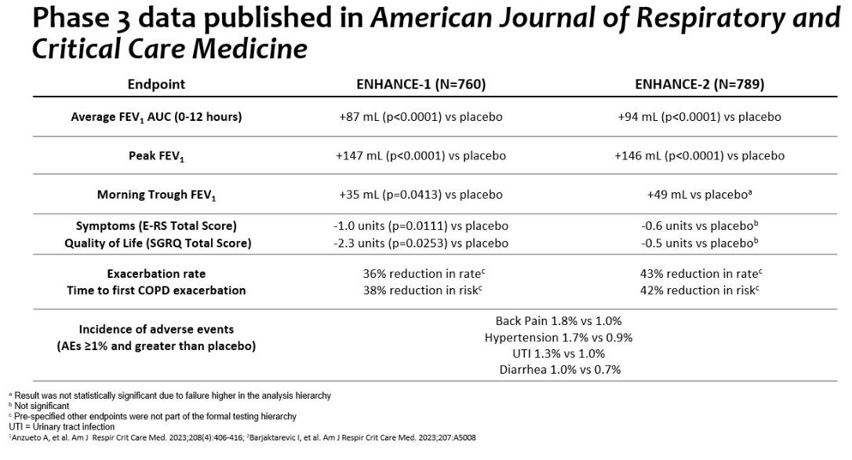

19

Clinical Development Activities

Ensifentrine / Long-Acting Muscarinic Antagonist fixed-dose combination

Fixed-dose combination therapies such as LABA / LAMA, LABA / ICS and LABA / LAMA / ICS are commonly used in the treatment of COPD and, based on our market research, an unmet need exists for a nebulized fixed-dose combination therapy. We believe the combination of ensifentrine with a LAMA could provide COPD patients with the first nebulized fixed-dosed combination with the potential to provide bronchodilation through a dual mechanism and also non-steroidal anti-inflammatory effects via PDE inhibition.

We are developing a fixed-dose combination formulation with ensifentrine and glycopyrrolate, a LAMA, for the maintenance treatment of patients with COPD via delivery in a nebulizer. We have filed patent applications in multiple jurisdictions including the U.S. We plan to start a dose-ranging Phase 2b trial to assess the safety and efficacy of the fixed-dose combination in the second half of 2025. We have successfully completed a dose-ranging Phase 2 trial with glycopyrrolate to support this program.

Non-cystic fibrosis bronchiectasis

Bronchiectasis is a chronic lung disease characterized by persistent cough, excess sputum production and frequent respiratory infections with more severe patients suffering exacerbations. The condition affects up to 500,000 adults in the U.S. and no therapies are specifically approved to treat it. Physicians currently use bronchodilators, antibiotics, steroids, mucus thinners and surgery.

Based on the clinical results of ensifentrine observed in patients with COPD, including improvements in lung function and symptoms of cough and sputum, we believe that ensifentrine could potentially be an effective treatment for bronchiectasis. In the third quarter of 2024, we commenced a Phase 2 clinical trial to assess the efficacy and safety of nebulized ensifentrine in patients with bronchiectasis.

Nuance Pharma

In 2021, we entered into an agreement with Nuance Pharma for exclusive rights to develop and commercialize ensifentrine in Greater China, with future potential milestone payments up to $179 million plus royalties. In August 2022, Nuance Pharma received clearance from the Center of Drug Evaluation for its IND application to conduct both Phase 1 and Phase 3 studies with ensifentrine for the maintenance treatment of COPD in mainland China. Nuance Pharma initiated a Phase 1 trial with ensifentrine in healthy volunteers in March 2023, and, in September 2024, Nuance completed enrollment in its own pivotal Phase 3 trial evaluating ensifentrine for the maintenance treatment of COPD in China with results expected in the second quarter of 2025.

Completion of treatment in the Phase 3 trial in March 2025 triggered a milestone payment of $5.0 million to the Company. This amount is due within 30 days.

In February 2025, Nuance announced that Ohtuvayre was approved in Macau, the first approval outside of the U.S., for the maintenance treatment of COPD in adult patients.

Critical accounting estimates

There were no material changes to the Company’s critical accounting estimates described in the Company’s 2024 Form 10-K during the three months ended March 31, 2025.

Components of results of operations

Product sales, net

With the FDA approval of Ohtuvayre and our commercial launch in the third quarter of 2024, we began to recognize product sales. We record product sales net of estimated distribution fees, government rebates and chargebacks, commercial chargebacks, product returns, co-pay assistance costs and other fees.

Other revenue

Other revenue consists of revenue unrelated to product sales of Ohtuvayre.

20

Cost of sales

We began to recognize cost of sales after the commercial launch of Ohtuvayre in the third quarter of 2024. Cost of sales includes the cost of producing inventory related to Ohtuvayre including manufacturing, freight and overhead as well as sales-based royalties due to Ligand.

Research and development costs

Research and development costs consist of salary and personnel related costs and third party costs for our research and development activities for ensifentrine. Personnel related costs include a share-based compensation charge relating to our share-based compensation. The largest component of third party costs is for clinical trials, as well as manufacturing for clinical supplies and associated development, and pre-clinical studies. Prior to obtaining regulatory approval for Ohtuvayre, we expensed costs relating to production of pre-launch inventory as research and development expense in our condensed consolidated statements of operations and comprehensive loss in the period incurred. All other research and development costs are expensed as incurred.

We expect our research and development costs to increase in future years related to our additional trials for a fixed-dose combination formulation for COPD patients and nebulized ensifentrine in patients with bronchiectasis.

Due to the nature of research and development, the expected costs are inherently uncertain and may vary significantly from our current expectations.

Selling, general and administrative costs

Selling, general and administrative costs consist of salary and personnel related costs, including share-based compensation, expenses relating to the launch of Ohtuvayre and other commercial activities, expenses relating to operating as a public company, including professional fees, insurance and commercial related costs, as well as other operating expenses.

As we continue to develop our knowledge of the market and refine our commercial operations, expected costs may vary significantly from our current expectations. Other income/(expense)

Other income/(expense) are driven by interest income and expense, foreign exchange movements on cash and cash equivalents and taxes receivable, and, historically, the U.K. research and development tax credits (the “R&D tax credit”).

We have historically participated in the U.K. Small and Medium Enterprises research and development tax relief program. The tax credits are calculated as a percentage of qualifying research and development expenditure and are payable in cash by the U.K. government to us on the basis that the Company is loss making. Credits recorded related to the 2023 and 2024 financial years are expected to be received in 2025.

Taxation

Our effective tax rate varies from the statutory U.K. tax rate in each period presented primarily due to the recording of a valuation allowance for our deferred tax assets. We assess the available positive and negative evidence to estimate whether sufficient future taxable income will be generated to permit use of the existing deferred tax assets. A significant piece of objective negative evidence evaluated was the cumulative consolidated loss incurred over the three-year period ended December 31, 2024. Such objective evidence limits the ability to consider other subjective evidence, such as our projections for future growth. We have determined that the reversal of future taxable temporary differences corresponding to our deferred tax liabilities will not provide a sufficient source of income for realization of our deferred tax assets.

21

Results of operations for the three months ended March 31, 2025 and 2024

The following table shows our statements of operations for the three months ended March 31, 2025 and 2024 (in thousands):

 |  | Three months ended March 31,
 |  | 2025 |  |  | 2024 |  |  | Change
Revenue:
Product sales, net | $ | 71,256 |  | $ | — |  | $ | 71,256
Other revenue |  | 5,000 |  |  | — |  |  | 5,000
Total revenue, net |  | 76,256 |  |  | — |  |  | 76,256
Operating expenses:
Cost of sales |  | 3,407 |  |  | — |  |  | 3,407
Research and development |  | 14,054 |  |  | 6,764 |  |  | 7,290
Selling, general and administrative |  | 69,112 |  |  | 20,434 |  |  | 48,678
Total operating expenses |  | 86,573 |  |  | 27,198 |  |  | 59,375
Operating loss |  | (10,317) |  |  | (27,198) |  |  | 16,881
Other income/(expense):
Research and development tax credit |  | — |  |  | 585 |  |  | (585)
Loss on extinguishment of debt |  | (407) |  |  | — |  |  | (407)
Interest income |  | 3,891 |  |  | 3,378 |  |  | 513
Interest expense |  | (10,195) |  |  | (1,586) |  |  | (8,609)
Foreign exchange gain/(loss) |  | 470 |  |  | (219) |  |  | 689
Total other (expense)/income, net |  | (6,241) |  |  | 2,158 |  |  | (8,399)
Loss before income taxes |  | (16,558) |  |  | (25,040) |  |  | 8,482
Income tax benefit/(expense) |  | 239 |  |  | (754) |  |  | 993
Net loss | $ | (16,319) |  | $ | (25,794) |  | $ | 9,475

Product sales, net

Ohtuvayre received FDA approval on June 26, 2024 and the product was commercially available in August 2024. Product sales, net for Ohtuvayre was $71.3 million for the three months ended March 31, 2025.

Other revenue

Other revenue was $5.0 million for the three months ended March 31, 2025, due to a milestone earned by the Company for Nuance Pharma’s completion of treatment in the Phase 3 trial development under the Nuance Agreement.

Cost of sales

Cost of sales was $3.4 million for the three months ended March 31, 2025 which includes Ohtuvayre manufacturing costs incurred after FDA approval, inventory overhead costs and sales-based royalties due to Ligand.

Research and development costs

Research and development costs were $14.1 million for the three months ended March 31, 2025, compared to $6.8 million for the three months ended March 31, 2024, an increase of $7.3 million. This increase was primarily due to a $5.5 million increase in share-based compensation as well as an increase of $1.9 million for clinical trial and other development costs as we incurred costs related to the two Phase 2 studies initiated in the third quarter of 2024 related to the combination of ensifentrine and glycopyrrolate and Ohtuvayre in patients with bronchiectasis.

22

Selling, general and administrative costs

Selling, general and administrative costs were $69.1 million for the three months ended March 31, 2025, compared to $20.4 million for the three months ended March 31, 2024, an increase of $48.7 million. This increase was driven primarily by a $9.3 million increase in people-related costs and $27.1 million in share-based compensation, each of which were impacted by the hiring of our field sales team in mid-2024 in the lead-up to the launch of Ohtuvayre. Additionally, our marketing and other commercial related activities, including travel, increased by $7.8 million as we continue to incur costs supporting the launch of Ohtuvayre. We also had an increase of $2.7 million related to professional and consulting fees, information technology costs, other support costs due to the continued buildout of our commercial organization as well as an increase of $1.0 million related to third party costs related to our RIPSA repurchase and the amendment and draw of Tranche C of the Term Loans.

Other income/(expense)

Other income/(expense), net for the three months ended March 31, 2025 was expense of $6.2 million compared to income of $2.2 million for the three months ended March 31, 2024, a change of $8.4 million. This increase in net expense was primarily due to an increase in interest expense of $8.6 million related to our higher average debt balance and the noncash interest expense recognized on the RIPSA, which was repurchased in the first quarter of 2025.

Cash flows

The following table summarizes our cash flows for the three months ended March 31, 2025 and 2024 (in thousands):

 | Three months ended March 31,
 | 2025 |  |  | 2024 |  |  |  | Change
Cash and cash equivalents at beginning of the period | $ | 399,757 |  | $ | 271,772 |  | $ | 127,985
Net cash used in operating activities |  | (11,561) |  |  | (13,610) |  |  | 2,049
Net cash used in investing activities |  | (535) |  |  | (16) |  |  | (519)
Net cash provided by/(used in) financing activities |  | 13,457 |  |  | (3,123) |  |  | 16,580
Effect of exchange rate changes on cash and cash equivalents |  | 297 |  |  | (141) |  |  | 438
Cash and cash equivalents at end of the period | $ | 401,415 |  | $ | 254,882 |  | $ | 146,533

Operating activities

Net cash used in operating activities was $11.6 million in the three months ended March 31, 2025, compared to $13.6 million during the three months ended March 31, 2024, a decrease of $2.0 million. The decrease in cash used in operating activities was primarily due to our cash received from product sales of Ohtuvayre which was partially offset by the increase of commercial costs of Ohtuvayre and the related increase in people-related costs for the field sales team and commercial and corporate support functions.

Financing activities

Net cash provided by financing activities was $13.5 million in the three months ended March 31, 2025, compared to net cash used of $3.1 million in the three months ended March 31, 2024, a change of $16.6 million. The increase in cash provided by financing activities was primarily due to current period net proceeds of $12.6 million from Tranche C draw under the Term Loans and RIPSA repurchase and increase of $4.3 million for the cash received from the exercise of share options.

23

Liquidity and capital resources

To date, we have financed our operations primarily through the issuances of our equity securities, from borrowings under term loan facilities, from product sales and from the Nuance Agreement.

We have incurred recurring losses since inception, including net losses of $16.3 million for the three months ended March 31, 2025, and $173.4 million for the year ended December 31, 2024. As of March 31, 2025, we had an accumulated deficit of $578.8 million. We may incur additional losses and negative cash flows from operations until we reach profitability, if at all, and we may continue to incur operating losses in the future as we have expenses related to our commercial efforts as well as costs to expand our research and development efforts, advance our clinical development of ensifentrine in other formulations or for other indications, acquire and develop additional assets and seek to obtain regulatory approval for and commercialization of our pipeline.

We have no ongoing material financing commitments, such as lines of credit or guarantees, that are expected to affect our liquidity over the next five years, other than leases and the Term Loans.

2025 Financing and Capital Transactions

During the three months ended March 31, 2025, we had the following financing transactions:

- Amended the Term Loans decreasing the interest rate from 11.0% to 9.7% and increasing the Tranche C draw under the Term Loans from $75.0 million to $125.0 million;

- Repurchased the RIPSA in full.

Refer also to Note 7 - Debt to the unaudited condensed consolidated financial statements for additional information on the Term Loans and RIPSA.

Funding requirements

We believe that our cash and cash equivalents as of March 31, 2025, our product sales and funding expected to become available under the Term Loans, will enable us to fund planned operating expenses and capital expenditure requirements for at least the next 12 months from the date of issuance of our condensed consolidated financial statements included elsewhere in this Form 10-Q. Future advances under the Term Loans are contingent upon achievement of certain commercial milestones and other specified conditions, and in the case of the Tranche E Term Loan, at the sole discretion of the lenders. We have based this estimate on assumptions that may prove to be incorrect, and we could use our available capital resources sooner than we currently expect. In addition, our operating plan may change as a result of many factors unknown to us. These factors, among others, may necessitate that we seek additional capital sooner than currently planned. In addition, we may seek additional capital due to favorable market conditions or strategic considerations, even if we believe we have sufficient funds for our current or future operating plans. We maintain the majority of our cash and cash equivalents in accounts with major U.S. and multi-national financial institutions, and our deposits at these institutions may exceed insured limits.

We may require additional capital to research and develop additional indications or additional formulations of or with ensifentrine. In addition, we may seek to initiate or conduct preclinical or clinical studies with ensifentrine in additional indications or to discover or in-license and develop additional product candidates. We may need to seek additional funding through public or private financings, debt financings, collaboration or licensing agreements and other arrangements. However, there is no guarantee that we will be successful in securing additional capital on acceptable terms, or at all. In addition, the magnitude and duration of the global instability due to the United States political environment, disruptions and extreme volatility in the global economy, including rising inflation and interest rates, declines in economic growth, and the ongoing conflicts in Europe and the Middle East and their impact on our liquidity and future funding requirements is uncertain as of the filing date of this Quarterly Report on Form 10-Q, as the situation continues to evolve.

We expect to finance our cash needs through a combination of the proceeds from Ohtuvayre product sales, securities offerings, debt financings, license and collaboration agreements and research grants. If we raise capital through equity securities offerings, the ownership interest of our ADS holders and shareholders will be diluted, and the terms of these securities may include liquidation or other preferences that adversely affect these holders’ rights as holders of our ADSs. Debt financing, if available, could result in fixed payment obligations, and we may be required to agree to certain restrictive covenants, such as limitations on our ability to incur additional debt, to acquire, sell or license intellectual property rights, to make capital expenditures, to declare dividends, or other operating restrictions.

24

If we raise additional funds through collaboration or licensing agreements, we may have to relinquish valuable rights to our technologies, future revenue streams or product candidates or grant licenses on terms that may not be favorable to us. In addition, we could also be required to seek funds through arrangements with collaborators or others at an earlier stage than otherwise would be desirable. If we raise funds through research grants, we may be subject to certain requirements, which may limit our ability to use the funds or require us to share information from our research and development. Raising additional capital through any of these or other means could adversely affect our business and the holdings or rights of our ADS holders and shareholders, and may cause the market price of our ADSs to decline.

Our future capital requirements will depend on many factors, including:

- the cost, progress and results of any studies required to support the commercial positioning of Ohtuvayre for the maintenance treatment of COPD in adult patients and any future product candidates;

- the number of potential new product candidates we decide to in-license and develop;

- the cost, progress and results of any clinical trials evaluating ensifentrine for the treatment of bronchiectasis, CF, asthma or other targeted indications, or for other formulations of ensifentrine, including fixed-dose combination products;

- the cost of manufacturing clinical and commercial supplies of the ensifentrine active ingredient and derived formulated drug products and for other formulations of ensifentrine in development;

- the scope, progress, results and costs of pre-clinical development, laboratory testing and clinical trials for ensifentrine in other target indications and of the development of DPI and pMDI formulations of ensifentrine, or fixed-dose combination formulations of ensifentrine for the maintenance treatment of COPD and potentially bronchiectasis, CF, asthma and other respiratory diseases;

- the costs involved in growing our organization to the size needed to allow for the research, development and commercialization of ensifentrine or any future product candidates;

- the costs, timing and outcomes of current and future commercialization activities, including manufacturing, marketing, sales and distribution, for Ohtuvayre;

- the costs and timing of preparing, filing and prosecuting patent applications, maintaining and enforcing our intellectual property rights and defending any intellectual property-related claims, including any claims by third parties that we are infringing upon their intellectual property rights;

- the sales price and availability of adequate third-party coverage and reimbursement for Ohtuvayre;

- the effect of competing technological and market developments;

- the extent to which we acquire or invest in businesses, products and technologies, including entering into licensing or collaboration arrangements for our products;

- any licensing or milestone fees we might have to pay during future development of ensifentrine or any future product candidates;

- selling and marketing activities undertaken in connection with the commercialization of Ohtuvayre, potential commercialization of ensifentrine in other indications or any future product candidates, if approved, and costs involved in the creation of an effective sales and marketing organization;

- the amount of revenue we may derive either directly or in the form of royalty payments from future sales of Ohtuvayre or any future product candidates, including ensifentrine in other indications;

- fully develop a sales, marketing and distribution infrastructure and scale up external manufacturing capabilities to commercialize Ohtuvayre and any product candidates for which we may obtain regulatory approval; and

- our ability to continue to operate as a public company.

25

Item 3. Quantitative and Qualitative Disclosures About Market Risk

Interest Rate Risk

We are exposed to market risk related to changes in interest rates. As of March 31, 2025 and December 31, 2024, we had cash and cash equivalents of $401.4 million and $399.8 million, respectively, consisting primarily of money market funds. Our cash equivalents are subject to interest rate risk and the rate of return would be negatively impacted by a decrease in interest rates. Due to the short-term nature of our cash equivalents, a sudden change in interest rates would not be expected to have a material effect on our business, financial condition or results of operations. There has been no material change to our interest rate sensitivity during the three months ended March 31, 2025.

Foreign Exchange Risk

The Company is exposed to foreign exchange risk as a result of transactions in currencies other than its functional currency, the U.S. dollar. The Company’s expenses in the three months ended March 31, 2025 were incurred primarily in U.S. dollars, but also included euros and pound sterling. As at March 31, 2025, approximately 2% of cash and cash equivalents and 5% of accounts payable were denominated in foreign currencies. In addition, the R&D tax credit receivable is in pound sterling. Due to the relative magnitude of our foreign currency holdings, a change of 1% in foreign exchange rates would not have a material effect on our business, financial condition or results of operations.

Item 4. Controls and Procedures

Limitations on Effectiveness of Controls and Procedures

In designing and evaluating our disclosure controls and procedures, management recognizes that any controls and procedures, no matter how well designed and operated, can provide only reasonable assurance of achieving the desired control objectives. In addition, the design of disclosure controls and procedures must reflect the fact that there are resource constraints and that management is required to apply judgment in evaluating the benefits of possible controls and procedures relative to their costs.

Evaluation of Disclosure Controls and Procedures

Our management, with the participation of our principal executive officer and principal financial officer, has evaluated the effectiveness of our disclosure controls and procedures (as defined in Rules 13a-15(e) and 15d-15(e)) under the Exchange Act as of the end of the period covered by this Quarterly Report on Form 10-Q. Based on such evaluation, our principal executive officer and principal financial officer have concluded that, as of March 31, 2025, our disclosure controls and procedures were effective at the reasonable assurance level.

Changes in Internal Control over Financial Reporting

No change in our internal control over financial reporting (as defined in Rules 13a-15(f) and 15d-15(f) under the Exchange Act) occurred during the quarter ended March 31, 2025 that has materially affected, or is reasonably likely to materially affect, our internal control over financial reporting.

26

PART II - OTHER INFORMATION

Item 1. Legal Proceedings

We are not currently subject to any material legal proceedings.

Item 1A. Risk Factors

Investing in our ADSs involves a high degree of risk. You should carefully consider the risks described below, as well as the other information in this Quarterly Report on Form 10-Q, including our condensed consolidated financial statements and the related notes and “Management’s Discussion and Analysis of Financial Condition and Results of Operations”. The occurrence of any of the events or developments described below could adversely affect our business, financial condition, results of operations and growth prospects. In such an event, the market price of our ADSs could decline, and you may lose all or part of your investment. Additional risks and uncertainties not presently known to us or that we currently deem immaterial also may impair our business operations.

Risks Related to Our Business and Industry

We have a limited operating history and have not generated any significant product revenue.

We are a biopharmaceutical company with a limited operating history, and have incurred significant operating losses since our inception. We had net losses of $16.3 million for the three months ended March 31, 2025, and $173.4 million for the year ended December 31, 2024. As of March 31, 2025, we had an accumulated deficit of $578.8 million. Our losses have resulted principally from expenses incurred in research and development of ensifentrine, and from general and administrative costs that we have incurred while building our business infrastructure. We may continue to incur significant operating losses for the foreseeable future as we expand our research and development efforts, advance our clinical development of ensifentrine in other formulations, and support the commercialization of ensifentrine under the brand name Ohtuvayre™ (ensifentrine), which was approved by the FDA on June 26, 2024 for the maintenance treatment of chronic obstructive pulmonary disease ("COPD”) in adult patients. We generally use “Ohtuvayre” when referring to our FDA-approved version of ensifentrine, and “ensifentrine” when referring to our investigational programs for ensifentrine. We anticipate that our expenses will increase substantially as we:

- initiate and conduct clinical trials of ensifentrine for the treatment of non-cystic fibrosis bronchiectasis (“bronchiectasis”), cystic fibrosis (“CF”), asthma or other indications;

- initiate and conduct other future clinical trials of ensifentrine in other formulations, including in combination with other active ingredients including fixed-dose combinations, for the treatment of COPD or other indications;

- initiate and conduct clinical pharmacology studies with any formulation;

- seek to discover and develop or in-license additional respiratory product candidates;

- conduct pre-clinical studies to support ensifentrine and potentially other future product candidates;

- develop the manufacturing processes and produce clinical and commercial supplies of the ensifentrine active pharmaceutical ingredient and formulated drug products derived from it;

- seek additional regulatory approvals of ensifentrine;

- maintain and potentially expand commercial infrastructure to support the commercialization of Ohtuvayre, including sales, marketing, operations, reimbursement, distribution and manufacturing capabilities to commercialize Ohtuvayre;

- maintain, expand and protect our intellectual property portfolio;

- secure, maintain or obtain freedom to operate for our in-licensed technologies and products;

- add clinical, scientific, operational, financial and management information systems and personnel, including personnel to support our product development and commercialization efforts; and

- expand our operations to support commercialization and research activities in the U.S. and elsewhere.

27

Our expenses may also increase substantially if we experience any delays or encounter any issues with any of the above, including, but not limited to, failed pre-clinical studies or clinical trials, complex results, safety issues, manufacturing difficulties, inadequate quantity or quality of ensifentrine for our clinical trials or finished drug product, or regulatory challenges.

We have devoted substantially all of our financial resources and efforts to the research and development, pre-clinical studies and clinical trials, and commercialization of Ohtuvayre for the maintenance treatment of COPD of adults in the U.S. We are continuing the development of ensifentrine in other formulations and for other targeted indications, and to support commercialization of Ohtuvayre in other territories, if and when approved in such territories.

To become and remain profitable, we must succeed in developing our product candidates and commercializing our product, Ohtuvayre, and any other products for which we may receive regulatory approval that generate significant revenue. This will require us to be successful in a range of challenging activities, including completing clinical trials of ensifentrine in other formulations and other targeted indications, discovering and developing additional product candidates, obtaining additional regulatory approvals for ensifentrine and for any future product candidates that successfully complete clinical trials, establishing manufacturing, commercial and marketing capabilities and ultimately distributing and selling any products for which we obtain regulatory approval, including our approved product Ohtuvayre. We are only in the preliminary stages of some of these activities, such as the commercialization of Ohtuvayre. We may never succeed in these activities and, even if we do, we may never generate revenue that is significant enough to achieve profitability.

Because of the numerous risks and uncertainties associated with pharmaceutical product development, we are unable to accurately predict the timing or amount of increased expenses or when, or if, we will be able to achieve profitability. If we are required by the FDA, the European Medicines Agency (“EMA”), or other regulatory authorities to perform studies in addition to those we currently anticipate, or if there are any delays in completing our planned clinical trials or the development of ensifentrine in additional formulations or for other targeted indications, or any other product candidates, our expenses could increase and revenue could be further delayed.

Ohtuvayre is our only product approved for marketing. It is approved in the U.S. and Macau but is not approved in any other jurisdiction, and may never receive approval in other jurisdictions. We may not be successful in obtaining regulatory approval for any additional products, and Ohtuvayre may never generate revenues sufficient to achieve or sustain profitability. The net losses we incur may fluctuate significantly from quarter to quarter and year to year. Our failure to achieve or sustain profitability would depress the market price of our ADSs and could impair our ability to raise capital, expand our business, diversify our product offerings or continue our operations. A decline in the market price of our ADSs also could cause our ADS holders to lose all or part of their investment.

We may need additional funding to complete development and commercialization of any future product candidates and to continue to commercialize Ohtuvayre. If we are unable to raise capital when needed, or if a failure of any financial institution where we maintain our cash and cash equivalents prevents or delays us from accessing uninsured funds, we could be forced to delay, reduce or eliminate our product development programs or commercialization efforts.

We expect our expenses to increase in connection with our ongoing and planned activities, particularly as we continue to commercialize Ohtuvayre, and conduct clinical trials of ensifentrine in other formulations and for other targeted indications. We expect to incur significant commercialization expenses related to activities including product positioning studies, product manufacturing, medical affairs, marketing, sales and distribution. Furthermore, we expect to incur ongoing costs associated with operating as a public company in the U.S. and maintaining a listing on the Nasdaq Global Market, or Nasdaq. Accordingly, we may need to obtain additional funding in connection with our continuing operations. If we are unable to raise capital when needed or on attractive terms, we could be forced to delay, reduce or eliminate our research and development programs or any future commercialization efforts.

We estimate that our existing cash resources, our product sales and additional funding received and expected to become available under the 2024 Term Loans (as defined below) will be sufficient to fund our operating expenses and capital expenditure requirements for at least the next 12 months from the date of issuance of our unaudited condensed consolidated financial statements included elsewhere in this Quarterly Report on Form 10-Q. Future advances under the 2024 Term Loans are contingent upon achievement of certain commercial milestones and other specified conditions. We have based this estimate on assumptions that may prove to be incorrect, and we could use our available capital resources sooner than we currently expect. In addition, our operating plan may change as a result of many factors unknown to us. These factors, among others, may necessitate that we seek additional capital sooner than currently planned. In addition, we may seek additional capital due to favorable market conditions or strategic considerations, even if we believe we have sufficient funds for our current or future operating plans. We maintain the majority of our cash and cash equivalents in accounts with major U.S. and multi-national financial

28

institutions, and our deposits at these institutions exceed insured limits. Market conditions can impact the viability of these institutions. In the event of failure of any of the financial institutions where we maintain our cash and cash equivalents, there can be no assurance that we would be able to access uninsured funds in a timely manner or at all. Any inability to access or delay in accessing these funds could adversely affect our business and financial position.

Our future capital requirements will depend on many factors, including:

- the cost, progress and results of any studies required to support the commercial positioning of Ohtuvayre for the maintenance treatment of COPD in adult patients and any future product candidates;

- the number of potential new product candidates we in-license and develop;

- the cost, progress and results of any clinical trials evaluating ensifentrine for the treatment of bronchiectasis, CF, asthma or other targeted indications, or for other formulations of ensifentrine, including fixed-dose combination products;

- the cost of manufacturing clinical and commercial supplies of the ensifentrine active ingredient and derived formulated drug products and for other formulations of ensifentrine in development;

- the scope, progress, results and costs of pre-clinical development, laboratory testing and clinical trials for ensifentrine in other target indications and of the development of DPI and pMDI formulations of ensifentrine, or fixed-dose combination formulations of ensifentrine for the maintenance treatment of COPD and potentially bronchiectasis, CF, asthma and other respiratory diseases;

- the costs involved in growing our organization to the size needed to allow for the research, development and commercialization of ensifentrine or any future product candidates;

- the costs, timing and outcomes of current and future commercialization activities, including manufacturing, marketing, sales and distribution, for Ohtuvayre;

- the costs and timing of preparing, filing and prosecuting patent applications, maintaining and enforcing our intellectual property rights and defending any intellectual property-related claims, including any claims by third parties that we are infringing upon their intellectual property rights;

- the sales price and availability of adequate third-party coverage and reimbursement for Ohtuvayre;

- the effect of competing technological and market developments;

- the extent to which we acquire or invest in businesses, products and technologies, including entering into licensing or collaboration arrangements for our products;

- any licensing or milestone fees we might have to pay during future development of ensifentrine or any future product candidates;

- selling and marketing activities undertaken in connection with the commercialization of Ohtuvayre, potential commercialization of ensifentrine in other indications or any future product candidates, if approved, and costs involved in the creation of an effective sales and marketing organization;

- the amount of revenue we may derive either directly or in the form of royalty payments from future sales of Ohtuvayre or any future product candidates, including ensifentrine in other indications;

- the cost of fully developing a sales, marketing and distribution infrastructure and scale up of external manufacturing capabilities to commercialize Ohtuvayre and any product candidates for which we may obtain regulatory approval; and

- our ability to continue to operate as a public company.

Any additional fundraising efforts may divert our management from their day-to-day activities, which may adversely affect our ability to develop and commercialize Ohtuvayre or our product candidates. In addition, we cannot guarantee that future financing will be available in sufficient amounts or on terms acceptable to us, if at all. Moreover, the terms of any financing may adversely affect our business, the holdings or the rights of our shareholders, or the value of our ordinary shares or ADSs.

If we are unable to obtain funding on a timely basis, we may be required to significantly curtail, delay or discontinue our research and development programs relating to ensifentrine or any commercialization efforts, be unable to expand our operations, or be unable to otherwise capitalize on our business opportunities, as desired, which could harm our business and potentially cause us to discontinue operations.

29

We depend solely on the commercial success of Ohtuvayre. If we are unable to generate significant revenue from the sale of Ohtuvayre or successfully develop ensifentrine for other indications, our financial condition will be adversely affected.

The FDA approved our New Drug Application (“NDA”) for Ohtuvayre for the maintenance treatment of COPD in adult patients on June 26, 2024, and we began generating revenue from the sale of Ohtuvayre in August 2024. We have invested substantially all of our efforts and financial resources on the development of Ohtuvayre and preparation for its commercial launch, including costs related to commercial drug supply, sales, and marketing, and it is our sole source of revenue. Our ability to achieve profitability depends heavily on its successful commercialization. In addition, we have not submitted a marketing authorization application (“MAA”) to the EMA or comparable applications to other regulatory authorities for Ohtuvayre. The success of Ohtuvayre will depend on many factors, including the following:

- the potential and perceived efficacy and potential advantages over alternative treatments, including over direct competitors;

- the prevalence and severity of any side effects, including any limitations or warnings contained in a product’s approved labeling;

- relative convenience and ease of administration;

- the willingness of the target patient population to try new therapies and of physicians to prescribe these therapies;

- the strength of marketing and distribution support and timing of market introduction of competitive products;

- the ability to offer Ohtuvayre for sale at a competitive price;

- publicity concerning our product, or competing products and treatments;

- the availability of third-party coverage and adequate reimbursement for Ohtuvayre;

- the possible occurrence of adverse clinical findings or decreased effectiveness of our product over time identified during continued monitoring and evaluation of patients;

- any restrictions on the use of our product together with other medications;

- the ability of our CMOs and supply chain to maintain sufficient quantity and quality, and uninterrupted supply, of Ohtuvayre;

- the ability to timely scale up manufacturing capabilities through current or additional sources to support any increase in market demand;

- unexpected manufacturing issues, product performance issues or stability issues;

- interactions of our product with other medicines patients are taking;

- the mix of private and governmental payers coverage, particularly if the percentage of patients receiving reimbursement from state Medicaid is high since such process can be slower to reimburse; and

- the continuing efforts of governmental and other third-party payors to contain, reduce or shift the costs of healthcare through various means, including an increased emphasis on managed care and attempts to limit or regulate the price of medical products and services, particularly for new and innovative products and therapies, any of which may result in downward pressure on pricing, reimbursement and utilization, which may adversely affect our product sales and results of operations.

Even if a product displays a favorable efficacy and safety profile in clinical studies, market acceptance of the product will not be known until some period after it is launched. Our efforts to educate the medical community and payers on the benefits of Ohtuvayre may require significant resources and may never be successful. Our efforts to educate the marketplace may require more resources than are required by the conventional technologies marketed by our competitors. Any of these factors may cause Ohtuvayre to be unsuccessful or less successful than anticipated.

The success of any product candidates, including our planned and ongoing development programs for ensifentrine, will depend on many factors, including the following:

- we may not be able to demonstrate that a product candidate is safe and effective as a treatment for our targeted indications to the satisfaction of the applicable regulatory authorities;

30

- the applicable regulatory authorities may require additional pre-clinical or clinical trials, which would increase our costs and prolong our development;

- the results of clinical trials of a product candidate may not meet the level of statistical or clinical significance required by the applicable regulatory authorities for marketing approval;

- the applicable regulatory authorities may disagree with the number, design, size, conduct or implementation of our clinical trials;

- the contract research organizations (“CROs”) that we retain to conduct clinical trials may take actions outside of our control that materially adversely impact our clinical trials;

- the applicable regulatory authorities may not find the data from pre-clinical studies and clinical trials sufficient to demonstrate that the clinical and other benefits of a product candidate outweigh its safety risks or may disagree with our interpretation of data;

- our ability to demonstrate a non-clinical safety profile that is acceptable to the applicable regulatory authorities;

- unexpected operational or clinical issues may prevent completion or interpretation of clinical study results;

- unexpected manufacturing issues, product performance issues or stability issues may delay or otherwise adversely affect the progress of our clinical development program;

- if regulatory authorities determine that inspections of the manufacturing facilities or clinical sites for our product candidates are required in connection with a marketing application, and such regulatory authorities are unable to conduct such inspections, whether due to travel restrictions or geopolitical conflict, including war and terrorism, such as the ongoing conflicts in Europe and the Middle East;

- the applicable regulatory authorities may not accept data generated at our clinical trial sites due to Good Clinical Practice (“GCP”) compliance issues, misconduct, or other reasons;

- the applicable regulatory authorities may require development of a risk evaluation and mitigation strategy (“REMS”) or similar risk management measures as a condition of approval;

- the applicable regulatory authorities may identify deficiencies in the manufacturing processes or facilities of our third-party manufacturers;

- the applicable regulatory authorities may change their approval policies or adopt new regulations;

- if we license a product candidate to others, the efforts of those parties in completing clinical trials of, receiving regulatory approval for, and commercializing that product candidate;

- through our clinical trials, we may discover factors that limit the commercial viability of a product candidate or make the commercialization of such product candidate unfeasible;

- if we retain rights under a collaboration agreement for a product candidate, our efforts in completing pre-clinical studies and clinical trials of, receiving marketing approvals for, establishing commercial manufacturing capabilities for, and commercializing such product candidate; and

- if approved, acceptance of a product by patients, the medical community and third-party payors, effectively competing with other therapies, a continued acceptable safety profile following approval and qualifying for, maintaining, enforcing and defending our intellectual property rights and claims.

An unfavorable outcome in any of these factors could result in our experiencing significant delays or an inability to successfully commercialize our product candidates.

We cannot be certain that any of our product candidates will be successful in clinical trials or receive regulatory approval. Further, our product candidates may not receive regulatory approval even if they are successful in clinical trials. If we do not receive regulatory approvals for our product candidates, we may not be able to continue our operations. Even if we successfully obtain regulatory approvals to manufacture and market our product candidates, our revenues will be dependent, in part, upon the size of the markets in the territories for which we gain regulatory approval and have commercial rights. If the markets for patient subsets that we are targeting are not as significant as we estimate, we may not generate significant revenues from sales of such products, if approved.

We have received FDA approval to commercialize ensifentrine in the U.S. for the maintenance treatment of COPD in adult patients under the brand name Ohtuvayre. We may in the future seek regulatory approval to commercialize ensifentrine in the European Union (“EU”) and additional countries. While the scope of regulatory approval is

31

similar in many countries, to obtain separate regulatory approval in multiple countries requires us to comply with the numerous and varying regulatory requirements of such countries regarding safety and efficacy and governing, among other things, clinical trials and commercial sales, pricing and distribution of ensifentrine, and we cannot predict success in these jurisdictions.

Our limited operating history may make it difficult for investors to evaluate the success of our business to date and to assess our future viability.

Since our inception in 2005, we have devoted substantially all of our resources to developing ensifentrine, building our intellectual property portfolio, developing our supply chain, planning our business, raising capital and providing general and administrative support for these operations. We have completed multiple Phase 1 and 2 clinical trials with different formulations of ensifentrine and for different indications, and two registrational Phase 3 clinical trials with nebulized ensifentrine for the maintenance treatment of COPD. While we have received approval for marketing ensifentrine in the U.S. for the maintenance treatment of COPD in adults, we are in the early stages of sales, marketing and distribution activities necessary for successful product commercialization. Additionally, we are not profitable and have incurred losses in each year since our inception, and we expect our financial condition and operating results to continue to fluctuate significantly from quarter to quarter and year to year due to a variety of factors, many of which are beyond our control. Consequently, any predictions investors make about our future success or viability may not be as accurate as they could be if we had a longer operating history.

The terms of our credit facility place restrictions on our operating and financial flexibility, and our existing and any future indebtedness could adversely affect our ability to operate our business.

On May 9, 2024 (the “2024 Effective Date”), Verona Pharma, Inc. entered into a term loan facility of up to $400.0 million (“2024 Term Loan Agreement”), with Oaktree Fund Administration, LLC, a Delaware limited liability company, as administrative agent, (in such capacity, the “Agent”) and certain funds managed by each of Oaktree Capital Management, L.P. (“Oaktree”) and OCM Life Sciences Portfolio LP (“OMERS”) party thereto (collectively the “Lenders”). On March 27, 2025 (the “First Amendment Effective Date”), we entered into the first amendment (the “First Amendment”) to the 2024 Term Loan Agreement with the Agent and the Lenders to, among other things, increase the Tranche C Term Loan commitment thereunder from $75.0 million to $125.0 million (increasing the overall term loan facility thereunder to a total of $450.0 million) and add a provision allowing us to incur a working capital credit facility of up to $75.0 million (the 2024 Term Loan Agreement as amended by the First Amendment, the “Term Loan Agreement” and the term loans borrowed thereunder, the “Term Loans”).

On the 2024 Effective Date, we received net proceeds of $52.8 million related to the Tranche A Term Loan under the 2024 Term Loan Agreement. We received net proceeds of $68.6 million related to the Tranche B Term Loan on June 28, 2024 following FDA approval of Ohtuvayre. On the First Amendment Effective Date, we drew down the full $125 million ($122.5 million in net proceeds) from the Tranche C Term Loans under the Term Loan Agreement. Pursuant to the First Amendment, the interest rate on the Term Loans was reduced from 11.0% per annum to 9.70% per annum, with a further reduction to 9.35% per annum upon achievement of certain sales milestones.

Our outstanding indebtedness, including any additional indebtedness incurred beyond our borrowings under the Term Loans, combined with our other financial obligations and contractual commitments could have significant adverse consequences, including:

- requiring us to dedicate a portion of our cash resources to the payment of interest and principal, reducing money available to fund working capital, capital expenditures, product candidate development and other general corporate purposes;

- increasing our vulnerability to adverse changes in general economic, industry and market conditions;

- subjecting us to restrictive covenants that may reduce our ability to take certain corporate actions or obtain further debt or equity financing;

- increasing our need to meet minimum net sales requirements when our future sales are uncertain;

- limiting our flexibility in planning for, or reacting to, changes in our business and the industry in which we compete; and

- placing us at a competitive disadvantage compared to our competitors that have less debt or better debt servicing options.

We intend to satisfy our current and future debt service obligations with our then existing cash and cash equivalents. However, we may not have sufficient funds, and may be unable to arrange for additional financing, to pay the

32

amounts due under the 2024 Term Loans or any other debt instruments. Failure to satisfy our current and future debt obligations, including covenants to take or avoid specific actions, under the 2024 Term Loan Agreement could result in an event of default and, as a result, the 2024 Lenders could accelerate all of the amounts due. In the event of an acceleration of amounts due under the 2024 Term Loan Agreement as a result of an event of default, we may not have sufficient funds or may be unable to arrange for additional financing to repay our indebtedness while still pursuing our current business strategy. In addition, the 2024 Lenders could seek to enforce their security interests in any collateral securing such indebtedness.

Further, if we are liquidated, the 2024 Lenders’ right to repayment would be senior to the rights of holders of our ADSs or our ordinary shares to receive any proceeds from the liquidation. Any declaration by the 2024 Lenders of an event of default could significantly harm our business and prospects and could cause the price of our ADS to decline. In addition, the covenants under the 2024 Term Loan Agreement, the pledge of our assets (including our intellectual property) as collateral could limit our ability to obtain additional debt financing. If we raise any additional debt financing, the terms of such additional debt could further restrict our operating and financial flexibility.

Raising additional capital may cause dilution to our holders, restrict our operations or require us to relinquish rights to our technologies or product candidates.

Until such time, if ever, as we can generate substantial product revenues, we expect to finance our cash needs through a combination of securities offerings, debt financings, license and collaboration agreements and research grants. If we raise capital through securities offerings, the ownership interest of our ADS holders and shareholders will be diluted, and the terms of these securities may include liquidation or other preferences that adversely affect these holders’ rights as holders of our ADSs. Debt financing, if available, could result in fixed payment obligations, and we may be required to agree to certain restrictive covenants, such as limitations on our ability to incur additional debt, to acquire, sell or license intellectual property rights, to make capital expenditures, to declare dividends, or other operating restrictions. If we raise additional funds through collaboration or licensing agreements, we may have to relinquish valuable rights to our technologies, future revenue streams or product candidates or grant licenses on terms that may not be favorable to us. In addition, we could also be required to seek funds through arrangements with collaborators or others at an earlier stage than otherwise would be desirable. If we raise funds through research grants, we may be subject to certain requirements, which may limit our ability to use the funds or require us to share information from our research and development. Raising additional capital through any of these or other means could adversely affect our business and the holdings or rights of our ADS holders and shareholders, and may cause the market price of our ADSs to decline.

Our business may become subject to economic, political, regulatory and other risks associated with international operations.

As a company based in the U.K. and whose securities are listed on Nasdaq, our business is subject to risks associated with conducting business internationally. Many of our suppliers and collaborative and clinical trial relationships are located outside the U.K. and the U.S. Accordingly, our future results could be harmed by a variety of factors, including:

- economic weakness, including rising inflation and interest rates, or political instability in particular non-U.S. economies and markets;

- differing regulatory requirements for drug approvals in non-U.S. countries;

- differing jurisdictions could present different issues for securing, maintaining or obtaining freedom to operate in such jurisdictions;

- potentially reduced protection for intellectual property rights;

- difficulties in compliance with non-U.S. laws and regulations;

- changes in non-U.S. regulations and customs, tariffs and trade barriers;

- changes in non-U.S. currency exchange rates of the euro and currency controls;

- changes in a specific country’s or region’s political or economic environment;

- trade protection measures, import or export licensing requirements or other restrictive actions by U.S. or non-U.S. governments;

- differing reimbursement regimes and price controls in certain non-U.S. markets;

33

- negative consequences from changes in tax laws, the imposition of tariffs, or trade wars;

- compliance with tax, employment, immigration and labor laws for employees living or traveling abroad;

- workforce uncertainty in countries where labor unrest is more common than in the U.S.;

- difficulties associated with staffing and managing international operations, including differing labor relations;

- production shortages resulting from any events affecting raw material supply or manufacturing capabilities abroad; and

- business interruptions resulting from geopolitical actions, including war and terrorism, such as the ongoing conflicts in Europe and the Middle East, natural disasters including earthquakes, typhoons, floods and fires, or public health emergencies.

Exchange rate fluctuations may materially affect our results of operations and financial condition.

Although we are based in the U.K., our financial statements are denominated in U.S. dollars and many of our business activities are carried out with partners outside the U.S. and U.K. and these transactions may be denominated in another currency. As a result, our business and the price of our ADSs may be affected by fluctuations in foreign exchange rates not only between the pound sterling and the U.S. dollar, but also the currencies of other countries, which may have a significant impact on our results of operations and cash flows from period to period. Currently, we do not have any exchange rate hedging arrangements in place.

Risks Related to Development, Clinical Testing and Regulatory Approval

Clinical drug development and regulatory approval involve a lengthy and expensive process, with uncertain outcomes. We may incur additional costs or experience delays in completing, or ultimately be unable to complete, the development and regulatory approval of our product candidates.

Clinical drug development is a lengthy and expensive process with uncertain timelines and uncertain outcomes. If clinical trials of our product candidates, including our ensifentrine programs for additional targeted indications and formulations, are prolonged or delayed, or if such clinical trials fail to show the safety and efficacy required by regulatory authorities, we or our collaborators may be unable to obtain required regulatory approvals and be unable to commercialize our product candidates on a timely basis, or at all.

To obtain the requisite regulatory approvals to market and sell our product candidates, we or any collaborator must demonstrate through extensive pre-clinical studies and clinical trials that such product candidates are safe and effective in humans. Clinical testing is expensive and can take many years to complete, and its outcome is inherently uncertain. Failure can occur at any time during the clinical trial process. The results of pre-clinical studies and early-stage clinical trials of product candidates may not be predictive of the results of later-stage clinical trials. Product candidates in later stages of clinical trials may fail to show the desired safety and efficacy traits despite having progressed through pre-clinical studies and initial clinical trials. Regulators’ interpretations of results may differ from our own, and expectations can change over time while a product is in clinical development.

A number of companies in the biopharmaceutical industry have suffered significant setbacks in advanced clinical trials due to lack of efficacy or adverse safety profiles, notwithstanding promising results in earlier trials. The FDA may require us to conduct additional pre-clinical studies or clinical trials that may not be successful, or may not be considered successful by regulators.

If we wish to commercialize ensifentrine in territories other than the U.S., the regulatory authorities in such territories may require us to conduct additional pre-clinical studies or clinical trials beyond those we successfully completed to obtain FDA approval of Ohtuvayre, and if we wish to commercialize ensifentrine in other formulations or for other targeted indications, we will also be required to conduct further clinical studies in the U.S. to support potential FDA approvals for such targeted indications and formulations.

We may experience delays in clinical trials of ensifentrine in different formulations, including fixed-dose combinations, and we do not know whether planned clinical trials will begin on time, need to be redesigned, enroll patients on time or be completed on schedule, if at all. Our clinical trials can be delayed, suspended, or terminated, or the utility of data from these trials may be compromised, for a variety of reasons, including the following:

- inability to generate sufficient preclinical, toxicology, drug product characterizations or other in vivo or in vitro data to support the initiation or continuation of clinical trials;

34

- delays in or failure to obtain regulatory agreement on clinical trial design or implementation, including dose and frequency of administration;

- delays in or failure to obtain regulatory authorization to commence a trial;

- delays in or failure to reach agreement on acceptable terms with prospective CROs and clinical trial sites, the terms of which can be subject to extensive negotiation and may vary significantly among different CROs and trial sites;

- inability of a CRO to meet their contracted obligations regarding subject enrollment, data collection, data monitoring, laboratory sample management, programming and analysis or other activities;

- delays in or failure to obtain institutional review board (“IRB”), or ethics committee approval or positive opinion at each site;

- delays in or failure to recruit suitable patients to participate in a trial;

- failure to have patients complete a trial or return for post-treatment follow-up;

- clinical sites deviating from trial protocol or dropping out of a trial or committing gross misconduct or fraud;

- delays to the addition of new clinical trial sites;

- inability to achieve or maintain double-blinding, when required by the applicable clinical trial protocol;

- unexpected technical issues during manufacture;

- variability in drug product performance and/or stability;

- discoveries that may reduce the commercial viability of the product candidate;

- inability to manufacture sufficient quantities of the applicable product candidates for use in clinical trials;

- the quality or stability of the product candidate falling below acceptable standards for either safety or efficacy;

- third-party actions claiming infringement by the product candidate in clinical trials and obtaining injunctions interfering with our progress;

- business interruptions resulting from geo-political actions, including war and terrorism, such as the ongoing conflicts in Europe and the Middle East, or natural disasters and other extreme weather-related events including earthquakes, hurricanes, typhoons, floods and fires;

- trade sanctions imposed by the U.S. or other governments impacting our ability to transfer money to certain countries, such as Russia, to pay clinical trials sites in those countries;

- safety or tolerability concerns causing us or our collaborators, as applicable, to suspend or terminate a trial if we or our collaborators find that the participants are being exposed to unacceptable health risks;

- changes in regulatory requirements, policies and guidelines;

- lower than anticipated retention rates of patients and volunteers in clinical trials;

- failure of our third-party research contractors to comply with regulatory requirements or to meet their contractual obligations to us in a timely manner, or at all; and

- difficulty in certain countries in identifying the populations that we are trying to evaluate in a particular trial, which may delay enrollment.

We could encounter delays if a clinical trial is suspended or terminated by us, by the IRBs of the institutions in which such trials are being conducted, by the Data Review Committee or Data Safety Monitoring Board for such trial or by the FDA or other regulatory authorities. Such authorities may impose such a suspension or termination due to a number of factors, including failure to conduct the clinical trial in accordance with regulatory requirements or our clinical protocols, inspection of the clinical trial operations or trial site by the FDA or other regulatory authorities resulting in the imposition of a clinical hold, unforeseen safety issues or adverse side effects, failure to demonstrate a benefit from using a drug, failure of our clinical trials to demonstrate adequate efficacy and safety, changes in governmental regulations or administrative actions or lack of adequate funding to continue the clinical trial.

35

Moreover, principal investigators for our clinical trials may serve as scientific advisors or consultants to us from time to time and receive compensation in connection with such services. Under certain circumstances, we may be required to report some of these relationships to the FDA or other regulatory authority. The FDA or other regulatory authority may conclude that a financial relationship between us and a principal investigator has created a conflict of interest or otherwise affected interpretation of the study. The FDA or other regulatory authority may therefore question the integrity of the data generated at the applicable clinical trial site and the utility of the clinical trial itself may be jeopardized. This could result in a delay in approval, or rejection, of our marketing applications by the FDA or other regulatory authority.

If we experience delays in the completion of any clinical trial of ensifentrine for any indication, or of any other product candidate, or any clinical trial of ensifentrine or any other product candidate is terminated, the commercial prospects of such product candidates may be harmed, and our ability to generate product revenues, if any, will be delayed. Moreover, any delays in completing our clinical trials will increase our costs, slow down the development and approval process and jeopardize our ability to commence product sales and generate revenue, if any. Significant clinical trial delays could also allow our competitors to bring products to market before we do or shorten any periods during which we have the exclusive right to commercialize our product candidates and could impair our ability to commercialize our product candidates. In addition, many of the factors that cause, or lead to, a delay in the commencement or completion of clinical trials may also ultimately lead to the denial of regulatory approval of any product candidate.

Clinical trials must be conducted in accordance with the laws and regulations of the FDA, EU rules and regulations and other applicable regulatory authorities’ legal requirements, regulations or guidelines, and are subject to oversight by these governmental agencies and IRBs (or other ethics committees) at the medical institutions where the clinical trials are conducted. In addition, clinical trials must be conducted with supplies of the product candidate produced under current good manufacturing practice (“cGMP”) and similar foreign requirements and other regulations. Furthermore, we rely on CROs and clinical trial sites to ensure the proper and timely conduct of our clinical trials and while we have agreements governing their committed activities, we have limited influence over their actual performance. We depend on our collaborators and on medical institutions and CROs to conduct our clinical trials in compliance with GCP requirements. To the extent our collaborators or the CROs fail to enroll participants for our clinical trials, fail to conduct the study to GCP standards or are delayed for a significant time in the execution of trials, including achieving full enrollment, we may be affected by increased costs, program delays or both. In addition, clinical trials that are conducted in countries outside the EU and the U.S. may subject us to further delays and expenses as a result of increased shipment costs, additional regulatory requirements and the engagement of non-EU and non-U.S. CROs, as well as expose us to risks associated with clinical investigators who are unknown to the FDA or the EMA, and different standards of diagnosis, screening and medical care.

In addition, the FDA’s and other regulatory authorities’ policies with respect to clinical trials may change and additional government regulations may be enacted. For instance, the regulatory landscape related to clinical trials in the EU recently evolved. The EU Clinical Trials Regulation (“CTR”), which was adopted in April 2014 and repeals the EU Clinical Trials Directive, became applicable on January 31, 2022. While the EU Clinical Trials Directive required a separate clinical trial application (“CTA”), to be submitted in each member state in which the clinical trial takes place, to both the competent national health authority and an independent ethics committee, the CTR introduces a centralized process and only requires the submission of a single application for multi-center trials. The CTR allows sponsors to make a single submission to both the competent authority and an ethics committee in each member state, leading to a single decision per member state. The assessment procedure of the CTA has been harmonized as well, including a joint assessment by all member states concerned, and a separate assessment by each member state with respect to specific requirements related to its own territory, including ethics rules. Each member state’s decision is communicated to the sponsor via the centralized EU portal. Once the CTA is approved, clinical study development may proceed. The CTR transition period ended on January 31, 2025 and all clinical trials and related applications are now fully subject to the provisions of the CTR. Compliance with the CTR requirements by us and our third-party service providers, such as CROs, may impact our developments plans.

It is currently unclear to what extent the U.K. will seek to align its regulations with the EU. The U.K. regulatory framework in relation to clinical trials is derived from the now-repealed EU Clinical Trials Directive (as implemented into U.K. law, through the Medicines for Human Use (Clinical Trials) Regulations 2004, as amended).

The extent to which the regulation of clinical trials in the U.K. will mirror the (EU) CTR in the long term is not yet certain, however, on December 12, 2024, the U.K. government introduced a legislative proposal - the Medicines for Human Use (Clinical Trials) Amendment Regulations 2024 - that, if implemented, will replace the current regulatory framework for clinical trials in the U.K. The U.K. government has provided the legislative proposal to the U.K. Parliament for its review and approval. Once the legislative proposal is approved (with or without amendment),

36

it will be adopted into U.K. law which is expected in early 2026. A decision by the U.K. not to closely align its regulations with the new approach that has been adopted in the EU may have an effect on the cost of conducting clinical trials in the U.K. compared with other countries.

If we are slow or unable to adapt to changes in existing requirements or the adoption of new requirements or policies governing clinical trials, our development plans may be impacted.

Our product and product candidates may have serious adverse, undesirable or unacceptable side effects which may delay or prevent marketing approval. If such side effects are identified during product development or following approval, if any, we may need to abandon our development programs, the commercial profile of any approved label may be limited, or we may be subject to other significant negative consequences following marketing approval, if any.

Undesirable side effects that may be caused by a product or product candidate could cause us or regulatory authorities to interrupt, delay or halt clinical trials and could result in a more restrictive or less desirable label or the delay or denial of regulatory approval by the FDA or other comparable foreign authorities. During the conduct of clinical trials, patients report changes in their health, including illnesses, injuries, and discomforts, to their study doctor. Often, it is not possible to determine whether or not the product candidate being studied caused these conditions. It is possible that as we test our product candidates in larger, longer and more extensive clinical trials, or as use of these product candidates becomes more widespread if they receive regulatory approval, illnesses, injuries, discomforts and other adverse events that were observed in previous trials, as well as conditions that did not occur or went undetected in previous trials, will be reported by patients. Many times, side effects are only detectable after investigational products are tested in large-scale clinical trials or, in some cases, after they are made available to patients on a commercial scale following approval. We have completed more than twenty Phase 1, 2 and 3 clinical trials of ensifentrine. In these trials, some patients have experienced mild to moderate adverse reactions, including urinary tract infection, back pain, hypertension, and diarrhea. An increase in psychiatric adverse events were reported with use of ensifentrine, although such events were rare and a causal relationship between ensifentrine and increased rates of psychiatric events could not be established at the time of FDA approval of Ohtuvayre.

Results of our future clinical trials could reveal a high and unacceptable severity and prevalence of adverse side effects. In such an event, our trials could be suspended or terminated and the FDA or other comparable foreign regulatory authorities could order us to cease further development of or deny approval of our product candidates for any or all targeted indications. The drug-related side effects could affect patient recruitment or the ability of enrolled patients to complete the trial or result in potential product liability claims. Additionally, if we or others identify undesirable or unacceptable side effects following regulatory approval, a number of potentially significant negative consequences could result, including:

- regulatory authorities may withdraw approvals of such products and require us to take them off the market;

- regulatory authorities may require the addition of labeling statements, specific warnings, a contraindication or field alerts to physicians and pharmacies;

- regulatory authorities may require a medication guide outlining the risks of such side effects for distribution to patients, or that we implement a REMS plan or similar risk management measures to ensure that the benefits of ensifentrine outweigh its risks;

- we may be required to change the way a product is administered, conduct additional clinical trials or change the labeling of the product;

- we may be subject to limitations on how we may promote a product;

- product sales may be adversely impacted;

- we may be subject to litigation or product liability claims; and

- our reputation may suffer.

Any of these events could prevent us or any collaborators from achieving or maintaining market acceptance of any approved products, including Ohtuvayre, or could have significant negative consequences on the commercialization of such products, which in turn could delay or prevent us from generating significant revenue from the sale of such products.

We may not be successful in our efforts to develop ensifentrine in different formulations, including fixed-dose combinations, and/or for other targeted indications, including bronchiectasis, CF, asthma or other respiratory diseases.

37

Part of our strategy is to continue to develop ensifentrine in different formulations and in indications other than COPD, such as bronchiectasis, CF and asthma and other formulations including fixed-dose combinations, MDI and DPI. Although our research and development efforts to date have suggested that ensifentrine has the potential to treat bronchiectasis, CF and asthma, we may not be able to successfully develop ensifentrine to address these or any other diseases or conditions. In addition, the potential use of ensifentrine in other diseases may not be suitable for clinical development, including as a result of difficulties enrolling patients in any clinical studies we plan to initiate or the potential for harmful side effects or other characteristics that might suggest marketing approval and market acceptance are unlikely. We may find that it may not be feasible to develop an acceptable combination of ensifentrine with other products, including LAMAs, or that chemical stability or drug product stability does not support further development. If we do not continue to successfully develop, obtain regulatory approval for, and begin to commercialize ensifentrine for additional indications or formulations, we will face difficulty in obtaining product revenues in future periods, which could significantly harm our financial position.

We depend on enrollment of patients in our clinical trials. If we are unable to enroll patients in our clinical trials, or enrollment is slower than anticipated, our research and development efforts could be adversely affected.

Successful and timely completion of clinical trials will require that we enroll a sufficient number of patient candidates. Trials may be subject to delays as a result of patient enrollment taking longer than anticipated or patient withdrawal and other external factors. Patient enrollment depends on many factors, including the size and nature of the patient population, the severity of the disease under investigation, eligibility criteria for the trial, the proximity of patients to clinical sites, the design of the clinical protocol, the ability to obtain and maintain patient consents, the risk that enrolled patients will drop out of a trial, the availability of competing clinical trials, the availability of new drugs approved for the indication the clinical trial is investigating and clinicians’ and patients’ perceptions as to the potential advantages of the drug being studied in relation to other available therapies. These factors may make it difficult for us to enroll enough patients to complete our clinical trials in a timely and cost-effective manner. Higher than expected numbers of patients could also discontinue participation in the clinical trials. Delays in the completion of any clinical trial will increase our costs, slow down our development and delay or potentially jeopardize our ability to commence product sales and generate revenue. In addition, some of the factors that cause, or lead to, a delay in the commencement or completion of clinical trials may also ultimately lead to the denial of regulatory approval.

We may become exposed to costly and damaging liability claims, either when testing product candidates in the clinic or at the commercial stage, and our product liability insurance may not cover all damages from such claims.

We are exposed to potential product liability and professional indemnity risks that are inherent in the research, development, manufacturing, marketing and use of pharmaceutical products. The current and future use of product candidates by us and any collaborators in clinical trials, and the commercial sale of Ohtuvayre by us or partners, may expose us to liability claims. These claims might be made by patients that use the product, healthcare providers, pharmaceutical companies, our collaborators or others selling Ohtuvayre. Any claims against us, regardless of their merit, could be difficult and costly to defend and could adversely affect the market for Ohtuvayre or any prospects for commercialization of other product candidates. In addition, regardless of the merits or eventual outcome, liability claims may result in:

- decreased demand for Ohtuvayre;

- injury to our reputation and the reputation of Ohtuvayre in the market;

- withdrawal of clinical trial participants;

- costs to defend related litigation;

- diversion of management’s time and our resources;

- substantial monetary awards to trial participants or patients;

- regulatory investigation, product recalls or withdrawals, or labeling, marketing or promotional restrictions;

- loss of revenue; and

- the inability to commercialize or promote any approved products, including Ohtuvayre.

Although the clinical trial process is designed to identify and assess potential side effects, it is always possible that a drug, even after regulatory approval, may exhibit unforeseen side effects. If our product candidates were to cause adverse side effects during clinical trials or after approval, we may be exposed to substantial liabilities. Physicians

38

and patients may not comply with warnings that identify known potential adverse effects and patients who should not use a product.

Although we maintain product liability insurance for our product candidates and commercial products including Ohtuvayre, it is possible that our liabilities could exceed our insurance coverage. We may not be able to maintain insurance coverage at a reasonable cost or obtain insurance coverage that will be adequate to satisfy any liability that may arise. If a successful product liability claim or series of claims is brought against us for uninsured liabilities or in excess of insured liabilities, our assets may not be sufficient to cover such claims and our business operations could be impaired.

The regulatory approval processes of the FDA, the EMA and comparable foreign regulatory authorities are lengthy, time consuming and inherently unpredictable, and if we are ultimately unable to obtain regulatory approval for ensifentrine for the maintenance treatment of COPD in adult patients in jurisdictions outside the U.S. or for ensifentrine for additional targeted indications and formulations, our business will be substantially harmed.

The time required to obtain approval by the FDA, the European Commission and comparable foreign regulatory authorities is unpredictable, but typically takes many years following the commencement of clinical trials and depends upon numerous factors, including substantial discretion of the regulatory authorities. In addition, approval policies, regulations, or the type and amount of clinical data necessary to gain approval may change during the course of a product candidate’s clinical development and may vary among jurisdictions. We have not obtained regulatory approval for ensifentrine outside of the U.S. and it is possible that ensifentrine or any product candidates we may develop in the future will never obtain the necessary or desired regulatory approvals.

Prior to obtaining approval to commercialize a product candidate in the U.S. or abroad, we or our collaborators must demonstrate with substantial evidence from well-controlled clinical trials, and to the satisfaction of the FDA or foreign regulatory agencies, that such product candidate is safe and effective for its intended uses. Results from nonclinical studies and clinical trials can be interpreted in different ways. Even if we believe the nonclinical or clinical data for our product candidate are promising, such data may not be sufficient to support approval by the applicable regulatory authority. The FDA or foreign regulatory agencies may also require us to conduct additional preclinical studies or clinical trials prior to or post-approval, or it may object to elements of our clinical development program.

Product candidates could fail to receive regulatory approval for many reasons, including the following:

- we may be unable to demonstrate to the satisfaction of the FDA, the EMA or comparable foreign regulatory authorities that a product candidate is safe and effective for its proposed indication;

- we may be unable to demonstrate that a product candidate’s benefits outweigh its safety risks;

- the FDA, the EMA or comparable foreign regulatory authorities may disagree with our interpretation of data from pre-clinical studies or clinical trials or may find the data to be unacceptable;

- the data collected from clinical trials may, for various reasons, be considered insufficient to support the submission or approval of an NDA or supplemental NDA in the U.S., an MAA or variation in the EU, or other comparable submission to obtain regulatory approval in other countries;

- the FDA or comparable foreign regulatory authorities may fail to approve the manufacturing processes or facilities of third-party manufacturers with which we contract for clinical and commercial supplies;

- FDA or comparable regulatory authorities may identify issues of GCP noncompliance or unacceptable practices at clinical sites or CROs participating in our clinical studies, rendering clinical data insufficient to support approval;

- the approval policies or regulations of the FDA or comparable foreign regulatory authorities may significantly change in a manner rendering our clinical data insufficient for approval;

- the FDA, the EMA or comparable foreign regulatory authorities may disagree with the design or implementation of our clinical trials; and

- the FDA, the EMA or comparable foreign regulatory authorities may disagree with our proposed product specifications and performance characteristics.

This lengthy approval process as well as the unpredictability of future clinical trial results may result in our failing to obtain the necessary or desired regulatory approvals for our product candidates. The FDA, the EMA and other

39

regulatory authorities have substantial discretion in the approval process, and determining when or whether regulatory approval will be obtained for our products. Even if we believe the data collected from our clinical trials are promising, such data may not be sufficient to support approval by the FDA, the European Commission or any other regulatory authority.

In addition, even if we receive regulatory approvals for our product candidates, regulatory authorities may approve our product candidates for fewer or more limited indications than we request, may not approve the price we intend to charge, may grant approval contingent on the performance of costly post-marketing clinical trials, or may approve a product candidate with a label that does not include the labeling claims necessary or desirable for successful commercialization. Any of the foregoing scenarios could materially harm the commercial prospects for our product candidates, if approved at all.

In addition, FDA and foreign regulatory authorities may change their approval policies and new regulations may be enacted. For instance, the EU pharmaceutical legislation is currently undergoing a complete review process, in the context of the Pharmaceutical Strategy for Europe initiative, launched by the European Commission in November 2020. The European Commission’s proposal for revision of several legislative instruments related to medicinal products (potentially reducing the duration of regulatory data protection, revising the eligibility for expedited pathways, etc.) was published on April 26, 2023. The proposed revisions remain to be agreed and adopted by the European Parliament and European Council and the proposals may therefore be substantially revised before adoption, which is not anticipated before early 2026. The revisions may however have a significant impact on the biopharmaceutical industry and our business in the long term.

Disruptions at the FDA and other government agencies caused by funding shortages, staffing limitations, or global health concerns could hinder their ability to hire, retain or deploy key leadership and other personnel, or otherwise prevent new or modified products from being developed, approved or commercialized in a timely manner or at all, which could negatively impact our business.

The ability of the FDA and comparable foreign regulatory authorities to review and approve new products can be affected by a variety of factors, including government budget and funding levels, statutory, regulatory, and policy changes, the FDA’s or foreign regulatory authorities’ ability to hire and retain key personnel and accept the payment of user fees, and other events that may otherwise affect the FDA’s or foreign regulatory authorities’ ability to perform routine functions. Average review times at the FDA and foreign regulatory authorities have fluctuated in recent years as a result. In addition, government funding of other government agencies that fund research and development activities is subject to the political process, which is inherently fluid and unpredictable. Disruptions at the FDA and other agencies may also slow the time necessary for new drugs, or modifications to cleared or approved drugs, to be reviewed and/ or approved by necessary government agencies, which would adversely affect our business. For example, in recent years, the U.S. government has shut down several times and certain regulatory agencies, such as the FDA, have had to furlough critical FDA employees and stop critical activities. In addition, the current U.S. Presidential administration has issued certain policies and Executive Orders directed towards reducing the employee headcount and costs associated with U.S. administrative agencies, including the FDA, and it remains unclear the degree to which these efforts may limit or otherwise adversely affect the FDA’s ability to conduct routine activities.

Separately, in response to the COVID-19 pandemic, the FDA postponed most inspections at domestic and foreign manufacturing facilities at various points. If a prolonged government shutdown occurs, or if funding shortages, staffing limitations, or renewed global health concerns otherwise hinder or prevent the FDA or other regulatory authorities from conducting their regular inspections, reviews, or other regulatory activities, it could significantly impact the ability of the FDA or other regulatory authorities to timely review and process our regulatory submissions, which could have a material adverse effect on our business.

Even though the FDA has approved Ohtuvayre, we remain subject to ongoing obligations and continued regulatory review, which may result in significant additional expense. Additionally, Ohtuvayre and any other approved products could be subject to labeling and other restrictions, or market withdrawal, and we may be subject to penalties if we fail to comply with regulatory requirements or experience unanticipated problems.

With respect to any products approved by the FDA or a comparable foreign regulatory, including Ohtuvayre, the manufacturing processes, labeling, packaging, distribution, adverse event reporting, storage, advertising, promotion and record keeping for such product remains subject to extensive and ongoing regulatory requirements. These requirements include, among other things, payment of annual user fees, submissions of safety and other post-marketing information and reports, facility registration and drug listing, as well as continued compliance with cGMP and similar foreign requirements for the manufacture of the product and GCP requirements for any clinical trials that we conduct post-approval, all of which may result in significant expense and limit our ability to commercialize any

40

approved products, including Ohtuvayre. In addition, any approval we may obtain could include significant limitations related to use, restrictions for specified age groups, warnings, precautions or contraindications, and may include burdensome post-approval study or risk management requirements.

We and our contract manufacturers will also be subject to periodic inspection by the FDA and other regulatory authorities to monitor compliance with these requirements. If we or a regulatory authority discover previously unknown problems with a product, such as adverse events of unanticipated severity or frequency, or problems with the facilities where the product is manufactured, a regulatory authority may impose restrictions on that product, the manufacturing facility or us, including requiring recall or withdrawal of the product from the market or suspension of manufacturing. In addition, failure to comply with FDA and other comparable foreign regulatory requirements may subject our company to administrative or judicially imposed sanctions, including:

- delays in or the rejection of product approvals;

- restrictions on our ability to conduct clinical trials, including full or partial clinical holds on ongoing or planned trials;

- restrictions on the products, manufacturers or manufacturing process;

- warning or untitled letters;

- civil and criminal penalties;

- injunctions;

- suspension or withdrawal of regulatory approvals;

- product seizures, detentions or import bans;

- voluntary or mandatory product recalls and publicity requirements;

- total or partial suspension of production; and

- imposition of restrictions on operations, including costly new manufacturing requirements.

The occurrence of any event or penalty described above may inhibit our ability to commercialize our products and generate revenue and could require us to expend significant time and resources in response and could generate negative publicity.

In addition, the policies of the FDA and of other regulatory authorities may change and additional government regulations may be enacted that could prevent, limit or delay regulatory approval of our product candidates. We cannot predict the likelihood, nature or extent of government regulation that may arise from future legislation or administrative or executive action, either in the U.S. or abroad. If we are slow or unable to adapt to changes in existing requirements or the adoption of new requirements or policies, or if we are not able to maintain regulatory compliance, we may be subject to enforcement action and we may not achieve or sustain profitability.

The FDA and other foreign regulatory agencies actively enforce the laws and regulations prohibiting the promotion of off-label uses which may result in significant liability if we are found to have violated such laws.

If we are found to have improperly promoted off-label uses for our products, we may become subject to significant liability. The FDA and other regulatory agencies strictly regulate the promotional claims that may be made about prescription products. In particular, a product may not be promoted for uses that are not approved by the FDA or such other regulatory agencies as reflected in the product’s approved labeling. For example, the FDA has approved Ohtuvayre for the maintenance treatment of COPD in adult patients, and we are not permitted to promote Ohtuvayre for any other uses. Physicians may nevertheless prescribe it to their patients in a manner that is inconsistent with the approved label. If we are found to have promoted such off-label uses, we may become subject to significant liability. The U.S. federal government has levied large civil and criminal fines against companies for alleged improper promotion of off-label use and has enjoined several companies from engaging in off-label promotion. The FDA has also requested that companies enter into consent decrees or permanent injunctions under which specified promotional conduct is changed or curtailed. If we cannot successfully manage the promotion of Ohtuvayre and any other products for which we may obtain regulatory approval, we could become subject to significant liability, which would materially adversely affect our business and financial condition.

In Europe, off-label use is not per se regulated by the EU pharmaceutical legislation and a difference is made between the strict regulation of medicinal product and the use of medicinal products in medical practice. Off-label use is deferred to national regulation and may vary depending on the EU member state(s).

41

We may never obtain approval or commercialize ensifentrine in other major markets outside of the U.S., which would limit our ability to realize its full market potential.

In order to market any products in a country or territory, we must establish and comply with numerous and varying regulatory requirements of such country or territory regarding safety and efficacy. Clinical trials conducted in one country may not be accepted by regulatory authorities in other countries, and regulatory approval in one country does not mean that regulatory approval will be obtained in any other country. Approval procedures vary among countries and can involve additional product testing and validation and additional administrative review periods. Seeking regulatory approvals in all major markets could result in significant delays, difficulties and costs for us and may require additional pre-clinical studies or clinical trials which would be costly and time consuming. Regulatory requirements can vary widely from country to country and could delay or prevent the introduction of ensifentrine in those countries. Satisfying these and other regulatory requirements is costly, time consuming, uncertain and subject to unanticipated delays. In addition, our failure to obtain regulatory approval in any country may delay or have negative effects on the process for regulatory approval in other countries. While we have received approval in the U.S. for Ohtuvayre for the maintenance treatment of COPD in adult patients, and in Macau for the maintenance treatment of COPD in adult patients in collaboration with Nuance Pharma, we currently do not have any product candidates approved for sale in any other jurisdiction, whether in the EU or any other international markets, and we do not have experience in obtaining regulatory approval in international markets. If we fail to comply with regulatory requirements in international markets or to obtain and maintain required approvals, our target market will be reduced and our ability to realize the full market potential of our products will be compromised.

Our employees and independent contractors, including principal investigators, CROs, consultants, vendors and collaboration partners may engage in misconduct or other improper activities, including noncompliance with regulatory standards and requirements.

We are exposed to the risk that our employees and independent contractors, including principal investigators, CROs, consultants, vendors and collaboration partners may engage in fraudulent conduct or other illegal activities. Misconduct by these parties could include intentional, reckless or negligent conduct or unauthorized activities that violate: (i) the laws and regulations of the FDA, the EU and other similar regulatory bodies, including those laws that require the reporting of true, complete and accurate information to such authorities; (ii) manufacturing standards; (iii) federal and state data privacy, security, fraud and abuse and other healthcare laws and regulations in the U.S. and abroad; or (iv) laws that require the reporting of true, complete and accurate financial information and data. Specifically, sales, marketing and business arrangements in the healthcare industry are subject to extensive laws and regulations intended to prevent fraud, misconduct, kickbacks, self-dealing and other abusive practices. These laws and regulations may restrict or prohibit a wide range of pricing, discounting, marketing and promotion, sales commission, customer incentive programs and other business arrangements. Activities subject to these laws could also involve the improper use or misrepresentation of information obtained in the course of clinical trials, creating fraudulent data in our pre-clinical studies or clinical trials or illegal misappropriation of drug product, which could result in regulatory sanctions and cause serious harm to our reputation. It is not always possible to identify and deter misconduct by employees and other third parties, and the precautions we take to detect and prevent this activity may not be effective in controlling unknown or unmanaged risks or losses or in protecting us from governmental investigations or other actions or lawsuits stemming from a failure to comply with such laws or regulations. Additionally, we are subject to the risk that a person or government could allege such fraud or other misconduct, even if none occurred. If any such actions are instituted against us, and we are not successful in defending ourselves or asserting our rights, those actions could have a significant impact on our business and results of operations, including the imposition of significant civil, criminal and administrative penalties, damages, monetary fines, disgorgements, possible exclusion from participation in Medicare, Medicaid and other U.S. federal healthcare programs or healthcare programs in other jurisdictions, integrity oversight and reporting obligations to resolve allegations of non-compliance, individual imprisonment, other sanctions, contractual damages, reputational harm, diminished profits and future earnings, and curtailment of our operations.

Interim, “top-line,” or preliminary data from our clinical trials that we announce or publish from time to time may change as more patient data become available and are subject to audit and verification procedures that could result in material changes in the final data.

From time to time, we may publicly disclose interim, top-line or preliminary data from our clinical trials, which is based on a preliminary analysis of then-available data, and the results and related findings and conclusions are subject to change following a more comprehensive review of the data related to the particular study or trial. We also make assumptions, estimations, calculations and conclusions as part of our analyses of data, and we may not have received or had the opportunity to fully and carefully evaluate all data. As a result, the top-line or preliminary results that we report may differ from future results of the same studies, or different conclusions or considerations may

42

qualify such results, once additional data have been received and fully evaluated. Top-line or preliminary data also remain subject to audit and verification procedures that may result in the final data being materially different from the top-line or preliminary data we previously published. As a result, top-line and preliminary data should be viewed with caution until the final data are available.

From time to time, we may also disclose interim data from our preclinical studies and clinical trials. Interim data from clinical trials that we may complete are subject to the risk that one or more of the clinical outcomes may materially change as patient enrollment continues and more patient data become available. Adverse differences between interim data and final data could significantly harm our business prospects.

Further, others, including regulatory agencies, may not accept or agree with our assumptions, estimates, calculations, conclusions or analyses or may interpret or weigh the importance of data differently, which could impact the value of the particular program, the approvability or commercialization of the particular product candidate or product and our company in general. In addition, the information we choose to publicly disclose regarding a particular study or clinical trial is based on what is typically extensive information, and you or others may not agree with what we determine is material or otherwise appropriate information to include in our disclosure.

If the interim, top-line or preliminary data that we report differ from actual results, or if others, including regulatory authorities, disagree with the conclusions reached, our ability to obtain approval for, and commercialize, our product candidates may be harmed, which could harm our business, operating results, prospects or financial condition.

Risks Related to Healthcare Laws and Other Legal Compliance Matters

Enacted and future legislation and regulation may increase the difficulty and cost for us to commercialize our products and may affect the prices we may set.

In the U.S., the EU and other foreign jurisdictions, there have been, and we expect there will continue to be, a number of legislative and regulatory changes and proposed changes to the healthcare system that could affect our future results of operations. In particular, there have been and continue to be a number of initiatives at the U.S. federal and state levels that seek to reduce healthcare costs and improve the quality of healthcare. For example, in March 2010, the Patient Protection and Affordable Care Act (the “ACA”) was enacted, which substantially changes the way healthcare is financed by both governmental and private insurers. Among the provisions of the ACA, those of greatest importance to the pharmaceutical and biotechnology industries include the following:

- an annual, non-deductible fee payable by any entity that manufactures or imports certain branded prescription drugs and biologic agents, which is apportioned among these entities according to their market share in certain government healthcare programs;

- an increase in the statutory minimum rebates a manufacturer must pay under the Medicaid Drug Rebate Program (the “MDRP”);

- a new methodology by which rebates owed by manufacturers under the MDRP are calculated for drugs that are inhaled, infused, instilled, implanted or injected and not generally distributed through the retail channel;

- extension of a manufacturer’s Medicaid rebate liability to covered drugs dispensed to individuals who are enrolled in Medicaid managed care organizations;

- expansion of eligibility criteria for Medicaid programs by, among other things, allowing states to offer Medicaid coverage to certain individuals with income at or below 133% of the federal poverty level, thereby potentially increasing a manufacturer’s Medicaid rebate liability;

- a new Patient-Centered Outcomes Research Institute to oversee, identify priorities in, and conduct comparative clinical effectiveness research, along with funding for such research; and

- establishment of a Center for Medicare and Medicaid Innovation at the Centers for Medicare and Medicaid Services, or CMS, to test innovative payment and service delivery models to lower Medicare and Medicaid spending, potentially including prescription drug spending.

Other legislative changes have been proposed and adopted in the U.S. since the ACA was enacted. For example, the Budget Control Act of 2011 has, among other things, led to aggregate reductions of Medicare payments to providers, which, due to subsequent legislative amendments to the statute, will remain in effect through 2032, unless additional action is taken by Congress. The American Taxpayer Relief Act of 2012, among other things, further reduced Medicare payments to several types of providers, including hospitals, imaging centers and cancer treatment centers, and increased the statute of limitations period for the government to recover overpayments to providers from three to

43

five years. In addition, the American Rescue Plan Act of 2021 eliminated the statutory Medicaid drug rebate cap, beginning January 1, 2024. The rebate was previously capped at 100% of a drug’s average manufacturer price. These laws and any laws enacted in the future may result in additional reductions in Medicare and other health care funding, which could have a material adverse effect on our customers and accordingly, our financial operations.

Most significantly, in August 2022, the Inflation Reduction Act of 2022, or IRA, was signed into law. This statute marks the most significant action by Congress with respect to the pharmaceutical industry since adoption of the ACA in 2010. Among other things, the IRA requires manufacturers of certain drugs to engage in price negotiations with Medicare, with prices that can be negotiated subject to a cap; imposes rebates under Medicare Part B and Medicare Part D to penalize price increases that outpace inflation (first due in 2023); redesigns the Medicare Part D benefit (beginning in 2024); and replaces the Part D coverage gap discount program with a new manufacturer discount program (beginning in 2025). CMS has published the negotiated prices for the initial ten drugs, which will first be effective in 2026, and has published the list of the subsequent 15 drugs that will be subject to negotiation. The IRA permits the Secretary of the Department of Health and Human Services, or HHS, to implement many of these provisions through guidance, as opposed to regulation, for the initial years. HHS has and will continue to issue and update guidance as these programs are implemented, although the Medicare drug price negotiation program is currently subject to legal challenges. The impact of the IRA on our company and the pharmaceutical industry cannot yet be fully determined but is likely to be significant.

Moreover, payment methodologies may be subject to changes in healthcare legislation and regulatory initiatives. For example, CMS may develop new payment and delivery models, such as bundled payment models. In addition, recently there has been heightened governmental scrutiny over the manner in which manufacturers set prices for their marketed products.

In addition, new and changing laws, regulations, executive orders and other governmental actions may also create uncertainty about how laws and regulations will be interpreted and applied. Regulatory changes and other actions that materially affect our business may be announced with little or no advance notice, and we may be unable to effectively mitigate all adverse impacts from such measures.

We expect that additional U.S. federal healthcare reform measures will be adopted in the future, any of which could limit the amounts that the U.S. federal government will pay for healthcare products and services, which could result in reduced demand for ensifentrine or additional pricing pressures.

Individual states in the U.S. have also become increasingly active in passing legislation and implementing regulations designed to control pharmaceutical and biological product pricing, including price or patient reimbursement constraints, discounts, restrictions on certain product access and marketing cost disclosure, drug price increase disclosure and other transparency measures, and, in some cases, designed to encourage importation from other countries and bulk purchasing. Some states have enacted legislation creating so-called prescription drug affordability boards, which ultimately may attempt to impose price limits on certain drugs in these states. Legally mandated price controls on payment amounts by third-party payors or other restrictions could harm our business, results of operations, financial condition and prospects. In addition, regional healthcare authorities and individual hospitals are increasingly using bidding procedures to determine what pharmaceutical products and which suppliers will be included in their prescription drug and other healthcare programs. This could reduce the ultimate demand for our products or put pressure on our product pricing.

In the EU, similar political, economic and regulatory developments may affect our ability to profitably commercialize our product candidates, if approved. In addition to continuing pressure on prices and cost containment measures, legislative developments at the EU or member state level may result in significant additional requirements or obstacles that may increase our operating costs. The delivery of healthcare in the EU, including the establishment and operation of health services and the pricing and reimbursement of medicines, is almost exclusively a matter for national, rather than EU, law and policy. National governments and health service providers have different priorities and approaches to the delivery of health care and the pricing and reimbursement of products in that context. In general, however, the healthcare budgetary constraints in most EU member states have resulted in restrictions on the pricing and reimbursement of medicines by relevant health service providers. Coupled with ever-increasing EU and national regulatory burdens on those wishing to develop and market products, this could prevent or delay marketing approval of our product candidates, restrict or regulate post-approval activities and affect our ability to commercialize our products, if approved. In international markets, reimbursement and healthcare payment systems vary significantly by country, and many countries have instituted price ceilings on specific products and therapies.

On December 13, 2021, Regulation No 2021/2282 on Health Technology Assessment (“HTA”) amending Directive 2011/24/EU, was adopted. The Regulation entered into force in January 2022 and has been applicable since January

44

2025, with phased implementation based on the type of product, i.e. oncology and advanced therapy medicinal products as of 2025, orphan medicinal products as of 2028, and all other medicinal products by 2030.

The Regulation intends to boost cooperation among EU member states in assessing health technologies, including new medicinal products, and provide the basis for cooperation at the EU level for joint clinical assessments in these areas. It will permit EU member states to use common HTA tools, methodologies, and procedures across the EU, working together in four main areas, including joint clinical assessment of the innovative health technologies with the highest potential impact for patients, joint scientific consultations whereby developers can seek advice from HTA authorities, identification of emerging health technologies to identify promising technologies early, and continuing voluntary cooperation in other areas. Individual EU member states will continue to be responsible for assessing non-clinical (e.g., economic, social, ethical) aspects of health technology, and making decisions on pricing and reimbursement.

We cannot predict the likelihood, nature or extent of government regulation that may arise from future legislation or administrative action, either in the U.S. or abroad. If we or our collaborators are slow or unable to adapt to changes in existing requirements or the adoption of new requirements or policies, or if we or our collaborators are not able to maintain regulatory compliance, we may be subject to enforcement action and we may not achieve or sustain profitability.

Our business operations and current and future relationships with investigators, healthcare professionals, consultants, third-party payors and customers will be subject to applicable healthcare regulatory laws, which could expose us to penalties.

Our business operations and current and future arrangements with investigators, healthcare professionals, consultants, third-party payors and customers, may expose us to broadly applicable fraud and abuse and other healthcare laws and regulations. These laws may constrain the business or financial arrangements and relationships through which we conduct our operations, including how we research, market, sell and distribute ensifentrine, if approved. Such laws include:

- the U.S. federal Anti-Kickback Statute, which prohibits, among other things, persons or entities from knowingly and willfully soliciting, offering, receiving or providing any remuneration (including any kickback, bribe, or certain rebate), directly or indirectly, overtly or covertly, in cash or in kind, to induce or reward, or in return for, either the referral of an individual for, or the purchase, lease, order or recommendation of, any good, facility, item or service, for which payment may be made, in whole or in part, under U.S. federal and state healthcare programs such as Medicare and Medicaid. A person or entity does not need to have actual knowledge of the statute or specific intent to violate it in order to have committed a violation;

- the U.S. federal false claims and civil monetary penalties laws, including the civil False Claims Act, which, among other things, impose criminal and civil penalties, including through civil whistleblower or qui tam actions, against individuals or entities for knowingly presenting, or causing to be presented, to the U.S. federal government, claims for payment or approval that are false or fraudulent, knowingly making, using or causing to be made or used, a false record or statement material to a false or fraudulent claim, or from knowingly making a false statement to avoid, decrease or conceal an obligation to pay money to the U.S. federal government. In addition, the government may assert that a claim including items and services resulting from a violation of the U.S. federal Anti-Kickback Statute constitutes a false or fraudulent claim for purposes of the False Claims Act;

- the U.S. federal Health Insurance Portability and Accountability Act of 1996, or HIPAA, which imposes criminal and civil liability for, among other things, knowingly and willfully executing, or attempting to execute, a scheme to defraud any healthcare benefit program, or knowingly and willfully falsifying, concealing or covering up a material fact or making any materially false statement, in connection with the delivery of, or payment for, healthcare benefits, items or services; similar to the U.S. federal Anti-Kickback Statute, a person or entity does not need to have actual knowledge of the statute or specific intent to violate it in order to have committed a violation;

- the FDCA, which prohibits, among other things, the adulteration or misbranding of drugs, biologics and medical devices;

- federal civil monetary penalties laws, which impose civil fines for, among other things, the offering or transfer of remuneration to a Medicare or state healthcare program beneficiary if the person knows, or should know, it is likely to influence the beneficiary’s selection of a particular provider, practitioner, or supplier of services reimbursable by Medicare or a state healthcare program, unless an exception applies;

45

- federal consumer protection and unfair competition laws, which broadly regulate marketplace activities and activities that potentially harm consumers;

- the U.S. federal legislation commonly referred to as Physician Payments Sunshine Act, enacted as part of the ACA, and its implementing regulations, which requires certain manufacturers of drugs, devices, biologics and medical supplies that are reimbursable under Medicare, Medicaid, or the Children’s Health Insurance Program to report annually to the government information related to certain payments and other transfers of value to physicians (defined to include doctors, dentists, optometrists, podiatrists and chiropractors), certain non-physician practitioners (physician assistants, nurse practitioners, clinical nurse specialists, certified nurse anesthetists, anesthesiology assistants and certified nurse-midwives), and teaching hospitals, as well as ownership and investment interests held by the physicians described above and their immediate family members;

- analogous state laws and regulations, including: state anti-kickback and false claims laws, which may apply to our business practices, including but not limited to, research, distribution, sales and marketing arrangements and claims involving healthcare items or services reimbursed by any third-party payor, including private insurers; state laws that require pharmaceutical companies to comply with the pharmaceutical industry’s voluntary compliance guidelines and the relevant compliance guidance promulgated by the U.S. federal government, or otherwise restrict payments that may be made to healthcare providers and other potential referral sources; and state laws and regulations that require drug manufacturers to file reports relating to pricing and marketing information, which requires tracking gifts and other remuneration and items of value provided to healthcare professionals and entities; and

- in the EU, interactions between pharmaceutical companies, health care professionals, and health care organizations are also governed by strict laws, regulations, industry self-regulation codes of conduct and physicians’ codes of professional conduct both at EU level and in the individual EU member states. The provision of benefits or advantages to physicians to induce or encourage the prescription, recommendation, endorsement, purchase, supply, order or use of pharmaceutical products is prohibited in the EU. Relationships with healthcare professionals and associations are subject to stringent anti-gift statutes and anti-bribery laws, the scope of which differs across the EU. In addition, national “Sunshine Acts” may require pharmaceutical companies to report/publish transfers of value provided to health care professionals and associations on a regular (e.g. annual) basis. Failure to comply with these requirements could result in reputational risk, public reprimands, administrative penalties, fines or imprisonment.

Ensuring that our internal operations and business arrangements with third parties comply with applicable healthcare laws and regulations involves substantial costs. It is possible that governmental authorities will conclude that our business practices do not comply with current or future statutes, regulations, agency guidance or case law involving applicable fraud and abuse or other healthcare laws and regulations. If our operations are found to be in violation of any of the laws described above or any other governmental laws and regulations that may apply to us, we may be subject to significant penalties, including civil, criminal and administrative penalties, damages, fines, exclusion from U.S. government funded healthcare programs, such as Medicare and Medicaid, or similar programs in other countries or jurisdictions, a corporate integrity agreement or other agreement to resolve allegations of non-compliance with these laws, disgorgement, individual imprisonment, contractual damages, reputational harm, diminished profits and the curtailment or restructuring of our operations. If any of the physicians or other providers or entities with whom we expect to do business are found to not be in compliance with applicable laws, they may be subject to criminal, civil or administrative sanctions, including exclusions from government funded healthcare programs and imprisonment, which could affect our ability to operate our business. Further, defending against any such actions can be costly, time-consuming and may require significant personnel resources. Therefore, even if we are successful in defending against any such actions that may be brought against us, our business may be impaired.

Actual or perceived failures to comply with applicable data protection, privacy and security laws, regulations, standards and other requirements could adversely affect our business, results of operations, and financial condition.

The global data protection landscape is rapidly evolving, and we are or may become subject to numerous state, federal and foreign laws, requirements and regulations governing the collection, use, disclosure, retention, and security of personal information, such as information that we may collect in connection with clinical trials and commercialization activities. Implementation standards and enforcement practices are likely to remain uncertain for the foreseeable future, and we cannot yet determine the impact future laws, regulations, standards, or perception of their requirements may have on our business. This evolution may create uncertainty in our business, affect our ability to operate in certain jurisdictions or to collect, store, transfer use and share personal information, necessitate

46

the acceptance of more onerous obligations in our contracts, result in liability or impose additional costs on us. The cost of compliance with these laws, regulations and standards is high and is likely to increase in the future. Any failure or perceived failure by us to comply with federal, state or foreign laws or regulations, our internal policies and procedures or our contracts governing our processing of personal information could result in negative publicity, government investigations and enforcement actions, claims by third parties and damage to our reputation, any of which could have a material adverse effect on our business, results of operation, and financial condition.

As our operations and business grow, we may become subject to or affected by new or additional data protection laws and regulations and face increased scrutiny or attention from regulatory authorities. In the U.S., HIPAA, as amended by the Health Information Technology for Economic and Clinical Health Act of 2009, and regulations implemented thereunder, or collectively HIPAA, imposes, among other things, certain standards relating to the privacy, security, transmission and breach reporting of individually identifiable health information. Most healthcare providers, including research institutions from which we obtain patient health information, are subject to privacy and security regulations promulgated under HIPAA. We do not believe that we are currently acting as a covered entity or business associate under HIPAA and thus are not directly subject to its requirements or penalties. However, depending on the facts and circumstances, we could face substantial criminal penalties if we knowingly receive individually identifiable health information from a HIPAA-covered healthcare provider or research institution that has not satisfied HIPAA’s requirements for disclosure of individually identifiable health information.

Certain states have also adopted comparable privacy and security laws and regulations, some of which may be more stringent than HIPAA. Such laws and regulations will be subject to interpretation by various courts and other governmental authorities, thus creating potentially complex compliance issues for us and our future customers and strategic partners. For example, the California Consumer Privacy Act, as amended by the California Privacy Rights Act (collectively, the “CCPA”), requires covered businesses that process the personal information of California residents to, among other things: (i) provide certain disclosures to California residents regarding the business’s collection, use, and disclosure of their personal information; (ii) receive and respond to requests from California residents to access, delete, and correct their personal information, or to opt out of certain disclosures of their personal information; and (iii) enter into specific contractual provisions with service providers that process California resident personal information on the business’s behalf. Additional compliance investment and potential business process changes may be required. Similar laws have passed in other states and are continuing to be proposed at the state and federal level, reflecting a trend toward more stringent privacy legislation in the U.S. The enactment of such laws could have potentially conflicting requirements that would make compliance challenging. In the event that we are subject to or affected by HIPAA, the CCPA, or other domestic privacy and data protection laws, any liability from failure to comply with the requirements of these laws could adversely affect our financial condition.

Furthermore, the Federal Trade Commission (“FTC”) has authority to initiate enforcement actions against entities that make deceptive statements about privacy and data sharing in privacy policies, fail to limit third-party use of personal health information, fail to implement policies to protect personal health information or engage in other unfair practices that harm customers or that may violate Section 5(a) of the FTC Act. For example, according to the FTC, failing to take appropriate steps to keep consumers’ personal information secure can constitute unfair acts or practices in or affecting commerce in violation of Section 5(a) of the Federal Trade Commission Act. The FTC expects a company’s data security measures to be reasonable and appropriate in light of the sensitivity and volume of consumer information it holds, the size and complexity of its business, and the cost of available tools to improve security and reduce vulnerabilities. The FTC and many state Attorneys General also continue to enforce federal and state consumer protection laws against companies for online collection, use, dissemination and security practices that appear to be unfair or deceptive, including by regulating the presentation of website content.

We are also subject to diverse laws and regulations relating to data privacy and security in the EU and the EEA, including the General Data Protection Regulation (“GDPR”). The GDPR went into effect in May 2018 and imposes strict requirements for processing the personal data of individuals within the EEA. The GDPR imposes strict obligations on the ability to process health-related and other personal data of individuals within the EEA, including in relation to use, collection, analysis, and transfer (including cross-border transfer) of such personal data. Companies that must comply with the GDPR face increased compliance obligations and risk, including more robust regulatory enforcement of data protection requirements and potential fines for noncompliance of up to €20 million or 4% of the annual global revenues of the noncompliant company, whichever is greater. In addition to fines, a breach of the GDPR may result in regulatory investigations, reputational damage, orders to cease/change our data processing activities, enforcement notices, assessment notices (for a compulsory audit) and/ or civil claims (including class actions). Among other requirements, the GDPR regulates transfers of personal data subject to the GDPR to third countries that have not been found to provide adequate protection to such personal data, including the

47

U.S., and the efficacy and longevity of current transfer mechanisms between the EEA and the U.S. remains uncertain. Case law from the Court of Justice of the European Union (“CJEU”) states that reliance on the standard contractual clauses-a standard form of contract approved by the European Commission as an adequate personal data transfer mechanism-alone may not necessarily be sufficient in all circumstances and that transfers must be assessed on a case-by-case basis. On July 10, 2023, the European Commission adopted its Adequacy Decision in relation to the new EU-U.S. Data Privacy Framework (“DPF”), rendering the DPF effective as a GDPR transfer mechanism to U.S. entities self-certified under the DPF, rendering the DPF effective as a GDPR transfer mechanism to U.S. entities self-certified under the DPF. We expect the existing legal complexity and uncertainty regarding international personal data transfers to continue. In particular, we expect the DPF Adequacy Decision to be challenged and international transfers to the U.S. and to other jurisdictions more generally to continue to be subject to enhanced scrutiny by regulators. As a result, we may have to make certain operational changes and we will have to implement revised standard contractual clauses and other relevant documentation for existing data transfers within required time frames.

Relatedly, since the beginning of 2021, following the U.K.’s withdrawal from the EEA and the EU, and the expiry of the transition period, companies have had to comply with both the GDPR and the GDPR as incorporated into U.K. national law, the latter regime having the ability to separately fine up to the greater of £17.5 million or 4% of global turnover. On October 12, 2023, the U.K. Extension to the DPF came into effect (as approved by the U.K. Government), as a data transfer mechanism from the U.K. to U.S. entities self-certified under the DPF. As we continue to expand into other foreign countries and jurisdictions, we may be subject to additional laws and regulations that may affect how we conduct business.

Compliance with applicable data protection laws and regulations could require us to take on more onerous obligations in our contracts, restrict our ability to collect, use and disclose data, or in some cases, impact our ability to operate in certain jurisdictions. Failure by us or our collaborators and third-party providers to comply with applicable data protection laws and regulations could result in government enforcement actions (which could include civil or criminal penalties), private litigation and/or adverse publicity and could negatively affect our operating results and business. Moreover, clinical trial subjects about whom we or our potential collaborators obtain information, as well as the providers who share this information with us, may contractually limit our ability to use and disclose such information. Claims that we have violated individuals’ privacy rights, failed to comply with data protection laws or breached our contractual obligations, even if we are not found liable, could be expensive and time consuming to defend, could result in adverse publicity and could have a material adverse effect on our business, financial condition, results of operations and prospects.

The varied and differing positions on environmental sustainability and social initiatives by government and other stakeholders could increase our costs, harm our reputation and adversely impact our financial results.

There has been varied and differing public focus by investors, environmental activists, the media, governmental and nongovernmental organizations, and other stakeholders on a variety of environmental, social and other sustainability matters. We may experience pressure to make commitments relating to sustainability matters that affect us, including the design and implementation of specific risk mitigation strategic initiatives relating to sustainability. If we are not effective in addressing environmental, social and other sustainability matters affecting our business, or setting and meeting relevant sustainability goals, our reputation and financial results may suffer. In addition, we may experience increased costs in order to execute upon our sustainability goals and measure achievement of those goals, which could have an adverse impact on our business and financial condition.

In addition, this emphasis on environmental, social and other sustainability matters has resulted and may result in the adoption of new laws and regulations, including new reporting requirements. We are currently assessing the potential impacts of the adopted or proposed laws, as well as other sustainability related disclosure obligations and evolving legal and regulatory requirements, to which we may be subject. If we fail to comply with new laws, regulations or reporting requirements, our reputation and business could be adversely impacted.

We are subject to environmental, health and safety laws and regulations, and we may become exposed to liability and substantial expenses in connection with environmental compliance or remediation activities.

Our sub-contracted operations, including our research, development, testing and manufacturing activities, are subject to numerous environmental, health and safety laws and regulations. These laws and regulations govern, among other things, the controlled use, handling, release and disposal of and the maintenance of a registry for, hazardous materials and biological materials, such as chemical solvents, human cells, carcinogenic compounds, mutagenic compounds and compounds that have a toxic effect on reproduction, laboratory procedures and exposure to blood-borne pathogens. If we fail to comply with such laws and regulations, we could incur significant costs associated with civil or criminal fines, penalties or other sanctions.

48

As with other companies engaged in activities similar to ours, we face a risk of environmental liability inherent in our current and historical activities, including liability relating to releases of or exposure to hazardous or biological materials. Environmental, health and safety laws and regulations are becoming more stringent. We may be required to incur substantial expenses in connection with future environmental compliance or remediation activities, in which case, our production and development efforts may be interrupted or delayed.

We are subject to anti-corruption laws, as well as export control laws, customs laws, sanctions laws and other laws governing our operations. If we fail to comply with these laws, we could be subject to civil or criminal penalties, other remedial measures and legal expenses.

Our operations are subject to anti-corruption laws, including the U.K. Bribery Act 2010 (the “ Bribery Act”), the U.S. Foreign Corrupt Practices Act (the “ FCPA”), and other anti-corruption laws that apply in countries where we do business and may do business in the future. The Bribery Act, FCPA and these other laws generally prohibit us, our officers and our employees and intermediaries from bribing, being bribed or making other prohibited payments to government officials or other persons to obtain or retain business or gain some other business advantage. We may in the future operate in jurisdictions that pose a high risk of potential Bribery Act or FCPA violations, and we may participate in collaborations and relationships with third parties whose actions could potentially subject us to liability under the Bribery Act, FCPA or local anti-corruption laws. In addition, we cannot predict the nature, scope or effect of future regulatory requirements to which any of our international operations might be subject or the manner in which existing laws might be administered or interpreted.

We also are subject to other laws and regulations governing any international operations, including regulations administered by the governments of the U.K. and the U.S., and authorities in the EU, including applicable export control regulations, economic sanctions on countries and persons, customs requirements and currency exchange regulations, or, collectively, the Trade Control laws.

There is no assurance that we will be completely effective in ensuring our compliance with all applicable anti-corruption laws, including the Bribery Act, the FCPA or other legal requirements, including Trade Control laws. If we are not in compliance with the Bribery Act, the FCPA and other anti-corruption laws or Trade Control laws, we may be subject to criminal and civil penalties, disgorgement and other sanctions and remedial measures and legal expenses. Any investigation of any potential violations of the Bribery Act, the FCPA, other anti-corruption laws or Trade Control laws by U.K., U.S. or other authorities, even if it is ultimately determined that we did not violate such laws, could be costly and time consuming, require significant personnel resources and harm our reputation.

We will seek to build and continuously improve our systems of internal controls and to remedy any weaknesses identified. There can be no assurance, however, that the policies and procedures will be followed at all times or effectively detect and prevent violations of the applicable laws by one or more of our employees, consultants, agents or collaborators and, as a result, we could be subject to fines, penalties or prosecution.

Risks Related to Commercialization

We operate in a highly competitive and rapidly changing industry, which may result in others discovering, developing or commercializing competing products before or more successfully than we do.

The biopharmaceutical and pharmaceutical industries are highly competitive and subject to significant and rapid technological change. Our success is highly dependent on our ability to discover, develop and obtain marketing approval for new products on a cost-effective basis and to market them successfully. We will face intense competition for our approved products from a variety of businesses, including large, fully integrated pharmaceutical companies, biopharmaceutical companies and specialty pharmaceutical companies, academic institutions, government agencies and other private and public research institutions in Europe, the U.S. and other jurisdictions. These organizations may have significantly greater resources than we do and conduct similar research, seek patent protection and establish collaborative arrangements for research, development, manufacturing and marketing of products that may compete with our products.

Given the number of products already on the market and in development to treat COPD, asthma, CF and bronchiectasis, we expect to face intense competition for our products, including for Ohtuvayre, and for ensifentrine, if approved for these additional indications. Companies including GlaxoSmithKline, AstraZeneca, Vertex, Viatris, Theravance, Gilead, Genentech, Regeneron and Sanofi currently have treatments on the market for COPD, CF and asthma, and we anticipate that new companies will enter these markets in the future. While no treatments for bronchiectasis currently have marketing approval in the U.S. or EU, there are products in late-stage clinical development and in the regulatory review process that could be approved in the future. Our products will compete with existing therapies and new therapies that may become available in the future. The highly competitive nature of,

49

and rapid technological changes in, the biopharmaceutical and pharmaceutical industries could render our products obsolete, less competitive or uneconomical. Our competitors may, among other things:

- have significantly greater name recognition, financial, manufacturing, marketing, drug development, technical and human resources than we do, and future mergers and acquisitions in the biopharmaceutical and pharmaceutical industries may result in even more resources being concentrated in our competitors;

- develop and commercialize products that are safer, more effective, less expensive, more convenient or easier to administer, or have fewer or less severe side effects;

- obtain quicker regulatory approval;

- establish superior proprietary positions covering our products and technologies;

- implement more effective approaches to sales, marketing and distribution; or

- form more advantageous strategic alliances.

Smaller and other early-stage companies may also prove to be significant competitors, particularly through collaborative arrangements with large and established companies. These third parties compete with us in recruiting and retaining qualified scientific and management personnel, establishing clinical trial sites and patient registration for clinical trials, as well as in acquiring technologies complementary to, or necessary for, our programs. In addition, any collaborators we may have may decide to market and sell products that compete with our products. Our commercial opportunity could be reduced or eliminated if our competitors develop and commercialize products that are more effective, have fewer or less severe side effects, are more convenient or are less expensive than our products. Our competitors may also obtain FDA or other regulatory approval for their product candidates more rapidly than we may obtain approval for ours, which could result in our competitors establishing or strengthening their market position before we are able to enter the market.

Forecasting potential sales for Ohtuvayre is difficult, and if our projections are inaccurate, our business may be harmed and our share price may be adversely affected.

Our business planning requires us to forecast or make assumptions regarding product demand and revenues for Ohtuvayre, despite numerous uncertainties. These uncertainties may be increased if we rely on third parties to conduct commercial activities in certain jurisdictions and provide us with accurate and timely information. Actual results may differ materially from projected results for various reasons, including the following, as well as risks identified in other risk factors:

- the efficacy and safety of Ohtuvayre, including as relative to marketed products and product candidates in development by third parties;

- pricing (including discounting and other promotions), reimbursement, product returns or recalls, competition, labeling, adverse events and other items that impact commercialization;

- the rate of adoption in the particular market, including fluctuations in demand for various reasons;

- potential market size;

- lack of patient and physician familiarity with Ohtuvayre;

- lack of patient use and physician prescribing history;

- lack of commercialization experience with Ohtuvayre;

- uncertainty relating to rate of adoption; and

- products provided without compensation through patient support programs or other free drug programs, may not eventually result in or contribute to revenue-producing prescriptions.

We expect that our revenues from sales of Ohtuvayre will be based in part on estimates, judgment and accounting policies. Any incorrect estimates or disagreements with regulators or others regarding such estimates, judgment or accounting policies may result in changes to our guidance, projections or previously reported results. Expected and actual product sales and quarterly and other results may greatly fluctuate, including in the near-term, and such fluctuations can adversely affect the price of our common stock, perceptions of our ability to forecast demand and revenues, and our ability to maintain and fund our operations. The metrics that we are tracking in order to evaluate the success of our sales efforts may not correlate to commercial success, particularly given the challenging market for Ohtuvayre.

50

The successful commercialization of Ohtuvayre will depend in part on the extent to which governmental authorities and health insurers establish adequate coverage, reimbursement levels and pricing policies for it. Failure to obtain or maintain adequate coverage and reimbursement for Ohtuvayre could limit our ability to market it and decrease our ability to generate revenue.

The availability and adequacy of coverage and reimbursement by governmental healthcare programs such as Medicare and Medicaid, private health insurers and other third-party payors are essential for most patients to be able to afford prescription medications such as Ohtuvayre. Our ability to achieve and maintain acceptable levels of coverage and reimbursement by governmental authorities, private health insurers and other organizations will have an effect on our ability to successfully commercialize ensifentrine. Assuming we obtain coverage for Ohtuvayre by a third-party payor, the resulting reimbursement payment rates may not be adequate or may require co-payments that patients find unacceptably high. Moreover, for drugs and biologics administered under the supervision of a physician, obtaining appropriate documentation for usage may be difficult because of the higher prices often associated with such products. We cannot be sure that coverage and reimbursement in the U.S., the EU or elsewhere will be available for Ohtuvayre or any product that we may develop, and any reimbursement that may become available may be decreased or eliminated in the future.

Third-party payors increasingly are challenging prices charged for pharmaceutical products and services, and many third-party payors may refuse to provide coverage and reimbursement for particular drugs when an equivalent generic drug or a less expensive therapy is available. It is possible that a third-party payor may consider Ohtuvayre as substitutable and only offer to reimburse patients for the less expensive product. Even if we show improved efficacy or improved convenience of administration with Ohtuvayre, pricing of existing drugs may limit the amount we will be able to charge for Ohtuvayre. These payors may deny or revoke the reimbursement status of a given product or establish prices for new or existing marketed products at levels that are too low to enable us to realize an appropriate return on our investment in ensifentrine. If reimbursement is not available or is available only at limited levels, we may not be able to successfully commercialize Ohtuvayre, and may not be able to obtain a satisfactory financial return on Ohtuvayre.

There is significant uncertainty related to the insurance coverage and reimbursement of newly approved products. In the U.S., third-party payors, including private and governmental payors, such as the Medicare and Medicaid programs, play an important role in determining the extent to which new drugs and biologics will be covered. The Medicare and Medicaid programs increasingly are used as models for how private payors and other governmental payors develop their coverage and reimbursement policies for drugs and biologics. Some third-party payors may require pre-approval of coverage for new or innovative devices or drug therapies before they will reimburse healthcare providers who use such therapies. It is difficult to predict at this time what third-party payors will decide with respect to the continued coverage and reimbursement for Ohtuvayre.

Obtaining and maintaining reimbursement status is time consuming and costly. No uniform policy for coverage and reimbursement for products exists among third-party payors in the U.S. Therefore, coverage and reimbursement for products can differ significantly from payor to payor. As a result, the coverage determination process is often a time- consuming and costly process that will require us to provide scientific and clinical support for the use of Ohtuvayre to each payor separately, with no assurance that coverage and adequate reimbursement will be applied consistently or obtained in the first instance. Furthermore, rules and regulations regarding reimbursement change frequently, in some cases at short notice, and we believe that changes in these rules and regulations are likely. Specifically, we believe that Ohtuvayre will be primarily reimbursed under a medical benefit through either Medicare Part B or Medicare Advantage programs, and changes within how products are reimbursed under these programs could occur and those changes may affect the overall coverage and reimbursement of Ohtuvayre in the future.

Outside the U.S., international operations are generally subject to extensive governmental price controls and other market regulations, and we believe the increasing emphasis on cost-containment initiatives in Europe and other countries has and will continue to put pressure on the pricing and usage of approved products. In many countries, the prices of medical products are subject to varying price control mechanisms as part of national health systems. Other countries allow companies to fix their own prices for medical products, but monitor and control company profits. Additional foreign price controls or other changes in pricing regulation could restrict the amount that we are able to charge for ensifentrine. Accordingly, in markets outside the U.S., the reimbursement for our products may be reduced compared with the U.S. and may be insufficient to generate commercially reasonable revenue and profits.

Moreover, increasing efforts by governmental and third-party payors in the United States and abroad to cap or reduce healthcare costs may cause such organizations to limit both coverage and the level of reimbursement for newly approved products and, as a result, they may not cover or provide adequate payment for our products. We expect to experience pricing pressures in connection with the sale of Ohtuvayre due to the trend toward managed

51

healthcare, the increasing influence of health maintenance organizations and additional legislative changes. The downward pressure on healthcare costs in general, particularly prescription drugs and surgical procedures and other treatments, has become very intense. As a result, increasingly high barriers are being erected to the entry of new products.

In addition, even if a pharmaceutical product obtains a marketing authorization in the EU, there can be no assurance that reimbursement for such product will be secured on a timely basis or at all.

If we fail to comply with our reporting and payment obligations under the Medicaid Drug Rebate Program or other governmental pricing programs in which we participate, we could be subject to additional reimbursement requirements, penalties, sanctions and fines, which could have a material adverse effect on our business, financial condition, results of operations and growth prospects.

Medicaid is a joint federal and state program administered by the states for low income and disabled beneficiaries. We participate in and have certain price reporting obligations under the MDRP, as a condition of having covered outpatient drugs payable under Medicaid and, if applicable, under Medicare Part B. The MDRP requires us to pay a rebate to state Medicaid programs every quarter for each unit of our covered outpatient drugs dispensed to Medicaid beneficiaries and paid for by a state Medicaid program. The rebate is based on pricing data that we must report on a monthly and quarterly basis to the Centers for Medicare & Medicaid Services, or CMS, the federal agency that administers the MDRP and other governmental healthcare programs. These data include the average manufacturer price (AMP) for each drug and, in the case of innovator products, the best price, which in general represents the lowest price available from the manufacturer to certain entities in the U.S. in any pricing structure, calculated to include all sales and associated rebates, discounts and other price concessions. The Medicaid rebate consists of two components, the basic rebate and the additional rebate, which is triggered if the AMP for a drug increases faster than inflation. If we become aware that our MDRP government price reporting submission for a prior quarter was incorrect or has changed as a result of recalculation of the pricing data, we must resubmit the corrected data for up to three years after those data originally were due. If we fail to provide information timely or are found to have knowingly submitted false information to the government, we may be subject to civil monetary penalties and other sanctions, including termination from the MDRP. In the event that CMS terminates our rebate agreement pursuant to which we participate in the MDRP, no federal payments would be available under Medicaid or Medicare Part B for our covered outpatient drugs. Our failure to comply with our MDRP price reporting and rebate payment obligations could negatively impact our financial results.

The recently-enacted IRA imposes rebates under Medicare Part B and Medicare Part D that are triggered by price increases that outpace inflation (first due in 2023), as described under the risk factor “Enacted and future legislation and regulation may increase the difficulty and cost for us to commercialize our products and may affect the prices we may set,” above. The Medicare Part D rebate will be calculated on the basis of the AMP figures we report pursuant to the MDRP.

Federal law requires that any company that participates in the MDRP also participate in the Public Health Service’s 340B drug pricing program in order for federal funds to be available for the manufacturer’s drugs under Medicaid and, if applicable, Medicare Part B. We participate in the 340B program, which is administered by the Health Resources and Services Administration, or HRSA, and requires us to charge statutorily defined covered entities no more than the 340B “ceiling price” for our covered outpatient drugs. These 340B covered entities include a variety of community health clinics and other entities that receive health services grants from the Public Health Service, as well as hospitals that serve a disproportionate share of low-income patients. The 340B ceiling price is calculated using a statutory formula based on the AMP and rebate amount for the covered outpatient drug as calculated under the MDRP, and in general, products subject to Medicaid price reporting and rebate liability are also subject to the 340B ceiling price calculation and discount requirement. We must report 340B ceiling prices to HRSA on a quarterly basis, and HRSA publishes those prices to 340B covered entities. In addition, HRSA has finalized regulations regarding the calculation of the 340B ceiling price and the imposition of civil monetary penalties on manufacturers that knowingly and intentionally overcharge covered entities for 340B-eligible drugs. HRSA has also finalized an administrative dispute resolution process through which 340B covered entities may pursue claims against participating manufacturers for overcharges, and through which manufacturers may pursue claims against 340B covered entities for engaging in unlawful diversion or duplicate discounting of 340B drugs. Our failure to comply 340B program requirements could negatively impact our financial results.

In order for Ohtuvayre or any product candidates, if approved, to be paid for with federal funds under the Medicaid and Medicare Part B programs and purchased by certain federal agencies and grantees, we also participate in the U.S. Department of Veterans Affairs, or VA, Federal Supply Schedule, or FSS, pricing program. As part of this program, we are required to make our products available for procurement on an FSS contract under which we must

52

comply with standard government terms and conditions and charge a price that is no higher than the statutory Federal Ceiling Price, or FCP, to four federal agencies (VA, U.S. Department of Defense, or DOD, Public Health Service, and U.S. Coast Guard). The FCP is based on the Non-Federal Average Manufacturer Price, or Non-FAMP, which we must calculate and report to the VA on a quarterly and annual basis. Pursuant to applicable law, knowing provision of false information in connection with a Non-FAMP filing can subject a manufacturer to significant civil monetary penalties for each item of false information. The FSS pricing and contracting obligations also contain extensive disclosure and certification requirements.

We also participate in the Tricare Retail Pharmacy program, under which we are required to pay quarterly rebates on utilization of innovator products that are dispensed through the Tricare Retail Pharmacy network to Tricare beneficiaries. The rebates are calculated as the difference between the annual Non-FAMP and FCP. We are required to list our innovator products on a Tricare Agreement in order for them to be eligible for DOD formulary inclusion. If we overcharge the government in connection with our FSS contract or Tricare Agreement, whether due to a misstated FCP or otherwise, we are required to refund the difference to the government. Failure to make necessary disclosures and/or to identify contract overcharges could result in allegations against us under the False Claims Act and other laws and regulations. Unexpected refunds to the government, and responding to a government investigation or enforcement action, would be expensive and time-consuming, and could have a material adverse effect on our business, financial condition, results of operations and growth prospects.

Individual states continue to consider and have enacted legislation to limit the growth of healthcare costs, including the cost of prescription drugs and combination products. A number of states have either implemented or are considering implementation of drug price transparency legislation. Requirements of pharmaceutical manufacturers under such laws include advance notice of planned price increases, reporting price increase amounts and factors considered in taking such increases, wholesale acquisition cost information disclosure to prescribers, purchasers, and state agencies, and new product notice and reporting. Such legislation could limit the price or payment for certain drugs, and a number of states are authorized to impose civil monetary penalties or pursue other enforcement mechanisms against manufacturers who fail to comply with drug price transparency requirements, including the untimely, inaccurate, or incomplete reporting of drug pricing information.

Pricing and rebate calculations vary among products and programs. The calculations are complex and are often subject to interpretation by us, governmental or regulatory agencies, and the courts. CMS, the Department of Health & Human Services Office of Inspector General, and other governmental agencies have pursued manufacturers that were alleged to have failed to report these data to the government in a timely or accurate manner. Governmental agencies may also make changes in program interpretations, requirements or conditions of participation, some of which may have implications for amounts previously estimated or paid. We cannot assure you that any submissions we are required to make under the MDRP, the 340B program, the VA/FSS program, the Tricare Retail Pharmacy Program, and other governmental drug pricing programs will not be found to be incomplete or incorrect.

If our products, including Ohtuvayre, do not gain market acceptance or if we fail to accurately forecast demand or manage our inventories, our business will suffer because we might not be able to fund future operations.

Patients or the medical community may not accept or use Ohtuvayre in the U.S. If Ohtuvayre does not achieve an adequate level of acceptance, we may not generate significant product revenues or any profits from operations. The degree of market acceptance of Ohtuvayre will depend on a variety of factors, including:

- the timing of market introduction;

- the price of our product relative to other products for the same or similar treatment;

- the number and clinical profile of competing products;

- the clinical indication for which Ohtuvayre is approved;

- our ability to provide acceptable evidence of safety and efficacy;

- the prevalence and severity of any side effects;

- relative convenience, frequency, and ease of administration;

- cost effectiveness;

- marketing, sales, and distribution support;

- availability of adequate coverage, reimbursement and adequate payment from health maintenance organizations and other insurers, both public and private; and

53

- other potential advantages over alternative treatment methods.

If our products do not gain market acceptance, we may not be able to fund future operations, including developing, testing and obtaining regulatory approval for new product candidates and expanding our sales and marketing efforts for our approved products, which would cause our business to suffer.

Our results of operations could be materially harmed if we are unable to accurately forecast customer demand for Ohtuvayre and manage our inventory. To ensure adequate inventory supply, we must forecast inventory needs and place orders with our suppliers based on our estimates of future demand for Ohtuvayre. Our ability to accurately forecast demand for Ohtuvayre could be negatively affected by many factors, including our failure to accurately manage our expansion strategy, product introductions by competitors, an increase or decrease in customer demand for Ohtuvayre or for products of our competitors, our failure to accurately forecast customer acceptance of new products, unanticipated changes in general market conditions or regulatory matters, and weakening of economic conditions or consumer confidence in future economic conditions.

We seek to maintain sufficient levels of inventory to protect ourselves from supply interruptions. As a result, we are subject to the risk that a portion of our inventory will become obsolete or expire, which could have a material adverse effect on our earnings and cash flows due to the resulting costs associated with the inventory impairment charges and costs required to replace such inventory.

Our commercial capabilities and infrastructure, including sales, marketing, operations, distribution, and reimbursement infrastructure, may not be adequate to successfully commercialize Ohtuvayre.

We are continuing to develop sales, marketing, operations, distribution and reimbursement capabilities and infrastructure after receiving approval of Ohtuvayre in June 2024, and we did not market, sell or distribute pharmaceutical products prior to the approval of Ohtuvayre. The establishment of commercial capabilities and infrastructure, including sales, marketing, operations, distribution, and reimbursement with technical expertise and supporting distribution capabilities to commercialize Ohtuvayre, is expensive and time consuming. Some or all of these costs were incurred in preparation for approval and will continue as we commercialize Ohtuvayre for the maintenance treatment of COPD in adult patients. In addition, our sales force may not be sufficient in size or have adequate expertise in the medical markets that we intend to target, and we may have difficulty retaining our sales employees or attracting new employees. Any failure of our internal sales, marketing, market access, and distribution capabilities on our own or through collaborations would adversely impact the commercialization of Ohtuvayre.

We are contracting third parties to perform certain services to support our sales, marketing, warehousing, distribution and reimbursement activities. To the extent that any of these third parties fail to perform their services in compliance with their obligations to us or other parties, we may not be successful in commercializing Ohtuvayre and our future product revenues may be adversely impacted.

To the extent that we enter into collaboration agreements with respect to marketing, sales or distribution, our product revenue may be lower than if we directly marketed or sold Ohtuvayre. In addition, any revenue we receive will depend in whole or in part upon the efforts of these third-party collaborators, which may not be successful and are generally not within our control. If we are unable to enter into these arrangements on acceptable terms or at all, we may not be able to successfully commercialize Ohtuvayre. If we are not successful in commercializing Ohtuvayre, either on our own or through collaborations with one or more third parties, our future product revenue will suffer and we may incur significant additional losses.

If we are unable to establish effective sales and marketing capabilities to market and sell our approved product, Ohtuvayre, we may be unable to generate adequate revenue.

We are continuing to establish our infrastructure for the sales, marketing, market access, and distribution of Ohtuvayre, and the cost of establishing and maintaining such an organization may exceed the benefits of doing so. Additionally, the infrastructure we have built to support the launch of Ohtuvayre, future indications of ensifentrine, or other potential marketed products may not be sufficient, and we may be required to increase spending or add resources to support commercialization efforts.

We have established an in-house sales force to promote Ohtuvayre to appropriate healthcare providers including those that may be associated with hospital networks, Integrated delivery networks and third-party payers in the United States. There are significant expenses and risks involved with establishing our own sales and marketing capabilities, including our ability to hire, retain and appropriately incentivize qualified individuals, generate sufficient sales leads, provide adequate training to sales and marketing personnel, and effectively manage a geographically dispersed sales and marketing team.

54

We compete with other companies to recruit, hire, train and retain sales and marketing personnel. We cannot be sure that we will be able to retain a sufficient number of qualified sales representatives or that they will be effective at promoting Ohtuvayre. In addition, we will need to commit significant additional management and other resources to build our sales organization to the desired size, and we may not be successful in a cost-effective manner.

Factors that may inhibit our efforts to establish and maintain our sales and marketing capabilities include:

- our inability to recruit, train and retain adequate numbers of effective sales and marketing personnel;

- the inability of sales personnel to obtain access to physicians in order to educate physicians about Ohtuvayre or our product candidates, once approved;

- higher fixed costs as compared to companies who market products using independent third parties, such as costs associated with employee benefits, training, and managing sales personnel; and

- unforeseen costs and expenses associated with creating an independent sales and marketing organization.

If we are unable to establish adequate sales, marketing and distribution capabilities, whether independently or with third parties, our business, results of operations, financial condition and prospects will be materially adversely impacted.

Beyond Ohtuvayre, we may leverage the sales and marketing capabilities that we establish for Ohtuvayre to commercialize additional product candidates or market Ohtuvayre for other indications, if approved by the FDA, in the United States. If we are unable to do so for any reason, we would need to expend additional resources to establish commercialization capabilities for those product candidates or Ohtuvayre for other indications, if approved.

Risks Related to Our Dependence on Third Parties

We rely, and expect to continue to rely, on third parties, including independent clinical investigators and CROs, to conduct our pre-clinical studies and clinical trials. If these third parties do not successfully carry out their contractual duties or meet expected deadlines, we may not be able to obtain regulatory approvals for or commercialize our product candidates and our business could be substantially harmed.

We have relied upon and plan to continue to rely upon third parties, including independent clinical investigators and CROs, to conduct our pre-clinical studies and clinical trials and to monitor and manage data for our ongoing pre-clinical and clinical programs. We rely on these parties for execution of our pre-clinical studies and clinical trials, and control only certain aspects of their activities. Nevertheless, we are responsible for ensuring that each of our studies and trials is conducted in accordance with the applicable protocol and legal, regulatory and scientific standards, and our reliance on these third parties does not relieve us of our regulatory responsibilities. We and our third-party contractors and CROs are required to comply with Good Laboratory Practice (“GLP”) and GCP requirements, which are regulations and guidelines enforced by the FDA and comparable foreign regulatory authorities with respect to the conduct of clinical trials, and in the case of GLP, certain animal studies. Regulatory authorities enforce these GLP and GCP requirements through periodic inspections of CROs, trial sponsors, principal investigators and trial sites. If we fail to exercise adequate oversight over any of our CROs or if we or any of our CROs fail to comply with applicable GLP or GCP requirements, the non-clinical or clinical data generated in our clinical trials may be deemed unreliable and the FDA, the EMA or comparable foreign regulatory authorities may require us to perform additional studies or clinical trials before approving our marketing applications. We cannot provide assurance that upon a regulatory inspection of us or our CROs or other third parties performing services in connection with our non-clinical studies or clinical trials, such regulatory authority will determine that any of our non-clinical or clinical trials complies with GLP or GCP regulations. In addition, our clinical trials must be conducted with product produced under applicable cGMP and similar foreign regulations. Our failure to comply with these regulations may require us to repeat clinical trials, which would delay the regulatory approval process.

Further, these investigators and CROs are not our employees and we will not be able to control, other than by contract, the amount of resources, including time, which they devote to our product candidates and clinical trials. If independent investigators or CROs fail to devote sufficient resources to the development of our product candidates, or if their performance is substandard, it may delay or compromise the prospects for approval and commercialization of our product candidates. In addition, the use of third-party service providers requires us to disclose our proprietary information to these parties, which could increase the risk that this information will be misappropriated.

Our existing and future CROs have or may have the right to terminate their agreements with us in the event of an uncured material breach. In addition, some of our CROs have an ability to terminate their respective agreements

55

with us if it can be reasonably demonstrated that the safety of the subjects participating in our clinical trials warrants such termination, if we make a general assignment for the benefit of our creditors or if we are liquidated.

If any of our relationships with these third-party CROs terminate, we may not be able to enter into arrangements with alternative CROs or to do so on commercially reasonable terms. Switching or adding CROs involves additional cost and requires management’s time and focus. In addition, there is a natural transition period when a new CRO commences work. As a result, delays could occur, which could materially impact our ability to meet our desired clinical development timelines. In addition, if our CROs do not successfully carry out their contractual duties or obligations or meet expected deadlines, or if the quality or accuracy of the clinical data they obtain is compromised due to the failure to adhere to our clinical protocols, regulatory requirements or for other reasons, our clinical trials may be extended, delayed or terminated and we may not be able to obtain regulatory approvals for, or commercialize, our product candidates. As a result, our results of operations and the commercial prospects would be harmed, our costs could increase and our ability to generate revenues could be delayed.

The collaboration and license agreement with Nuance Pharma is important to our business. If Nuance Pharma is unable to develop and commercialize products containing ensifentrine in Greater China, if we or Nuance Pharma fail to adequately perform under the Nuance Agreement, or if we or Nuance Pharma terminate the Nuance Agreement, our business would be adversely affected.

We entered into a collaboration and license agreement with Nuance Pharma effective June 9, 2021 (the “Nuance Agreement”) under which we granted Nuance Pharma the exclusive rights to develop and commercialize products containing ensifentrine (the “Nuance Licensed Products”) in Greater China (China, Taiwan, Hong Kong and Macau).

The Nuance Agreement will continue on a jurisdiction-by-jurisdiction and product-by-product basis until the expiration of royalty payment obligations with respect to such product in such jurisdiction unless earlier terminated by the parties. Either party may terminate the Nuance Agreement for an uncured material breach or bankruptcy of the other party. Nuance Pharma may also terminate the Nuance Agreement at will upon 90 days' prior written notice.

Termination of the Nuance Agreement could cause significant setbacks in our ability to develop and commercialize the Nuance Licensed Products in Greater China. Any suitable alternative collaboration or license agreement would take considerable time to negotiate and could also be on less favorable terms to us. In addition, under the Nuance Agreement, Nuance Pharma agreed to assume all costs related to clinical development and commercialization of the Nuance Licensed Products in Greater China. If the Nuance Agreement were to be terminated, and whether or not we identify another suitable collaborator, we may need to seek additional financing to support the clinical development and commercialization of the Nuance Licensed Products in Greater China, which could have a material adverse effect on our business.

Under the Nuance Agreement, we are dependent upon Nuance Pharma to successfully develop and commercialize Nuance Licensed Products. Although we have formed a joint steering committee with Nuance Pharma to oversee and coordinate the overall conduct of the clinical development and commercialization of the Nuance Licensed Products in Greater China, we do not control all aspects of Nuance Pharma’s development and commercialization or the resources it allocates to the development of the Nuance Licensed Products identified under the Nuance Agreement. Our interests and Nuance Pharma’s interests may differ or conflict from time to time, or we may disagree with Nuance Pharma’s level of effort or resource allocation. Nuance Pharma may internally prioritize programs under development within the collaboration differently than we would, or it may not allocate sufficient resources to effectively or optimally develop or commercialize the Nuance Licensed Products. If these events were to occur, our ability to receive revenue from the commercialization of the Nuance Licensed Products would be reduced, and our business would be adversely affected. In addition, under the Nuance Agreement, we have an obligation to supply Nuance Pharma with the ensifentrine drug product for their development and commercialization activities in Greater China and if our supply price is too high, the price at which Nuance Pharma sells the drug product in Greater China may not be competitive, which could have a material adverse effect on Nuance Pharma’s ability to successfully commercialize Nuance Licensed Products and the returns that we generate under the Nuance Agreement.

Under the Nuance Agreement, we remain the marketing authorization holder for ensifentrine in the People’s Republic of China (“PRC”). In recent years, the regulatory framework in the PRC regarding the pharmaceutical industry has undergone significant changes, and we expect that it will continue to undergo significant changes. Any such changes or amendments may result in increased compliance costs on our business or cause delays in or prevent the successful development or commercialization of ensifentrine under the Nuance Agreement, and could have a material adverse effect on Nuance Pharma’s ability to successfully commercialize ensifentrine and the returns that we generate under the Nuance Agreement.

56

Furthermore, the safety and/or efficacy data from Nuance Pharma’s clinical development activities could for various reasons differ from our data and could potentially impact our clinical development and commercialization activities, including our ability to obtain regulatory approval of ensifentrine in other countries.

If we fail to enter into new strategic relationships for ensifentrine, our business, research and development and commercialization prospects could be adversely affected.

Our development programs for our product candidates and, if approved, their commercialization will require substantial additional cash to fund expenses. Therefore, we may decide to enter into collaborations with pharmaceutical or biopharmaceutical companies for their development and commercialization. For example, we may seek a collaborator for development of our DPI or pMDI formulation of ensifentrine for the maintenance treatment of COPD and potentially asthma and other respiratory diseases.

We face significant competition in seeking appropriate collaborators. Collaborations are complex and time consuming to negotiate and document. We may also be restricted under existing and future collaboration agreements from entering into agreements on certain terms with other potential collaborators. We may not be able to negotiate collaborations on acceptable terms, or at all. If that were to occur, we may have to curtail the development of our product candidates, reduce or delay development programs, delay commercialization or reduce the scope of our sales or marketing activities, or increase our expenditures and undertake development or commercialization activities at our own expense. If we elect to increase our expenditures to fund development or commercialization activities on our own, we may need to obtain additional capital, which may not be available to us on acceptable terms or at all. If we do not have sufficient funds, we will not be able to bring our products or product candidates to market and generate product revenue. If we do enter into collaboration agreements, we could be subject to the following risks, among others, any of which could adversely affect our ability to develop and commercialize our products and product candidates:

- we may not be able to control the amount and timing of resources that the collaborator devotes to the development of the product candidate;

- the collaborator may experience financial difficulties;

- we may be required to relinquish important rights such as marketing, distribution and intellectual property rights;

- a collaborator could move forward with a competing product developed either independently or in collaboration with third parties, including our competitors;

- safety and/or efficacy data from a collaborator’s clinical development activities may conflict with our data and could potentially impact our global clinical development and commercialization activities;

- a collaborator may unlawfully use or disclose confidential information and materials in breach of confidentiality obligations to us;

- business combinations or significant changes in a collaborator’s business strategy may adversely affect our willingness to complete our obligations under any arrangement;

- we or a collaborator could fail to adequately perform our obligations under the agreement and/or the agreement could fall into dispute; or

- we may be involved in lawsuits to protect or enforce patents covering our products or product candidates, or relating to the terms of our collaborations, which could be expensive, time consuming and unsuccessful.

We currently rely on third-party manufacturers and suppliers for production of the active pharmaceutical ingredient ensifentrine and its derived formulated products. Our dependence on these third parties may impair the advancement of our research and development programs. Moreover, we rely on third parties to produce commercial supplies of Ohtuvayre, and commercialization could be stopped, delayed or made less profitable if those third parties fail to maintain the necessary approvals from the FDA or comparable regulatory authorities, fail to provide us with sufficient quantities of product in a timely manner or fail to do so at acceptable quality levels or prices or fail to otherwise complete their duties in compliance with their obligations to us or other parties.

We do not own facilities for manufacturing ensifentrine and its derived formulated products. Instead, we rely on and expect to continue to rely on third-party CMOs, for the supply of cGMP- or GMP-grade clinical trial materials of ensifentrine and its derived formulated products, including commercial quantities of Ohtuvayre. While we may contract with other CMOs in the future, we currently have one CMO for the manufacture of ensifentrine drug

57

substance and one CMO for each formulation of ensifentrine. The facilities used to manufacture ensifentrine and its derived formulated products must be approved for the manufacture of ensifentrine by the FDA, and by comparable foreign regulatory authorities for approvals outside the U.S. While we provide sponsor oversight of manufacturing activities, we do not and will not directly control the manufacturing process of, and are or will be essentially dependent on, our CMOs for compliance with cGMP and similar foreign requirements for the manufacture of ensifentrine and its derived formulated products. If a CMO cannot successfully manufacture material that conforms to our specifications and the regulatory requirements of the FDA or a comparable foreign regulatory authority, it will not be able to secure or maintain regulatory approval for the manufacture of ensifentrine and its derived formulated products in its manufacturing facilities. In addition, we have little direct control over the ability of a CMO to maintain adequate quality control, quality assurance and qualified personnel. If the FDA or a comparable foreign regulatory authority does not approve these facilities for the manufacture of ensifentrine and its derived formulated products or if it withdraws any such approval in the future, we may need to find alternative manufacturing facilities, which would delay our development program and significantly impact our ability to develop, and obtain or maintain regulatory approval for or market ensifentrine and its derived formulated products. In addition, any failure to achieve and maintain compliance with these laws, regulations and standards could subject us to the risk that we may have to suspend the manufacture of ensifentrine and its derived formulated products or that obtained approvals could be revoked. Furthermore, third-party providers may breach existing agreements they have with us because of factors beyond our control. They may also terminate or refuse to renew their agreement because of their own financial difficulties or business priorities, at a time that is costly or otherwise inconvenient for us. If we were unable to find an adequate replacement or another acceptable solution in time, our clinical trials could be delayed or our commercial activities could be harmed. In addition, the fact that we are dependent on our suppliers, CMOs and other third parties for the manufacture, storage and distribution of ensifentrine and its derived formulated products means that we are subject to the risk that ensifentrine and its derived formulated products may have manufacturing defects that we have limited ability to prevent, detect or control.

We rely on and will continue to rely on CMOs to purchase from third-party suppliers the materials necessary to produce ensifentrine and its derived formulated products and the inhalation and nebulization devices to deliver ensifentrine. We do not and will not have any direct control over the process or timing of the acquisition and delivery of these supplies by any CMO or its third-party suppliers, or the quality or quantity of such supplies. These supplies could be interrupted from time to time and, if interrupted, we cannot be certain that alternative supplies could be obtained within a reasonable timeframe, at an acceptable cost or quality, or at all. There are a limited number of suppliers for the raw materials that we may use to manufacture ensifentrine and for the drug delivery devices (e.g. nebulizers) that we use for clinical trials with ensifentrine, and we may need to assess alternate suppliers to prevent a possible disruption to our clinical trials and commercial sales. Although we generally do not begin a clinical trial unless we believe we have on hand, or will be able to obtain, a sufficient supply of ensifentrine to complete the clinical trial, any significant delay in the supply of ensifentrine drug products, or the raw material components needed to produce, or devices needed to deliver, ensifentrine, for an ongoing clinical trial due to our CMOs or their third-party suppliers could considerably delay completion of our clinical trials, product testing and potential regulatory approval of ensifentrine. If our CMOs, their third-party supplies, or we are unable to purchase these supplies, there would be a shortage in supply, which would impair our ability to generate revenues from the sale of Ohtuvayre. In addition, growth in the costs and expenses of these supplies may impair our ability to cost-effectively manufacture ensifentrine. Additionally, CMOs may experience labor constraints which could impact their ability to manufacture and deliver ensifentrine.

We rely and will continue to rely on CMOs and third-party suppliers to comply with and respect the proprietary rights of others in conducting their contractual obligations for us. If a CMO or third-party suppliers fails to acquire the proper licenses or otherwise infringes third-party proprietary rights in the course of providing services to us, we may have to find alternative CMOs or third-party suppliers, or defend against claims of infringement, either of which would significantly impact our ability to develop, obtain regulatory approval for, or market ensifentrine and any of its derived formulated products.

Certain of our pharmaceutical products are manufactured outside of the U.S.. In certain years, the U.S. government has initiated substantial changes in U.S. trade policy and U.S. trade agreements, including the initiation of tariffs on certain foreign goods. In response to these tariffs, certain foreign governments, including Canada, China and Mexico, have instituted or are considering imposing tariffs on certain U.S. goods. If the U.S. imposes additional tariffs on a broader range of imports from certain countries, and in response those countries take further retaliatory trade measures, these actions could impose additional costs on our business. Increased tariffs could require us to increase our prices which could decrease demand for our product, and in certain cases we may be unable to pass along increased costs to our customers.

58

Risks Related to Intellectual Property

We rely on patents and other intellectual property rights to protect our products and product candidates, the enforcement, defense and maintenance of which may be challenging and costly.

Failure to enforce or protect these rights adequately could harm our ability to compete and impair our business.

Our commercial success depends in part on obtaining and maintaining patents and other forms of intellectual property rights for our products and product candidates, or on in-licensing such rights. The registrations of the assignment of each of these patents and patent applications with the relevant authorities in certain jurisdictions in which the patent and patent applications are registered have been granted, but there is no assurance that any additional registrations will be effected in a timely manner or at all. Failure to protect or to obtain, maintain or extend adequate patent and other intellectual property rights could adversely affect our ability to develop and market Ohtuvayre or our product candidates.

The patent prosecution process is expensive and time-consuming, and we or our licensors, licensees or collaborators may not be able to prepare, file and prosecute all necessary or desirable patent applications at a reasonable cost or in a timely manner or in all jurisdictions. It is also possible that we or our licensors, licensees or collaborators will fail to identify patentable aspects of inventions made in the course of development and commercialization activities before it is too late to obtain patent protection on them. Moreover, depending on the terms of any future in-licenses to which we may become a party, in some circumstances we may not have the right to control the preparation, filing and prosecution of patent applications, or to maintain the patents, covering technology in-licensed from third parties. Therefore, these patents and applications may not be prosecuted and enforced in a manner consistent with the best interests of our business. Further, the issuance, scope, validity, enforceability and commercial value of our and our current or future licensors’, licensees’ or collaborators’ patent rights are highly uncertain. Our and our licensors’ pending and future patent applications may not result in patents being issued which protect our technology or products, in whole or in part, or which effectively prevent others from commercializing competitive technologies and products. The patent examination process may require us or our licensors, licensees or collaborators to narrow the scope of the claims of our or our licensors’, licensees’ or collaborators’ pending and future patent applications, which may limit the scope of patent protection that may be obtained. We cannot provide assurance that all of the potentially relevant prior art relating to our patents and patent applications has been found. If such prior art exists, it can invalidate a patent or prevent a patent from issuing from a pending patent application. Even if patents do successfully issue and even if such patents cover ensifentrine, third parties may initiate an opposition, interference, re-examination, post-grant review, inter partes review, nullification or derivation action in court or before patent offices, or similar proceedings challenging the validity, enforceability or scope of such patents, which may result in the patent claims being narrowed or invalidated. Our and our licensors’, licensees’ or collaborators’ patent applications cannot be enforced against third parties practicing the technology claimed in such applications unless and until a patent issues from such applications, and then only to the extent the issued claims cover the technology.

Because patent applications are confidential for a period of time after filing, and some remain so until issued, we cannot be certain that we or our licensors were the first to file any patent application related to ensifentrine. Furthermore, if third parties have filed such patent applications on or before March 15, 2013, the date on which the U.S. patent filing system changed from a first-to-invent to a first-to-file standard, an interference proceeding can be initiated by such third parties to determine who was the first to invent any of the subject matter covered by the patent claims of our applications. If third parties have filed such applications after March 15, 2013, a derivation proceeding can be initiated by such third parties to determine whether our invention was derived from theirs. Even where we have a valid and enforceable patent, we may not be able to exclude others from practicing our invention where the other party can show that they used the invention in commerce before our filing date or the other party benefits from a compulsory license.

We may not identify relevant third-party patents or may incorrectly interpret the relevance, scope or expiration of a third-party patent which might adversely affect our ability to develop, manufacture and market our products and our product candidates, if approved.

We cannot guarantee that any of our or our licensors’ patent searches or analyses, including but not limited to the identification of relevant patents, the scope of patent claims or the expiration of relevant patents, are complete or thorough, nor can we be certain that we have identified each and every third-party patent and pending application in the U.S. and abroad that is relevant to or necessary for the commercialization of our products in any jurisdiction. For example, U.S. applications filed before November 29, 2000 and certain U.S. applications filed after that date that will not be filed outside the U.S. remain confidential until patents issue. Patent applications in the U.S. and

59

elsewhere are published approximately 18 months after the earliest filing for which priority is claimed, with such earliest filing date being commonly referred to as the priority date. Therefore, patent applications covering our products or product candidates could have been filed by others without our knowledge. Additionally, pending patent applications that have been published can, subject to certain limitations, be later amended in a manner that could cover our products or product candidates. The scope of a patent claim is determined by an interpretation of the law, the written disclosure in a patent and the patent’s prosecution history. Our interpretation of the relevance or the scope of a patent or a pending application may be incorrect, which may negatively impact our ability to market our products and, if approved, our product candidates. We may incorrectly determine that one of our products or product candidates is not covered by a third-party patent or may incorrectly predict whether a third party’s pending application will issue with claims of relevant scope. Our determination of the expiration date of any patent in the U.S. or abroad that we consider relevant may be incorrect, which may negatively impact our ability to develop and market our products or, if approved, our product candidates. Our failure to identify and correctly interpret relevant patents may negatively impact our ability to develop and market our products and, if approved, our product candidates.

If we fail to identify and correctly interpret relevant patents, we may be subject to infringement claims. We cannot guarantee that we will be able to successfully settle or otherwise resolve such infringement claims. If we fail in any such dispute, in addition to being forced to pay damages, we may be temporarily or permanently prohibited from commercializing our products or, if approved, our product candidates. We might, if possible, also be forced to redesign our products or product candidates so that we no longer infringe the third-party intellectual property rights. Any of these events, even if we were ultimately to prevail, could require us to divert substantial financial and management resources that we would otherwise be able to devote to our business.

We may be involved in lawsuits to protect or enforce patents covering our products or product candidates, which could be expensive, time consuming and unsuccessful, and issued patents could be found invalid or unenforceable if challenged in court.

To protect our competitive position, we may from time to time need to resort to litigation in order to enforce or defend any patents or other intellectual property rights owned by or licensed to us, or to determine or challenge the scope or validity of patents or other intellectual property rights of third parties. As enforcement of intellectual property rights is difficult, unpredictable, time consuming and expensive, we may fail in enforcing our rights - in which case our competitors may be permitted to use our technology without being required to pay us any license fees. In addition, however, litigation involving our patents carries the risk that one or more of our patents will be held invalid (in whole or in part, on a claim-by-claim basis) or held unenforceable. Such an adverse court ruling could allow third parties to commercialize our products or product candidates, and then compete directly with us, without payment to us. If we in-license intellectual property rights, our agreements may give our licensors the first right to control claims of third-party infringement, or to defend validity challenges. Therefore, these patents and patent applications may not be enforced or defended in a manner consistent with the best interests of our business.

If we were to initiate legal proceedings against a third party to enforce a patent covering one of our products or product candidates, the defendant could counterclaim that our patent is invalid or unenforceable. In patent litigation in the U.S. or in Europe, defendant counterclaims alleging invalidity or unenforceability are commonplace. Grounds for a validity challenge could be an alleged failure to meet any of several statutory requirements, for example, lack of novelty, obviousness or non-enablement. Grounds for an unenforceability assertion could be an allegation that someone connected with prosecution of the patent withheld relevant information from the U.S. Patent and Trademark Office, or USPTO, or made a misleading statement, during prosecution. The outcome following legal assertions of invalidity and unenforceability during patent litigation is unpredictable. With respect to the validity question, for example, we cannot be certain that there is no invalidating prior art of which we and the patent examiner were unaware during prosecution. If a defendant were to prevail on a legal assertion of invalidity or unenforceability, we would lose at least part, and perhaps all, of the patent protection on our products or product candidates. Patents and other intellectual property rights also will not protect our technology if competitors design around our protected technology without infringing our patents or other intellectual property rights.

Furthermore, because of the substantial amount of discovery required in connection with intellectual property litigation, there is a risk that some of our confidential information could be compromised by disclosure during this type of litigation. There could also be public announcements of the results of hearings, motions or other interim proceedings or developments. If securities analysts, industry commentators or investors perceive these results to be negative, it could have an adverse effect on the price of our ADSs.

Third parties may initiate legal proceedings alleging that we are infringing their intellectual property rights, the outcome of which would be uncertain and could have a negative impact on the success of our business.

60

Our commercial success depends, in part, upon our ability, and the ability of our future collaborators, to develop, manufacture, market and sell our products and, if approved, our product candidates without alleged or actual infringement, misappropriation or other violation of the patents and proprietary rights of third parties. There have been many lawsuits and other proceedings involving patent and other intellectual property rights in the biotechnology and pharmaceutical industries, including patent infringement lawsuits, interferences, oppositions and reexamination proceedings before the USPTO and corresponding foreign patent offices. The various markets in which we plan to operate are subject to frequent and extensive litigation regarding patents and other intellectual property rights. In addition, many companies in intellectual property-dependent industries, including the biopharmaceutical and pharmaceutical industries, have employed intellectual property litigation as a means to gain an advantage over their competitors. Numerous U.S. and foreign issued patents and pending patent applications, which are owned by third parties, exist in the fields in which we are developing ensifentrine. Some claimants may have substantially greater resources than we do and may be able to sustain the costs of complex intellectual property litigation to a greater degree and for longer periods of time than we could. In addition, patent holding companies that focus solely on extracting royalties and settlements by enforcing patent rights may target us. As the biotechnology and pharmaceutical industries expand and more patents are issued, the risk increases that our products may be subject to claims of infringement of the intellectual property rights of third parties.

We may in the future become party to, or be threatened with, adversarial proceedings or litigation regarding intellectual property rights with respect to Ohtuvayre and any existing or future product candidates, including interference or derivation proceedings, post grant review and inter partes review before the USPTO or similar adversarial proceedings or litigation in other jurisdictions. Similarly, we or our licensors or collaborators may initiate such proceedings or litigation against third parties, for example, to challenge the validity or scope of intellectual property rights controlled by third parties. Third parties may assert infringement claims against us based on existing patents or patents that may be granted in the future, regardless of their merit. There is a risk that third parties may choose to engage in litigation with us to enforce or to otherwise assert their patent rights against us. Even if we believe such claims are without merit, a court of competent jurisdiction could hold that these third-party patents are valid, enforceable and infringed, and the holders of any such patents may be able to block our ability to commercialize such product candidate unless we obtained a license under the applicable patents, or until such patents expire or are finally determined to be invalid or unenforceable. Similarly, if any third-party patents were held by a court of competent jurisdiction to cover aspects of our compositions, formulations, or methods of treatment, prevention or use, the holders of any such patents may be able to block our ability to develop and commercialize the applicable product or product candidate unless we obtained a license or until such patent expires or is finally determined to be invalid or unenforceable. Such licenses may not be available on reasonable terms, or at all, or may be non-exclusive thereby giving our competitors access to the same technologies licensed to us.

If we fail in any such dispute, we may be forced to pay damages, including the possibility of treble damages in a patent case if a court finds us to have willfully infringed certain intellectual property rights. We or our licensees may be temporarily or permanently prohibited from commercializing Ohtuvayre or from selling, incorporating, manufacturing or using our products or product candidates in the U.S. and/or other jurisdictions that use the subject intellectual property. We might, if possible, also be forced to redesign our products or product candidates so that we no longer infringe the third-party intellectual property rights, which may result in significant cost or delay to us, or which redesign could be technically infeasible. Any of these events, even if we were ultimately to prevail, could require us to divert substantial financial and management resources that we would otherwise be able to devote to our business.

In addition, if the breadth or strength of protection provided by our or our licensors’ or collaborators’ patents and patent applications is threatened, it could dissuade companies from collaborating with us to license, develop or commercialize Ohtuvayre or any existing or future product candidates.

We may be subject to claims challenging the inventorship of our patents and other intellectual property.

Although we are not currently experiencing any claims challenging the inventorship of our patents or ownership of our intellectual property, we may in the future be subject to claims that former employees, collaborators or other third parties have an interest in our patents or other intellectual property as an inventor or co-inventor. While it is our policy to require our employees and contractors who may be involved in the conception or development of intellectual property to execute agreements assigning such intellectual property to us, we may be unsuccessful in executing such an agreement with each party who, in fact, conceives or develops intellectual property that we regard as our own. For example, the assignment of intellectual property rights may not be self-executing or the assignment agreements may be breached, or we may have inventorship disputes arise from conflicting obligations of consultants or others who are involved in developing our product candidates. Litigation may be necessary to defend against these and other claims challenging inventorship. If we fail in defending any such claims, in addition to paying

61

monetary damages, we may lose valuable intellectual property rights, such as exclusive ownership of, or right to use, valuable intellectual property. Even if we are successful in defending against such claims, litigation could result in substantial costs and be a distraction to management and other employees.

Intellectual property litigation could cause us to spend substantial resources and distract our personnel from their normal responsibilities.

Even if resolved in our favor, litigation or other legal proceedings relating to intellectual property claims may cause us to incur significant expenses and could distract our technical and management personnel from their normal responsibilities. In addition, there could be public announcements of the results of hearings, motions or other interim proceedings or developments and if securities analysts or investors perceive these results to be negative, such perceptions could have a substantial adverse effect on the price of our ADSs. Such litigation or proceedings could substantially increase our operating losses and reduce our resources available for development activities. We may not have sufficient financial or other resources to adequately conduct such litigation or proceedings. Some of our competitors may be able to sustain the costs of such litigation or proceedings more effectively than we can because of their substantially greater financial resources. Uncertainties resulting from the initiation and continuation of patent litigation or other proceedings could have an adverse effect on our ability to compete in the marketplace.

If we fail to comply with our obligations under our existing and any future intellectual property licenses, the 2024 Loan Agreement, or any other future loan agreements with third parties, we could lose rights that are important to our business.

We are party to a license agreement with Ligand, under which we in-license certain intellectual property and were assigned certain patents and patent applications related to our business. We may enter into additional license agreements in the future. We expect that any future license agreements would impose various diligence, milestone payment, royalty, insurance and other obligations on us. We also entered into the 2024 Loan Agreement with the 2024 Lenders. The 2024 Term Loans are secured by a first-priority lien on substantially all of the assets of Verona Pharma, Inc. and the Company, including intellectual property. For further description of the 2024 Term Loans, see Note 7 – Debt to the unaudited condensed consolidated financial statements included elsewhere in this Quarterly Report on Form 10-Q. Any uncured, material breach under any of these agreements could result in our loss of rights to practice the patent rights and other intellectual property under these agreements, and could compromise our development and commercialization efforts for our products. Moreover, our future licensors may own or control intellectual property that has not been licensed to us and, as a result, we may be subject to claims, regardless of their merit, that we are infringing or otherwise violating the licensor’s rights.

We may not be successful in maintaining the necessary rights to our products or product candidates or obtaining other intellectual property rights important to our business through acquisitions and in-licenses.

We currently own and have in-licensed rights to intellectual property, including patents, patent applications and know-how, and our success will likely depend on maintaining these rights. Because our programs may require the use of proprietary rights held by third parties, the growth of our business will likely depend in part on our ability to acquire, in-license, maintain or use these proprietary rights. In addition, our products or product candidates may require specific formulations to work effectively and the rights to these formulations may be held by others. We may be unable to acquire or in-license any compositions, methods of use, processes, or other third-party intellectual property rights that we identify as necessary for our products or product candidates. The licensing and acquisition of third-party intellectual property rights is a competitive area, and a number of more established companies also are pursuing strategies to license or acquire third-party intellectual property rights that we may consider attractive. These established companies may have a competitive advantage over us due to their size, cash resources and greater clinical development and commercialization capabilities.

In addition, companies that perceive us to be a competitor may be unwilling to assign or license rights to us. We may also be unable to license or acquire third-party intellectual property rights on a timely basis, on terms that would allow us to make an appropriate return on our investment, or at all. Even if we are able to obtain a license to intellectual property of interest, we may not be able to secure exclusive rights, in which case others could use the same rights and compete with us. If we are unable to successfully obtain a license to third-party intellectual property rights necessary for a development program on acceptable terms, we may have to abandon that development program.

If our trademarks and trade names are not adequately protected, then we may not be able to build name recognition in our markets of interest and our competitive position may be adversely affected.

We have registered trademarks in some territories and made applications to register the trademarks in other territories for potential trade names for our business and products and product candidates. We may not be able to

62

obtain trademark protection for our trade names in territories that we consider of significant importance to us. If we register trademarks, our trademark applications may be rejected during trademark registration proceedings. Although we will be given an opportunity to respond to those rejections, we may be unable to overcome such rejections. In addition, any of our trademarks or trade names, whether registered or unregistered, may be challenged, opposed, infringed, cancelled, circumvented or declared generic or determined to be infringing on other marks. We may not be able to protect our rights to these trademarks and trade names, which we need to build name recognition by potential collaborators or customers in our markets of interest. Over the long-term, if we are unable to establish name recognition based on our trademarks and trade names, then we may not be able to compete effectively and our business may be adversely affected. If other entities use trademarks similar to ours in different jurisdictions, or have senior rights to ours, it could interfere with our use of our current trademarks throughout the world.

If we do not obtain protection under the Hatch-Waxman Amendments and similar non-U.S. legislation for extending the term of patents covering Ohtuvayre and any of our product candidates, our ability to compete effectively could be impaired.

Patents have a limited lifespan. In the U.S., if all maintenance fees are timely paid, the natural expiration of a patent is generally 20 years from its earliest U.S. non-provisional filing date. The issued patents covering the composition of matter for Ohtuvayre expired in 2020. Our other issued patents covering Ohtuvayre will expire between 2031 and 2044, subject to any patent extensions that may be available for such patents. If patents are issued on our pending US patent applications relating to Ohtuvayre, the resulting US patents are projected to expire on dates ranging from 2043 to 2045. Various extensions may be available, but the life of a patent, and the protection it affords, is limited. Even if patents covering Ohtuvayre are obtained, once the patent life has expired for a product, we may be open to competition from competitive medications, including generic medications. Given the amount of time required for the development, testing and regulatory review of new product candidates, patents protecting such candidates might expire before or shortly after such candidates are commercialized. As a result, our owned and licensed patent portfolio may not provide us with sufficient rights to exclude others from commercializing products similar or identical to ours.

One of our U.S. patents for Ohtuvayre may be eligible for limited patent term extension under the Drug Price Competition and Patent Term Restoration Act of 1984, referred to as the Hatch-Waxman Amendments, and similar legislation in the EU. The Hatch-Waxman Amendments permit a patent term extension of up to five years for a patent covering an approved product as compensation for effective patent term lost during product development and the FDA regulatory review process. However, we may not receive an extension if we fail to satisfy applicable requirements. Moreover, the length of the extension could be less than we request. If we are unable to obtain patent term extension or the term of any such extension is less than we request, the period during which we can enforce our patent rights for that product will be shortened and our competitors may obtain approval to market competing products sooner. As a result, our revenue from applicable products could be reduced, possibly materially.

Generic drug companies can also challenge the patents of a brand-name drug under the Hatch-Waxman Act. When a generic drug manufacturer files an Abbreviated New Drug Application (ANDA) or a New Drug Application (under 21 U.S.C. § 355(b)(2)) with the FDA to seek approval for a generic version of a brand-name drug that is already on the market, they must make certain certifications regarding the patents listed for such drug in the FDA’s publication entitled Approved Drug Products with Therapeutic Equivalence Evaluations (Orange Book). The Orange Book lists patents that innovator drug companies assert cover their drug products or use of those products and a Paragraph IV certification is a legal challenge to the validity or enforceability, or infringement, of the patent(s) listed in the Orange Book. If the generic applicant makes a Paragraph IV certification, they must also notify the patent holder and the NDA (New Drug Application) holder that they have filed an ANDA or NDA with a Paragraph IV certification, providing detailed reasons why the patent is not valid or not infringed. The filing of a Paragraph IV certification can trigger a statutory stay of approval of the ANDA or NDA for 30 months while the parties engage in patent litigation, unless the litigation is resolved in favor of the generic applicant sooner or the court orders otherwise. This process can be a critical aspect of the generic drug approval pathway and may impact the timing of a generic drug’s entry into the market. Currently, there are four patents listed in the Orange Book for our product Ohtuvayre. Additional pending patent applications related to Ohtuvayre may result in granted patents that are then eligible for Orange Book listing. Ohtuvayre (and the patents listed in the Orange Book for Ohtuvayre) may be cited by potential competitors as a reference listed drug in support of approval of an ANDA for a generic version of Ohtuvayre. Our ability to assert or defend patents covering Ohtuvayre through this process will be adversely affected if we fail to seek or maintain listing of eligible patents in the Orange Book, or fail to otherwise maintain patents for which we have already obtained Orange Book listing.

We enjoy only limited geographical protection with respect to certain patents and may face difficulties in certain jurisdictions, which may diminish the value of our intellectual property rights in those jurisdictions.

63

We generally file our first patent application, or priority filing, at the U.K. Intellectual Property Office or the U.S. Patent and Trademark Office. International applications under the Patent Cooperation Treaty, or PCT, are usually filed within 12 months after the priority filing. Based on the PCT filing, national and regional patent applications may be filed in additional jurisdictions where we believe a product candidate may be marketed or manufactured. We have so far not filed for patent protection for our products in all national and regional jurisdictions where such protection may be available. Filing, prosecuting and defending patents in all countries throughout the world would be prohibitively expensive, and our intellectual property rights in some countries outside the U.S. can be less extensive than those in the U.S.. In addition, we may decide to abandon national and regional patent applications before grant. The grant proceeding of each national or regional patent is an independent proceeding which may lead to situations in which applications might in some jurisdictions be refused by the relevant patent offices, while granted by others. For example, unlike other countries, China has a heightened requirement for patentability, and specifically requires a detailed description of medical uses of a claimed drug. Furthermore, generic drug manufacturers or other competitors may challenge the scope, validity or enforceability of our or our licensors’ patents, requiring us or our licensors to engage in complex, lengthy and costly litigation or other proceedings. Generic drug manufacturers may develop, seek approval for and launch generic versions of our products. It is also quite common that depending on the country, the scope of patent protection may vary for the same product candidate or technology.

Competitors may use our or our licensors’ or collaborators’ technologies in jurisdictions where we have not obtained patent protection to develop their own products and, further, may export otherwise infringing products to territories where we or our licensors or collaborators have patent protection, but enforcement is not as strong as that in the U.S.. These products may compete with our product candidates, and our and our licensors’ or collaborators’ patents or other intellectual property rights may not be effective or sufficient to prevent them from competing.

The laws of some jurisdictions do not protect intellectual property rights to the same extent as the laws or rules and regulations in the U.S. and the EU, and many companies have encountered significant difficulties in protecting and defending such rights in such jurisdictions. The legal systems of certain countries, particularly certain developing countries, do not favor the enforcement of patents, trade secrets and other intellectual property protection, which could make it difficult for us to stop the infringement of our patents or marketing of competing products in violation of our proprietary rights generally. Proceedings to enforce our patent rights in foreign jurisdictions, whether or not successful, could result in substantial costs and divert our efforts and attention from other aspects of our business, could put our patents at risk of being invalidated or interpreted narrowly and our patent applications at risk of not issuing, and could provoke third parties to assert claims against us. We may not prevail in any lawsuits that we initiate and the damages or other remedies awarded, if any, may not be commercially meaningful. Accordingly, our efforts to enforce our intellectual property rights around the world may be inadequate to obtain a significant commercial advantage from the intellectual property that we develop or license. Furthermore, while we intend to protect our intellectual property rights in our expected significant markets, we cannot ensure that we will be able to initiate or maintain similar efforts in all jurisdictions in which we may wish to market our product candidates. Accordingly, our efforts to protect our intellectual property rights in such countries may be inadequate, which may have an adverse effect on our ability to successfully commercialize our product candidates in all of our expected significant foreign markets. If we or our licensors encounter difficulties in protecting, or are otherwise precluded from effectively protecting, the intellectual property rights important for our business in such jurisdictions, the value of these rights may be diminished and we may face additional competition from others in those jurisdictions.

Some countries have compulsory licensing laws under which a patent owner may be compelled to grant licenses to third parties. In addition, some countries limit the enforceability of patents against government agencies or government contractors. In these countries, the patent owner may have limited remedies, which could materially diminish the value of such patent. If we or any of our licensors is forced to grant a license to third parties with respect to any patents relevant to our business, our competitive position may be impaired.

In addition, geo-political actions in the United States and in foreign countries could increase the uncertainties and costs surrounding the prosecution or maintenance of our patent applications or those of any current or future licensors and the maintenance, enforcement or defense of our issued patents or those of any current or future licensors. For example, the United States and foreign government actions related to Russia’s conflict in Ukraine may limit or prevent filing, prosecution, and maintenance of patent applications in Russia. Government actions may also prevent maintenance of issued patents in Russia. These actions could result in abandonment or lapse of our patents or patent applications, resulting in partial or complete loss of patent rights in Russia. If such an event were to occur, it could have a material adverse effect on our business. In addition, a decree was adopted by the Russian government in March 2022, allowing Russian companies and individuals to exploit inventions owned by patentees from the United States without consent or compensation. Consequently, we would not be able to prevent third parties from

64

practicing our inventions in Russia or from selling or importing products made using our inventions in and into Russia. Accordingly, our competitive position may be impaired, and our business, financial condition, results of operations and prospects may be adversely affected.

Intellectual property rights do not necessarily address all potential threats to our competitive advantage.

The degree of future protection afforded by our intellectual property rights is uncertain because intellectual property rights have limitations, and may not adequately protect our business, or permit us to maintain our competitive advantage. The following examples are illustrative:

- Others may be able to make compounds that are the same as or similar to our products or product candidates but that are not covered by the claims of the patents that we own or have exclusively licensed;

- The patents of third parties may impair our ability to develop or commercialize our products or product candidates;

- We or our licensors or any future strategic collaborators might not have been the first to conceive or reduce to practice the inventions covered by the issued patent or pending patent application that we own or have exclusively licensed;

- We or our licensors or any future collaborators might not have been the first to file patent applications covering certain of our inventions;

- Others may independently develop similar or alternative technologies or duplicate any of our technologies without infringing our intellectual property rights;

- It is possible that our pending patent applications will not lead to issued patents;

- Issued patents that we own or have exclusively licensed may not provide us with any competitive advantage, or may be held invalid or unenforceable, as a result of legal challenges by our competitors;

- Our competitors might conduct research and development activities in countries where we do not have patent rights and then use the information learned from such activities to develop competitive products for sale in our major commercial markets;

- Third parties performing manufacturing or testing for us using our product candidates or technologies could use the intellectual property of others without obtaining a proper license; and

- We may not develop additional technologies that are patentable.

Changes in patent laws or patent jurisprudence could diminish the value of patents in general, thereby impairing our ability to protect our products or any existing or future product candidates.

As is the case with other biopharmaceutical companies, our success is heavily dependent on intellectual property, particularly patents. Obtaining and enforcing patents in the biopharmaceutical industry involve both technological complexity and legal complexity. Therefore, obtaining and enforcing biopharmaceutical patents is costly, time consuming and inherently uncertain. In addition, the America Invents Act (the “AIA”), which was passed on September 16, 2011, resulted in significant changes to the U.S. patent system.

An important change introduced by the AIA is that, as of March 16, 2013, the U.S. transitioned to a “first-to-file” system for deciding which party should be granted a patent when two or more patent applications are filed by different parties claiming the same invention. A third party that files a patent application in the USPTO, after that date but before us could therefore be awarded a patent covering an invention of ours even if we had made the invention before it was made by the third party. This requires us to be cognizant of the time from invention to filing of a patent application, but circumstances could prevent us from promptly filing patent applications on our inventions.

Among some of the other changes introduced by the AIA are changes that limit where a patentee may file a patent infringement suit and providing opportunities for third parties to challenge any issued patent in the USPTO. This applies to all of our U.S. patents, even those issued before March 16, 2013. Because of a lower evidentiary standard in USPTO proceedings compared to the evidentiary standard in U.S. federal courts necessary to invalidate a patent claim, a third party could potentially provide evidence in a USPTO proceeding sufficient for the USPTO to hold a claim invalid even though the same evidence would be insufficient to invalidate the claim if first presented in a district court action.

65

Accordingly, a third party may attempt to use the USPTO procedures to invalidate our patent claims that would not have been invalidated if first challenged by the third party as a defendant in a district court action. It is not clear what, if any, impact the AIA will have on the operation of our business. However, the AIA and its implementation could increase the uncertainties and costs surrounding the prosecution of our or our licensors’ or collaboration partners’ patent applications and the enforcement or defense of our or our licensors’ or collaboration partners’ issued patents.

Additionally, the U.S. Supreme Court has ruled on several patent cases in recent years either narrowing the scope of patent protection available in certain circumstances or weakening the rights of patent owners in certain situations. In addition to increasing uncertainty with regard to our ability to obtain patents in the future, this combination of events has created uncertainty with respect to the value of patents, once obtained. Depending on decisions by Congress, the federal courts and the USPTO, the laws and regulations governing patents could change in unpredictable ways that could weaken our ability to obtain new patents or to enforce our existing patents and patents that we might obtain in the future. Similarly, the complexity and uncertainty of European patent laws has also increased in recent years. In addition, the European patent system is relatively stringent in the type of amendments that are allowed during prosecution. Complying with these laws and regulations could limit our ability to obtain new patents in the future that may be important for our business.

Finally, a Unitary Patent and Unified Patent Court (“UPC”) system was implemented in Europe on June 1, 2023. This new regime may present uncertainties for our ability to protect and enforce our patent rights against competitors in Europe. Under the UPC, all European patents in countries taking part in the UPC, including those issued prior to ratification of the European Patent Package, by default automatically fall under the jurisdiction of the UPC. The UPC provides our competitors with a new forum to centrally revoke our European patents in UPC countries, and allows for the possibility of a competitor to obtain pan-European injunctions. It will be several years before we will understand the scope of patent rights that will be recognized and the strength of patent remedies that will be provided by the UPC. Under the UPC agreement, we will have the right to opt our patents out of the UPC over the first seven years of the court’s existence, but doing so may preclude us from realizing the benefits of the new unified court.

Confidentiality agreements with employees and others may not adequately prevent disclosure of trade secrets and protect other proprietary information.

We consider proprietary trade secrets and confidential know-how and unpatented know-how to be important to our business. We may rely on trade secrets or confidential know-how to protect our technology, especially where patent protection is believed to be of limited value. However, trade secrets and confidential know-how are difficult to maintain as confidential.

To protect this type of information against disclosure or appropriation by competitors, our policy is to require our employees, consultants, contractors and advisors to enter into confidentiality agreements with us. We also seek to preserve the integrity and confidentiality of our data, trade secrets and know-how by maintaining physical security of our premises and physical and electronic security of our information technology systems. Monitoring unauthorized uses and disclosures is difficult, and we do not know whether the steps we have taken to protect our proprietary technologies will be effective. We cannot guarantee that our trade secrets and other proprietary and confidential information will not be disclosed or that competitors will not otherwise gain access to our trade secrets. However, current or former employees, consultants, contractors and advisors may unintentionally or willfully disclose our confidential information to competitors, and confidentiality agreements may not provide an adequate remedy in the event of unauthorized disclosure of confidential information. Enforcing a claim that a third party obtained illegally and is using trade secrets and/or confidential know-how is expensive, time consuming and unpredictable. The enforceability of confidentiality agreements may vary from jurisdiction to jurisdiction. Furthermore, if a competitor lawfully obtained or independently developed any of our trade secrets, we would have no right to prevent such competitor from using that technology or information to compete with us, which could harm our competitive position. Additionally, if the steps taken to maintain our trade secrets are deemed inadequate, we may have insufficient recourse against third parties for misappropriating the trade secret.

Failure to obtain or maintain trade secrets and confidential know-how trade protection could adversely affect our competitive position. Moreover, our competitors may independently develop substantially equivalent proprietary information and may even apply for patent protection in respect of the same. If successful in obtaining such patent protection, our competitors could limit our use of our trade secrets and/or confidential know-how.

We may be subject to claims by third parties asserting that our employees or we have misappropriated their intellectual property, or claiming ownership of what we regard as our own intellectual property.

66

Many of our employees, including our senior management, were previously employed at universities or at other biopharmaceutical companies, including our competitors or potential competitors. Some of these employees executed proprietary rights, non-disclosure and non-competition agreements in connection with such previous employment. Although we try to ensure that our employees do not use the proprietary information or know-how of others in their work for us, we may be subject to claims that we or these employees have used or disclosed confidential information or intellectual property, including trade secrets or other proprietary information, of any such employee’s former employer. Litigation may be necessary to defend against these claims.

If we fail in prosecuting or defending any such claims, in addition to paying monetary damages, we may lose valuable intellectual property rights or personnel or sustain damages. Such intellectual property rights could be awarded to a third party, and we could be required to obtain a license from such third party to commercialize our technology or products. Such a license may not be available on commercially reasonable terms or at all. Even if we successfully prosecute or defend against such claims, litigation could result in substantial costs and distract management.

Obtaining and maintaining our patent protection depends on compliance with various procedural, document submission, fee payment and other requirements imposed by governmental patent agencies, and our patent protection could be reduced or eliminated for non-compliance with these requirements.

Periodic maintenance and annuity fees on any issued patent are due to be paid to the USPTO and foreign patent agencies in several stages over the lifetime of the patent. The USPTO and various foreign governmental patent agencies require compliance with a number of procedural, documentary, fee payment and other similar provisions during the patent application process. While an inadvertent lapse can in many cases be cured by payment of a late fee or by other means in accordance with the applicable rules, there are situations in which noncompliance can result in abandonment or lapse of the patent or patent application, resulting in partial or complete loss of patent rights in the relevant jurisdiction. Non-compliance events that could result in abandonment or lapse of a patent or patent application include failure to respond to official actions within prescribed time limits, non-payment of fees and failure to properly legalize and submit formal documents. If we or our licensors or collaboration partners fail to maintain the patents and patent applications covering our products or product candidates, our competitors might be able to enter the market, which would hurt our competitive position and could impair our ability to successfully commercialize Ohtuvayre or any existing or future product candidate.

Risks Related to Information Technology

Our information technology systems, and those of our manufacturers, suppliers and other third parties that we use to perform services for us or otherwise collaborate with, may fail or suffer security breaches, which could distract our operations and cause delays in our research and development and commercialization activities, and may adversely affect our business, operations and financial performance.

In the ordinary course of our business, we and our manufacturers, suppliers and third parties that we use to perform services for us or otherwise collaborate with, collect and store sensitive data, including intellectual property, clinical trial data, sales, forecasting, and commercial performance data, proprietary business information and personally identifiable information (collectively, “Confidential Information”) in our and third-party data centers and on our and third-party networks. The secure processing, maintenance and transmission of Confidential Information is critical to our operations. Our information technology and other internal infrastructure systems, including cloud services, corporate firewalls, servers, leased lines and connection to the Internet, and that of our manufacturers, suppliers and other third parties that we use to perform services for us or otherwise collaborate with, face the risk of systemic failure that could disrupt our operations. A significant disruption in the availability of these information technology and other internal infrastructure systems could cause interruptions in our collaborations and delays in our research and development and commercialization activities.

Further, our information technology systems and those of our third-party service providers, strategic partners and other contractors or consultants are vulnerable to damage, attack or interruption from computer viruses, malware (e.g. ransomware), misconfigurations, “bugs” or other vulnerabilities, natural disasters, terrorism, war, telecommunication and electrical failures, hacking, cyberattacks, phishing attacks and other social engineering schemes, malicious code, employee theft or misuse, human error, fraud, denial or degradation of service attacks, sophisticated nation-state and nation-state-supported actors or unauthorized access or use by persons inside our organization, or persons with access to systems inside our organization. Attacks upon information technology systems are increasing in their frequency, levels of persistence, sophistication and intensity, and are being conducted by sophisticated and organized groups and individuals with a wide range of motives and expertise. As a result of a continued hybrid working environment, we may also face increased cybersecurity risks due to our reliance on

67

internet technology and the number of our employees who are working remotely, which may create additional opportunities for cybercriminals to exploit vulnerabilities. Furthermore, because the techniques used to obtain unauthorized access to, or to sabotage or disrupt, systems change frequently and often are not recognized until launched against a target, we may be unable to anticipate these techniques or implement adequate preventative measures. We may also experience security breaches that may remain undetected for an extended period. Even if identified, we may be unable to adequately investigate or remediate incidents or breaches due to attackers increasingly using tools and techniques that are designed to circumvent controls, to avoid detection, and to remove or obfuscate forensic evidence. There can also be no assurance that our and our manufacturers’, suppliers’ and other critical third parties’ cybersecurity risk management program and processes, including policies, controls or procedures, will be fully implemented, complied with or effective in protecting our systems, networks and Confidential Information.

Despite security measures that we and our critical third parties (e.g., collaborators) implement, our information technology and infrastructure may be vulnerable to attacks by hackers or internal bad actors, breaches due to human error, technical vulnerabilities, malfeasance or other disruptions. We and certain of our service providers are from time to time subject to cyberattacks and security incidents. Although to our knowledge we have not experienced any significant security breach to date, any such breach could compromise our information technology systems and the Confidential Information stored there could be accessed, publicly disclosed, lost or stolen. Any such access, disclosure or other loss of information could result in legal claims or proceedings, liability under laws that protect the privacy of personal data, regulatory penalties, disrupt our operations, damage our reputation, and cause a loss of confidence in us and our ability to conduct clinical trials and commercialize our product candidates, which could adversely affect our reputation and delay clinical development and commercialization of our product candidates. Any adverse impact to the availability, integrity or confidentiality of our or third-party systems or Confidential Information can result in legal claims or proceedings (such as class actions), regulatory investigations and enforcement actions, fines and penalties, negative reputational impacts that cause us to lose existing or future customers, and/or significant incident response, system restoration or remediation and future compliance costs. Any losses, costs or liabilities may not be covered by, or may exceed the coverage limits of, any or all applicable insurance policies.

Risks Related to Employee Matters and Managing Growth

Our future growth and ability to compete depends on our ability to retain our key personnel and recruit additional qualified personnel.

Our success depends upon the contributions of our key management, scientific and technical personnel, many of whom have been instrumental for us and have substantial experience with ensifentrine and related technologies. Our key management individuals include our chief executive officer, David Zaccardelli, our chief financial officer, Mark Hahn, our general counsel, Andrew Fisher, our chief medical officer, Kathleen Rickard, our chief regulatory officer, Caroline Diaz, our chief commercial officer, Christopher Martin, and our chief development officer, Tara Rheault. The loss of key personnel could impact our commercialization efforts and research and development activities. In addition, the competition for qualified personnel in the biopharmaceutical and pharmaceutical field is intense, and our future success depends upon our ability to attract, retain and motivate highly skilled scientific, technical and managerial employees. We face competition for personnel from other companies, universities, public and private research institutions and other organizations. If our recruitment and retention efforts are unsuccessful in the future, it may be difficult for us to achieve our commercialization goals for Ohtuvayre and our product candidate development objectives, raise additional capital and implement our business strategy.

We are continuing to expand our development, regulatory, commercial, sales, marketing, reimbursement and distribution capabilities, and as a result, we may encounter difficulties in managing our growth, which could disrupt our operations.

We have experienced significant growth in the number of our employees and the scope of our operations, particularly in the areas of commercial operations and sales, marketing, reimbursement and distribution. To manage this growth, we must continue to implement and improve our managerial, operational and financial systems, expand our facilities and continue to recruit and train additional qualified personnel. Due to our limited financial resources and the limited experience of our management team in managing a company with such growth, we may not be able to effectively manage the expansion of our operations or recruit and train additional qualified personnel. The expansion of our operations may lead to significant costs and may divert our management and business development resources. Any inability to manage growth could delay the execution of our business plans or disrupt our operations.

68

Risks Related to Our ADSs

Certain of our shareholders, members of our board of directors, and senior management who own our ordinary shares (including ordinary shares represented by ADSs) may be able to exercise significant control over us.

Depending on the level of attendance at our general meetings of shareholders, these shareholders either alone or voting together as a group may be in a position to determine or significantly influence the outcome of decisions taken at any such general meeting. Any shareholder or group of shareholders controlling more than 50% of the share capital present and voting at our general meetings of shareholders may control any shareholder resolution requiring a simple majority, including the appointment of board members, certain decisions relating to our capital structure, and the approval of certain significant corporate transactions. Among other consequences, this concentration of ownership may have the effect of delaying or preventing a change in control and might therefore negatively affect the market price of our ADSs and ordinary shares.

Because we do not anticipate paying any cash dividends on our ADSs or ordinary shares in the foreseeable future, capital appreciation, if any, will be our ADS holders’ and shareholders’ sole source of gains and they may never receive a return on their investment.

Under current English law, a company’s accumulated realized profits must exceed its accumulated realized losses (on a non-consolidated basis) before dividends can be paid. Therefore, we must have distributable profits before issuing a dividend. We have not paid dividends in the past on our ordinary shares. We intend to retain earnings, if any, for use in our business and do not anticipate paying any cash dividends in the foreseeable future. As a result, capital appreciation, if any, on our ADSs or ordinary shares will be our ADS holders’ and shareholders’ sole source of gain for the foreseeable future, and they will suffer a loss on their investment if they are unable to sell their ADSs or ordinary shares at or above the price at which they were purchased. Investors seeking cash dividends should not purchase our ADSs or ordinary shares.

Holders of our ADSs may not have the same voting rights as the holders of our ordinary shares and may not receive voting materials in time to be able to exercise their right to vote.

Holders of our ADSs are not able to exercise voting rights attaching to the ordinary shares evidenced by our ADSs on an individual basis. Holders of our ADSs have appointed a depositary as their representative to exercise the voting rights attaching to the ordinary shares represented by their ADSs. Holders of our ADSs may not receive voting materials in time to instruct the depositary to vote, and it is possible that they, or persons who hold their ADSs through brokers, dealers or other third parties, will not have the opportunity to exercise a right to vote. Furthermore, the depositary will not be liable for any failure to carry out any instructions to vote, for the manner in which any vote is cast or for the effect of any such vote. As a result, holders of our ADSs may not be able to exercise voting rights and may lack recourse if their ADSs are not voted as requested. In addition, holders of our ADSs will not be able to call a shareholders’ meeting.

Holders of our ADSs may not receive distributions on our ordinary shares represented by our ADSs or any value for them if it is illegal or impractical to make them available to them.

The depositary for our ADSs has agreed to pay to holders of our ADSs the cash dividends or other distributions it or the custodian receives on our ordinary shares or other deposited securities after deducting its fees and expenses. Holders of our ADSs will receive these distributions in proportion to the number of our ordinary shares their ADSs represent. However, in accordance with the limitations set forth in the deposit agreement entered into with the depositary, it may be unlawful or impractical to make a distribution available to holders of our ADSs. We have no obligation to take any other action to permit the distribution of our ADSs, ordinary shares, rights or anything else to holders of our ADSs. This means that holders of our ADSs may not receive the distributions we make on our ordinary shares or any value from them if it is unlawful or impractical to make the distributions available to them. These restrictions may have a material adverse effect on the value of our ADSs.

Holders of our ADSs may be subject to limitations on transfer of their ADSs.

ADSs are transferable on the books of the depositary. However, the depositary may close its transfer books at any time or from time to time when it deems expedient in connection with the performance of its duties. In addition, the depositary may refuse to deliver, transfer or register transfers of ADSs generally when our books or the books of the depositary are closed, or at any time if we or the depositary deems it advisable to do so because of any requirement of law or of any government or governmental body, or under any provision of the deposit agreement, or for any other reason in accordance with the terms of the deposit agreement. These limitations on transfer may have a material adverse effect on the value of our ADSs.

69

The rights of our shareholders may differ from the rights typically offered to shareholders of a U.S. corporation.

We are incorporated under English law. The rights of holders of ordinary shares and, therefore, certain of the rights of holders of ADSs, are governed by English law, including the provisions of the Companies Act 2006, and by our Articles of Association. These rights differ in certain material respects from the rights of shareholders in typical U.S. corporations. As a result, investors in our ordinary shares or ADSs may not have the same protections or rights as they would if they had invested in a U.S. corporation. This may make our ADSs less attractive to such investors, which could harm the value of our ADSs.

Claims of U.S. civil liabilities may not be enforceable against us.

We are incorporated under English law. Some of our assets are located outside the U.S. and certain members of our board of directors reside outside the U.S. As a result, it may not be possible for investors to effect service of process within the U.S. upon such persons or to enforce judgments obtained in U.S. courts against them or us, including judgments predicated upon the civil liability provisions of the U.S. federal securities laws.

The U.S. and the U.K. do not currently have a treaty providing for recognition and enforcement of judgments (other than arbitration awards) in civil and commercial matters. Consequently, a final judgment for payment given by a court in the U.S., whether or not predicated solely upon U.S. securities laws, would not automatically be recognized or enforceable in the U.K.. In addition, uncertainty exists as to whether U.K. courts would entertain original actions brought in the U.K. against us or our directors or senior management predicated upon the securities laws of the U.S. or any state in the U.S.. Any final and conclusive monetary judgment for a definite sum obtained against us in U.S. courts would be treated by the courts of the U.K. as a cause of action in itself and sued upon as a debt at common law so that no retrial of the issues would be necessary, provided that certain requirements are met. Whether these requirements are met in respect of a judgment based upon the civil liability provisions of the U.S. securities laws, including whether the award of monetary damages under such laws would constitute a penalty, is an issue for the court making such decision. If an English court gives judgment for the sum payable under a U.S. judgment, the English judgment will be enforceable by methods generally available for this purpose. These methods generally permit the English court discretion to prescribe the manner of enforcement.

As a result, U.S. investors may not be able to enforce against us or our board of directors or certain experts named herein who are residents of the U.K. or countries other than the U.S. any judgments obtained in U.S. courts in civil and commercial matters, including judgments under the U.S. federal securities laws.

If we fail to maintain an effective system of internal control over financial reporting, we may not be able to accurately report our financial results or prevent fraud. As a result, shareholders could lose confidence in our financial and other public reporting, which would harm our business and the trading price of our ADSs.

Effective internal controls over financial reporting are necessary for us to provide reliable financial reports and, together with adequate disclosure controls and procedures, are designed to prevent fraud. Any failure to implement required new or improved controls, or difficulties encountered in their implementation could cause us to fail to meet our reporting obligations. In addition, any testing by us conducted in connection with Section 404, or any subsequent testing by our independent registered public accounting firm, may reveal deficiencies in our internal controls over financial reporting that are deemed to be material weaknesses or that may require prospective or retroactive changes to our financial statements or identify other areas for further attention or improvement. Since becoming a commercial company following the FDA’s approval of Ohtuvayre, our internal controls over financial reporting may become more complex, which could increase the probability of deficiencies in our internal controls in the future. Inadequate internal controls could also cause investors to lose confidence in our reported financial information, which could have a negative effect on the trading price of our ADSs.

Risks Related to Taxation

Changes in our tax rates, unavailability of certain tax credits or reliefs or exposure to additional tax liabilities or assessments could affect our profitability, and audits by tax authorities could result in additional tax payments for prior periods.

New income, sales use or other tax laws, statutes, rules, regulations or ordinances could be enacted at any time, or interpreted, changed, modified or applied adversely to us, any of which could adversely affect our business operations and financial performance. We are currently unable to predict whether such changes will occur and, if so, the ultimate impact on our business. To the extent that such changes have a negative impact on us, including as a result of related uncertainty, these changes may materially and adversely impact our business, financial condition, results of operations and cash flows.

70

We carry out research and development activities including, but not limited to, developing ensifentrine for various indications and delivery methods, and as a result we have previously benefitted in the U.K. from the HM Revenue and Customs, or HMRC, small and medium sized enterprises research and development relief, or SME R&D Relief, which provides relief against U.K. Corporation Tax or is surrenderable for a cash credit where a company is loss making and relevant criteria are met.

Broadly, SME R&D Relief allows qualifying SMEs to deduct a total of 186% of their qualifying expenditure from their yearly profit for U.K. Corporation Tax purposes (the deduction is given by allowing an additional 86% deduction plus the usual 100% deduction). Where there are not sufficient profits for U.K. Corporation Tax purposes to fully utilize the SME R&D Additional Deduction, the excess (“surrenderable losses”) can be carried forward to offset against future taxable profits, or a tax credit currently equal to 10% of such surrenderable loss can be claimed in cash, or the SME R&D Tax Credit (i.e., the excess losses are surrendered in exchange for a cash credit payment).

In addition, for accounting periods beginning on or after April 1, 2024, the R&D intensive loss-making SME scheme threshold (broadly, the proportion of qualifying R&D expenditure compared to total expenditure, including connected group companies) is 30%. Therefore, loss-making SMEs with qualifying R&D expenditure of 30% or more of its total expenditure may claim an enhanced deduction of 86% and a repayable credit of 14.5%.

Based on criteria established by HMRC a portion of expenditure incurred in relation to our research and development activities including, but not limited to, operating clinical trials, manufacturing, consultant and salary and related costs, is eligible for the SME R&D Additional Deduction. Our consequential surrenderable losses are currently eligible for the SME R&D Tax Credit, in accordance with HMRC criteria.

In the financial statements for the years ended December 31, 2024 and December 31, 2023, we recorded SME R&D Tax Credits of $3.7 million and $2.0 million, respectively. We received the credit relating to the year ended December 31, 2022 in June 2024. Based on the HMRC criteria, we expect to receive the credit relating to the years ended December 31, 2023 and 2024 in 2025.

Changes to the U.K.’s SME R&D Relief regime that take effect for accounting periods beginning on or after April 1, 2024, may adversely affect the financial benefit of the R&D claim. Such changes have introduced a single R&D relief regime which merges the current “RDEC” and SME R&D Relief scheme. The credit rate under the legislation is 20% of qualifying expenditure, with the credit itself subject to U.K. corporation tax. The credit will therefore be reduced by the applicable rate of U.K. corporation tax (the main rate of which is currently 25%), although the notional tax rate that applies to loss-making companies will be set at the lower rate of 19% for the purposes of the new R&D relief regime. Therefore, under current rates of U.K. corporation tax, profitable businesses subject to the main rate of U.K. corporation tax will effectively receive a credit of 15% of qualifying expenditure whilst loss-making businesses will receive a credit of 16.2%.

If we are classified as a passive foreign investment company, certain adverse U.S. federal income tax consequences could apply to U.S. Holders.

Based on the composition of our income and assets and the value of our assets in the taxable year ended December 31, 2024, we believe that we were not a passive foreign investment company (“PFIC”) for U.S. federal income tax purposes for such taxable year. However, no assurances regarding our PFIC status can be provided for any taxable year, including the current taxable year. If we are or have been classified as a PFIC for any taxable year during which a U.S. Holder (as defined below) holds our ordinary shares or ADSs, certain adverse U.S. federal income tax consequences could apply to such U.S. Holder, including (i) the treatment of all or a portion of any gain on disposition of our ordinary shares or ADSs as ordinary income, (ii) the application of a deferred interest charge on such gain and the receipt of certain dividends, and (iii) the obligation to comply with certain reporting requirements. We cannot provide any assurances that we will furnish to any U.S. Holder information that may be necessary to comply with the aforementioned reporting and tax payment obligations.

A non-U.S. corporation will generally be considered a PFIC for any taxable year in which (i) 75% or more of its gross income consists of passive income or (ii) 50% or more of the value of its assets (generally determined on the basis of a quarterly average) consists of assets that produce, or are held for the production of, passive income. For purposes of these tests, passive income includes dividends, interest, gains from the sale or exchange of investment property and certain rents and royalties. In addition, for purposes of the above calculations, a non-U.S. corporation that directly or indirectly owns at least 25% by value of the shares of another corporation is treated as holding and receiving directly its proportionate share of the assets and income of such corporation. The determination of whether we are a PFIC is a fact-intensive determination made on an annual basis applying principles and methodologies that in some circumstances are unclear and subject to varying interpretation. Under the income test, our status as a PFIC depends on the composition of our income which will depend on the transactions we enter into and our corporate

71

structure. The composition of our income and assets is also affected by the spending of the cash we raise in any offering. Each U.S. Holder should consult its tax advisors with respect to the potential adverse U.S. tax consequences to it if we are a PFIC.

If we are or have been classified as a PFIC in any year with respect to which a U.S. Holder owns our ordinary shares or ADSs, we will continue to be treated as a PFIC with respect to such U.S. Holder in all succeeding years during which the U.S. Holder owns our ordinary shares or ADSs, regardless of whether we continue to meet the PFIC tests described above, unless the U.S. Holder makes a specified election once we cease to be a PFIC.

A “U.S. Holder” is any beneficial owner of our ordinary shares or ADSs that, for U.S. federal income tax purposes, is or is treated as any of the following: a citizen or individual resident of the U.S.; a corporation, or other entity taxable as a corporation, created or organized in or under the laws of the U.S., any state therein or the District of Columbia; an estate the income of which is subject to U.S. federal income taxation regardless of its source; or a trust that (i) is subject to the supervision of a U.S. court and all substantial decisions of which are subject to the control of one or more “United States persons” (within the meaning of Section 7701(a)(30) of the United States Internal Revenue Code of 1986, as amended (the “Internal Revenue Code”)), or (ii) has a valid election in effect to be treated as a United States person.

If a U.S. Holder is treated as owning at least 10% of our ordinary shares or ADSs, such holder may be subject to adverse U.S. federal income tax consequences.

If a U.S. Holder (as defined above) is treated as owning (directly, indirectly or constructively) at least 10% of the value or voting power of our ordinary shares or ADSs, such U.S. Holder would generally be treated as a “United States shareholder” (within the meaning of Section 951(b) of the Internal Revenue Code) with respect to each “controlled foreign corporation” (within the meaning of Section 957(a) of the Internal Revenue Code) (a “CFC”) in our group, if any. Because our group includes one or more U.S. subsidiaries, certain of our non-U.S. subsidiaries could be treated as CFCs, regardless of whether we are treated as a CFC. A United States shareholder of a CFC may be required to report annually and include in its U.S. taxable income its pro rata share of “Subpart F income,” “global intangible low-taxed income” and investments in U.S. property by such CFC, regardless of whether such CFC makes any distributions. Failure to comply with these reporting obligations may subject a United States shareholder to significant monetary penalties and may prevent the expiration of the statute of limitations with respect to such shareholder’s U.S. federal income tax return for the year for which reporting was due. An individual that is a U.S. shareholder with respect to a CFC generally would not be allowed certain tax deductions or foreign tax credits that would be allowed to a U.S. shareholder that is a U.S. corporation. We cannot provide any assurances that we will assist investors in determining whether we or any of our non-U.S. subsidiaries are treated as CFCs or whether any such investor is treated as a U.S. shareholder with respect to any such CFCs. Further, we cannot provide any assurances that we will furnish to any U.S. shareholder information that may be necessary to comply with the reporting and tax payment obligations described above. U.S. Holders should consult their tax advisors regarding the potential application of these rules to their investment in our ordinary shares or ADSs.

General Risks

The price of our ADSs may be volatile and may fluctuate due to factors beyond our control.

The trading market for publicly traded emerging biopharmaceutical and drug discovery and development companies has been highly volatile and is likely to remain highly volatile in the future. The market price of our ADSs may fluctuate significantly due to a variety of factors, including:

- public concern relating to the commercial value or safety of ensifentrine, including for our approved product Ohtuvayre;

- developments in our competitors’ businesses;

- delays in entering into collaborations and strategic relationships with respect to commercialization of Ohtuvayre or development of ensifentrine in other target indications or formulations, or entry into collaborations and strategic relationships on terms that are not deemed to be favorable to us;

- technological innovations or commercial product introductions by us or competitors;

- changes in government regulations;

- changes in healthcare payment systems;

- developments concerning proprietary rights, including patents and litigation matters;

72

- positive or negative results from, or delays in, clinical trials of ensifentrine;

- financing or other corporate transactions;

- actual or anticipated fluctuations in our financial condition or operating results;

- our failure or the failure of our competitors to meet analysts’ projections or guidance that we or our competitors may give to the market;

- limitations regarding the ownership of ADSs, including as related to their inclusion in U.S. market indices;

- publication of research reports or comments by securities or industry analysts or commentators;

- general market conditions in the pharmaceutical industry or in the economy as a whole;

- changes in U.S. and non-U.S. customs, tariffs and trade barriers;

- global geopolitical instability, including the ongoing conflicts in Europe and the Middle East;

- the loss of any of our key scientific or senior management personnel;

- sales of our ADSs by us, our senior management or board members, and significant holders of our ADSs; or

- other events and factors, many of which are beyond our control.

These and other market and industry factors may cause the market price and demand for our ADSs to fluctuate substantially, regardless of our actual operating performance, which may limit or prevent investors from readily selling their ADSs and may otherwise negatively affect the liquidity of our ADSs. In addition, the stock market in general, and biopharmaceutical companies in particular, have experienced extreme price and volume fluctuations that have often been unrelated or disproportionate to the operating performance of these companies. In the past, when the market price of a stock has been volatile, holders of that stock have sometimes instituted securities class action litigation against the issuer. If any of the holders of our ADSs were to bring such a lawsuit against us, we could incur substantial costs defending the lawsuit and the attention of our senior management would be diverted from the operation of our business. Any adverse determination in litigation could also subject us to significant liabilities.

Future sales, or the possibility of future sales, of a substantial number of our ADSs or ordinary shares could adversely affect the price of our ADSs.

Future sales of a substantial number of our ADSs or ordinary shares, or the perception that such sales will occur, could cause a decline in the market price of our ADSs. Sales in the U.S. of our ADSs and ordinary shares held by our directors, officers and affiliated shareholders are subject to restrictions. If these shareholders sell substantial amounts of ordinary shares or ADSs in the public market, or the market perceives that such sales may occur, the market price of our ADSs and our ability to raise capital through an issue of equity securities in the future could be adversely affected.

Unstable market and economic conditions may have serious adverse consequences on our business and financial condition and the price of our ADSs. The global economy, including credit and financial markets, has recently experienced extreme volatility and disruptions, including severely diminished liquidity and credit availability, fluctuating interest and inflation rates, tariffs and trade wars, declines in consumer confidence, declines in economic growth, increases in unemployment rates and uncertainty about economic stability. If the equity and credit markets continue to deteriorate or the U.K. or the U.S. enters a recession, it may make any necessary debt or equity financing more difficult to obtain in a timely manner or on favorable terms, more costly or more dilutive. In addition, there is a risk that one or more of our CROs, suppliers or other third-party providers may not survive an economic downturn or recession. As a result, our business, results of operations and price of our ADSs may be adversely affected.

If securities or industry analysts or commentators publish inaccurate or unfavorable research, about our business, the price of our ADSs and ordinary shares and our trading volume could decline.

The trading market for our ADSs and ordinary shares depends in part on the research and reports that securities or industry analysts or commentators publish about us, our business or our industry. If one or more of the analysts who cover us downgrade our ADSs or if they or other industry commentators publish inaccurate or unfavorable research or comments about our business, the price of our ADSs and ordinary shares would likely decline. If one or more of these analysts cease coverage of us or fail to publish reports on us regularly, demand for our ADSs could decrease, which might cause the price of our ADSs and ordinary shares and trading volume to decline.

73

We have incurred and expect to continue to incur increased costs as a result of operating as a public company in the U.S., and our senior management are required to devote substantial time to new compliance initiatives and corporate governance practices.

As a U.S. public company, we have incurred and expect to continue to incur significant legal, accounting and other expenses that we did not incur prior to becoming a U.S. public company. The Sarbanes-Oxley Act of 2002, the Dodd-Frank Wall Street Reform and Consumer Protection Act, the listing requirements of Nasdaq and other applicable securities rules and regulations impose various requirements on non-U.S. reporting public companies, including the establishment and maintenance of effective disclosure and financial controls and corporate governance practices. Our senior management and other personnel have devoted and will need to continue to devote a substantial amount of time to these compliance initiatives. Moreover, these rules and regulations will continue to increase our legal and financial compliance costs and will make some activities more time-consuming and costly.

These rules and regulations are often subject to varying interpretations, in many cases due to their lack of specificity, and, as a result, their application in practice may evolve over time as new guidance is provided by regulatory and governing bodies. This could result in continuing uncertainty regarding compliance matters and higher costs necessitated by ongoing revisions to disclosure and governance practices.

Pursuant to Section 404 of the Sarbanes-Oxley Act of 2002, or Section 404, we are required to furnish a report by our senior management on our internal control over financial reporting and an attestation report on internal control over financial reporting issued by our independent registered public accounting firm. To maintain compliance with Section 404(b), we have implemented a process of documenting and evaluating our internal control over financial reporting. In this regard, we have dedicated, and will need to continue to dedicate, internal resources, engage outside consultants and pursue a detailed work plan to assess and document the adequacy of internal control over financial reporting, continue steps to improve control processes as appropriate, validate through testing that controls are functioning as documented and implement a continuous reporting and improvement process for internal control over financial reporting, which is both costly and challenging. Despite our efforts, there is a risk that we will not be able to conclude that our internal control over financial reporting is effective as required by Section 404. If we identify one or more material weaknesses, it could result in an adverse reaction in the financial markets due to a loss of confidence in the reliability of our financial statements.

Business interruptions could adversely affect our operations.

Our operations are potentially vulnerable to interruption by fire, severe weather conditions, power loss, telecommunications failure, terrorist activity, public health crises and pandemic diseases, and other natural and man- made disasters or events beyond our control. Our facilities are located in regions that experience severe weather from time to time. We have not undertaken a systematic analysis of the potential consequences to our business and financial results from a major tornado, flood, fire, earthquake, power loss, terrorist activity, public health crisis, pandemic diseases or other disasters and do not have a recovery plan for such disasters. In addition, we do not carry sufficient insurance to compensate us for actual losses from interruption of our business that may occur, and any losses or damages incurred by us could harm our business. The occurrence of any of these business disruptions could seriously harm our operations and financial condition and increase our costs and expenses.

Item 2. Unregistered Sales of Equity Securities and Use of Proceeds

None.

Item 3. Defaults Upon Senior Securities

None.

Item 4. Mine Safety Disclosures

Not applicable.

74

Item 5. Other Information

Rule 10b5-1 Trading Plans

From time to time, our officers (as defined in Rule 16a-1(f)) and directors may enter into Rule 10b5-1 or non-Rule 10b5-1 trading plans (as each such term is defined in Item 408 of Regulation S-K). The trading plans are intended to satisfy the affirmative defense in Rule 10b5-1(c). During the three months ended March 31, 2025, our officers and directors took the following actions with respect to 10b5-1 trading plans:

 |  |  |  |  |  |  |  | Aggregate Number of ADS to be
Name and Title |  | Action |  | Date |  | End Date |  | Sold Pursuant to Trading
 |  |  |  |  |  |  |  | Arrangement
Andrew Fisher, General Counsel |  | Adopt |  | January 15, 2025 |  | February 28, 2026 |  | 100,000
David Zaccardelli, President and |  | Adopt |  | January 29, 2025 |  | February 28, 2026 |  | 250,000
Chief Executive Officer
Mark Hahn, Chief Financial Officer |  | Adopt |  | January 29, 2025 |  | February 28, 2026 |  | 250,000
Christina Ackermann, Non- |  | Adopt |  | February 12, 2025 |  | February 28, 2026 |  | 20,000
Executive Director

75

Item 6. Exhibits

Incorporated by Reference to Filings Indicated

Exhibit Number |  |  |  | Exhibit Description |  |  |  |  |  |  |  |  |  |  |  |  |  | Form | File No. | Exhibit No. | Filing date
3.1 |  |  |  | Articles of Association, as amended and as currently in effect |  |  |  |  |  |  |  |  |  |  |  |  |  | 6-K | 001-38067 | 1 | 12/30/2020
10.1† |  |  |  | First Amendment to Credit Agreement and Guaranty, dated as of March 27, |  |  |  |  |  |  |  |  |  |  |  |  |  | 8-K | 001-38067 | 10.1 | 3/28/2025
 |  |  |  | 2025, by and among the Company, Verona Pharma, Inc., Oaktree Fund
 |  |  |  | Administration, LLC, as administrative agent, and the lenders party thereto.
10.2 |  |  |  | Form of Option Agreement pursuant to the Verona Pharma plc 2017 Second
 |  |  |  | Amended and Restated Incentive Award Plan
10.3 |  |  |  | Form of Restricted Share Unit Agreement pursuant to the Verona Pharma plc
 |  |  |  | 2017 Second Amended and Restated Incentive Award Plan
10.4 |  |  |  | Form of Performance Restricted Share Unit Agreement pursuant to the Verona
 |  |  |  | Pharma plc 2017 Second Amended and Restated Incentive Award Plan
31.1 |  |  |  | Rule 13a-14(a)/15d-14(a) Certification of Chief Executive Officer
31.2 |  |  |  | Rule 13a-14(a)/15d-14(a) Certification of Chief Financial Officer
32.1 |  |  |  | Section 1350 Certification of Chief Executive Officer
32.2 |  |  |  | Section 1350 Certification of Chief Financial Officer
101.INS |  |  |  | Inline XBRL Instance Document
101.SCH |  |  |  | Inline XBRL Taxonomy Extension Schema Document
101.CAL |  |  |  | Inline XBRL Taxonomy Extension Calculation Linkbase Document
101.LAB |  |  |  | Inline XBRL Taxonomy Extension Label Linkbase Document
101.PRE |  |  |  | Inline XBRL Taxonomy Extension Presentation Linkbase Document
101.DEF |  |  |  | Inline XBRL Taxonomy Extension Definition Linkbase Document
- Cover Page Interactive Data File (formatted as Inline XBRL and contained in Exhibit 101)

Filed/Furnished Herewith

*

*

*

*

*

**

**

*

*

*

*

*

*

*

- Portions of this exhibit (indicated by brackets and asterisks) have been omitted pursuant to Item 601(b)(10)(iv) of Regulation S-K. Schedules and exhibits have been omitted pursuant to Item 601(a)(5). The Company agrees to furnish supplementally to the SEC a copy of any omitted schedule or exhibit upon request by the SEC.

* Filed herewith.

** Furnished herewith.

76

SIGNATURES

Pursuant to the requirements of the Securities Exchange Act of 1934, the registrant has duly caused this report to be signed on its behalf by the undersigned thereunto duly authorized.

 | VERONA PHARMA PLC
Date: April 29, 2025 | By: | /s/ David Zaccardelli
 |  | David Zaccardelli, Pharm. D.
 |  | President and Chief Executive Officer
Date: April 29, 2025 | By: | /s/ Mark W. Hahn
 |  | Mark W. Hahn
 |  | Chief Financial Officer

77

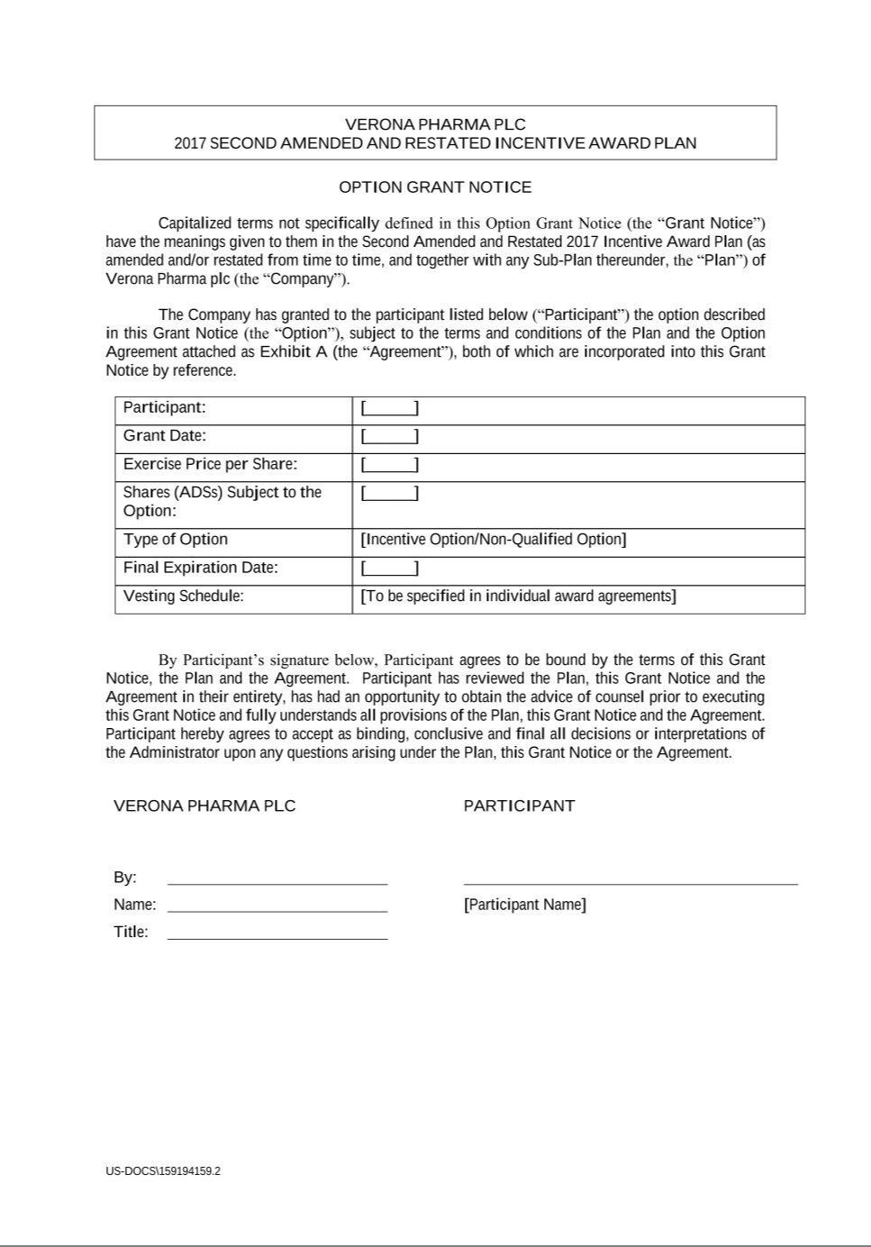

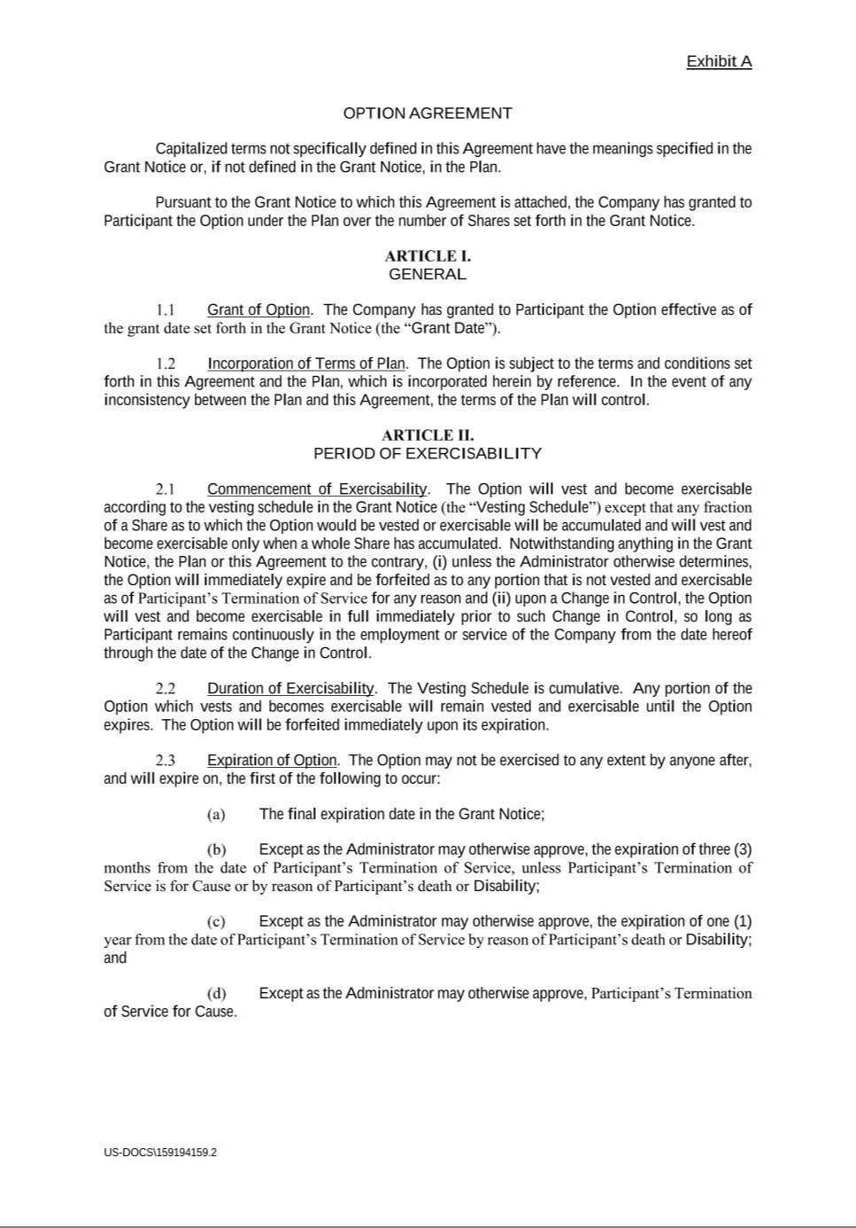

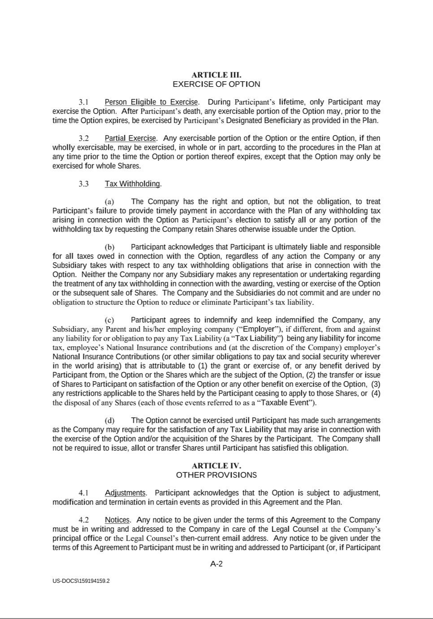

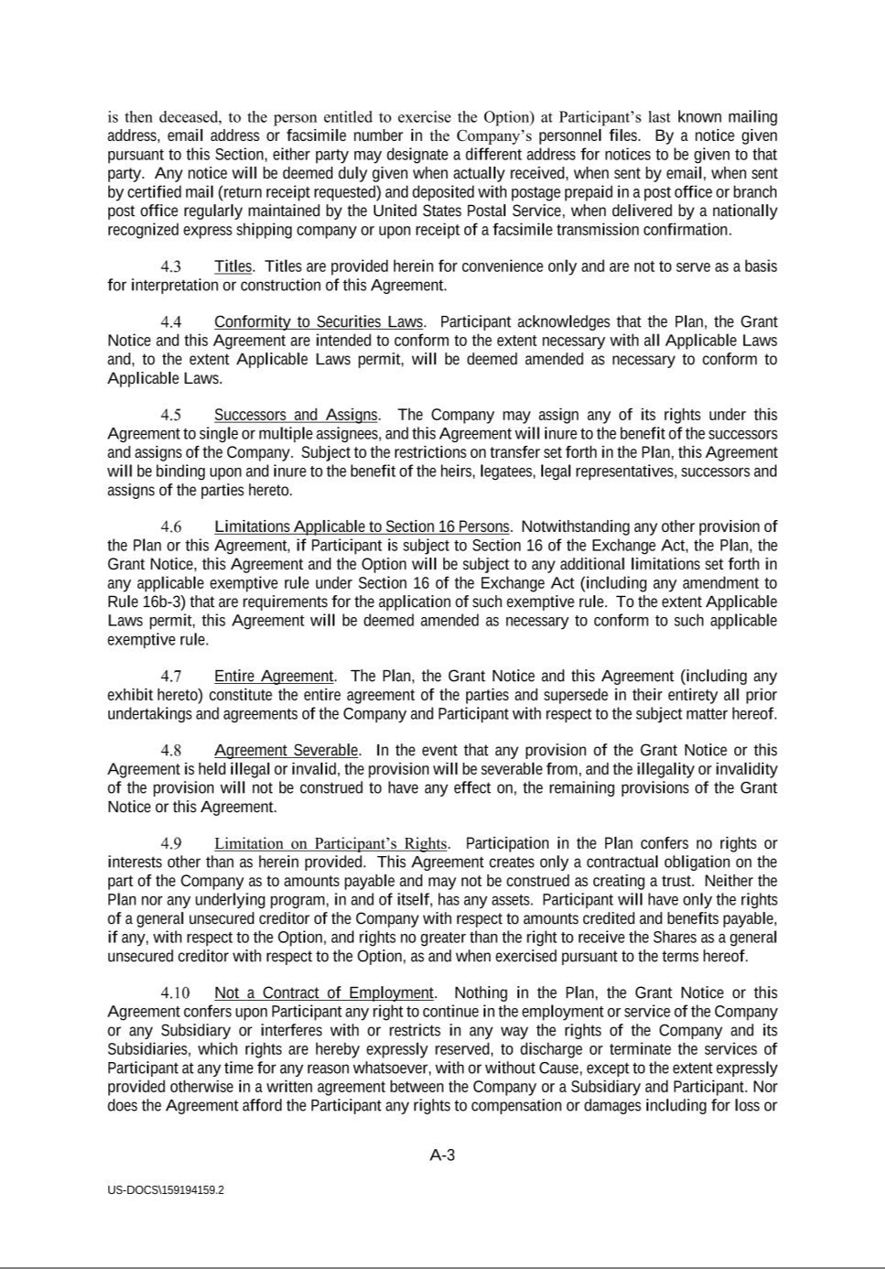

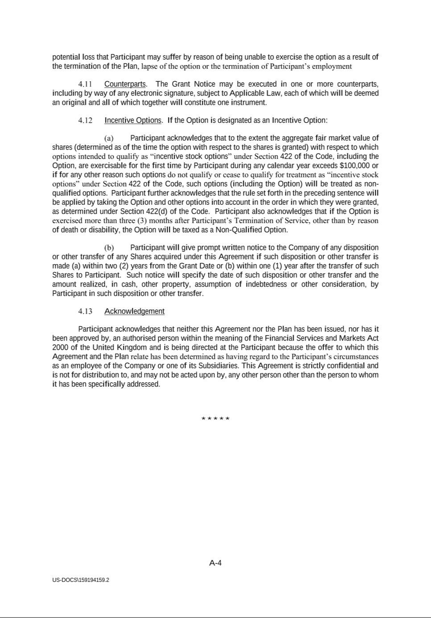

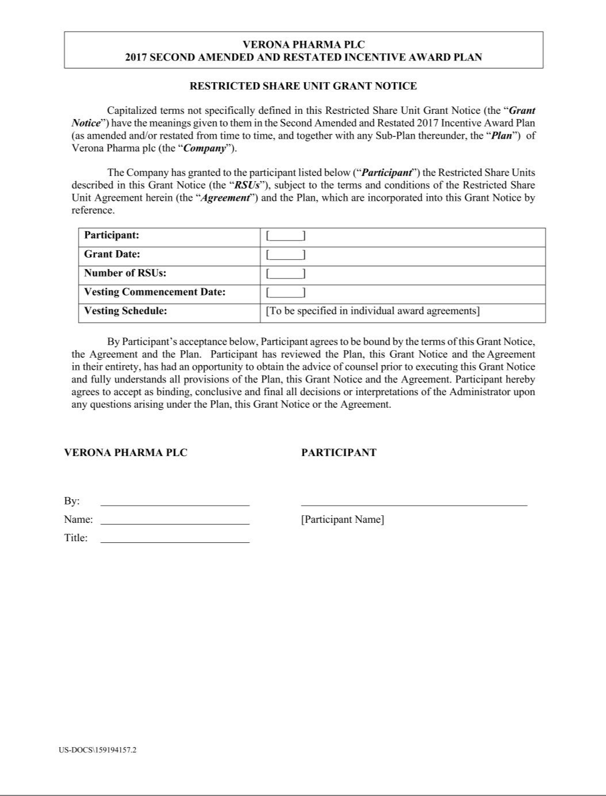

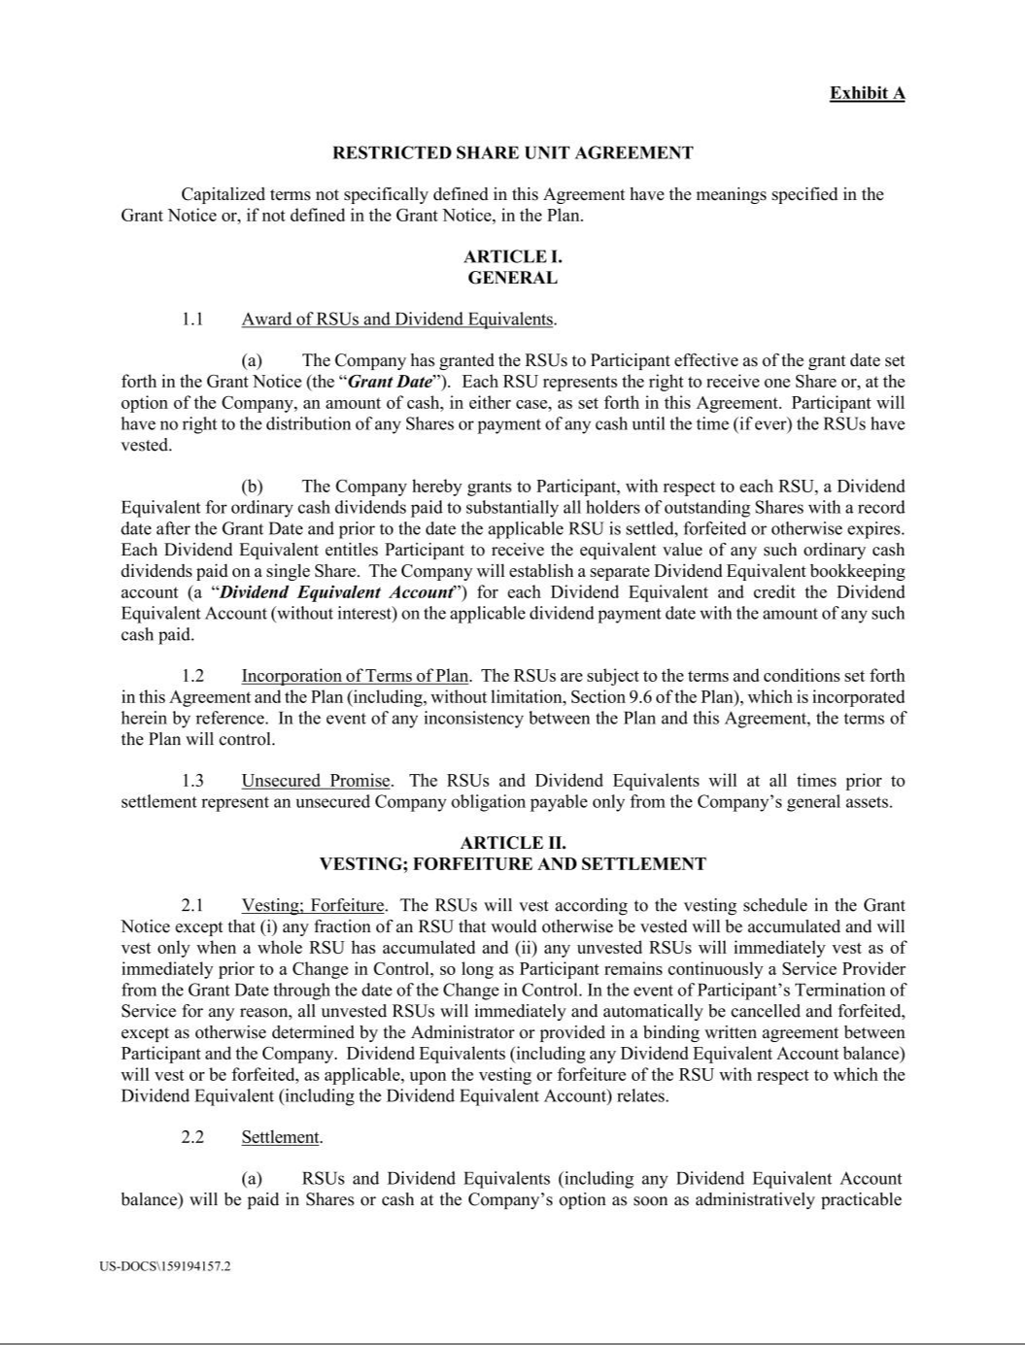

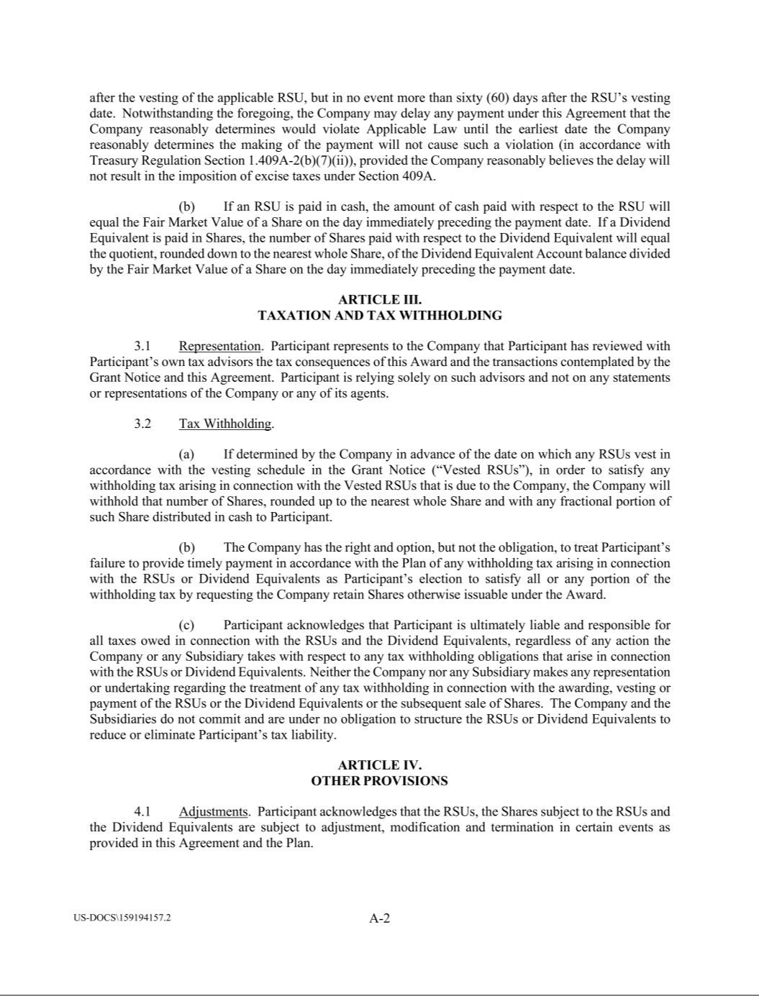

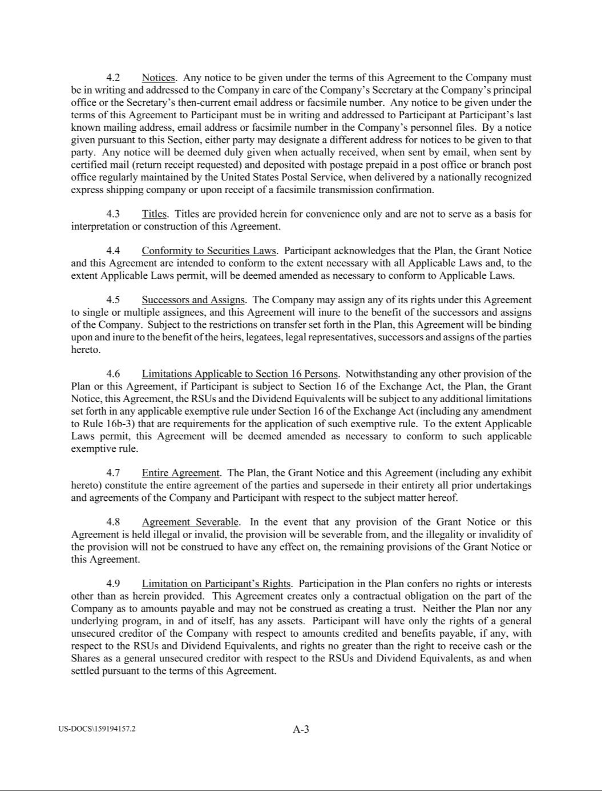



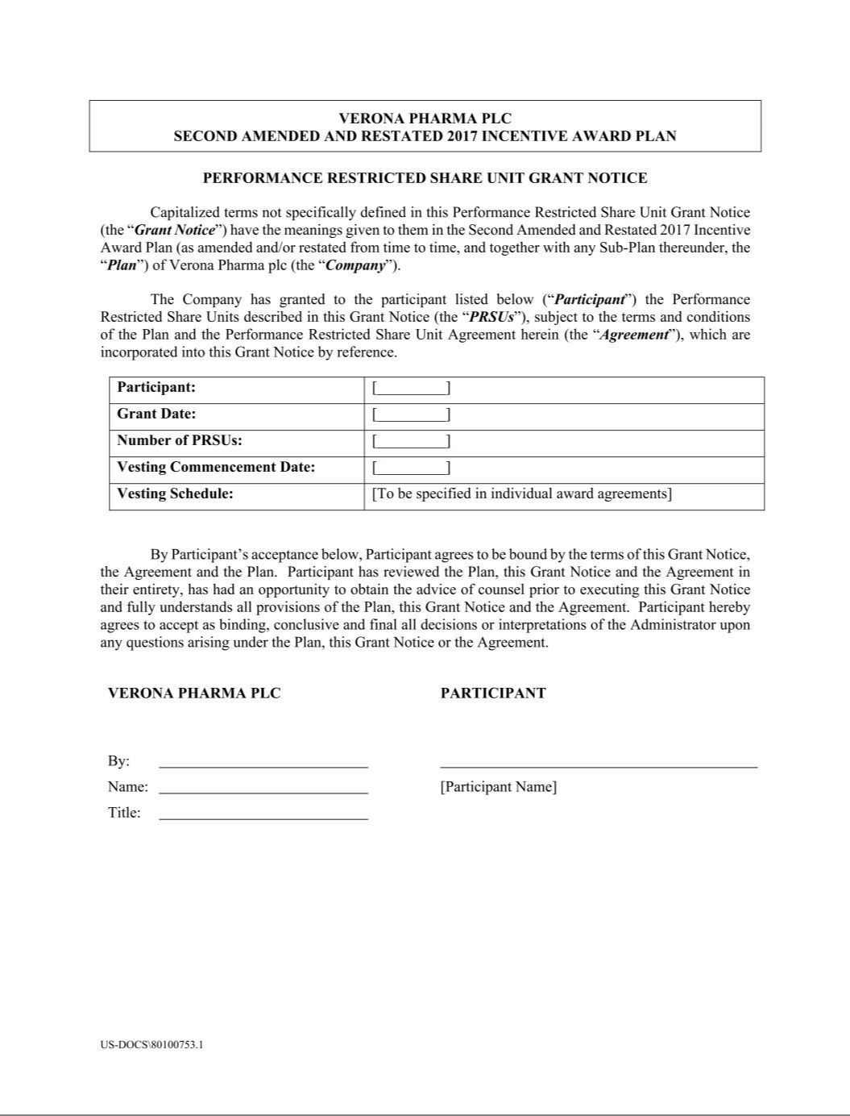

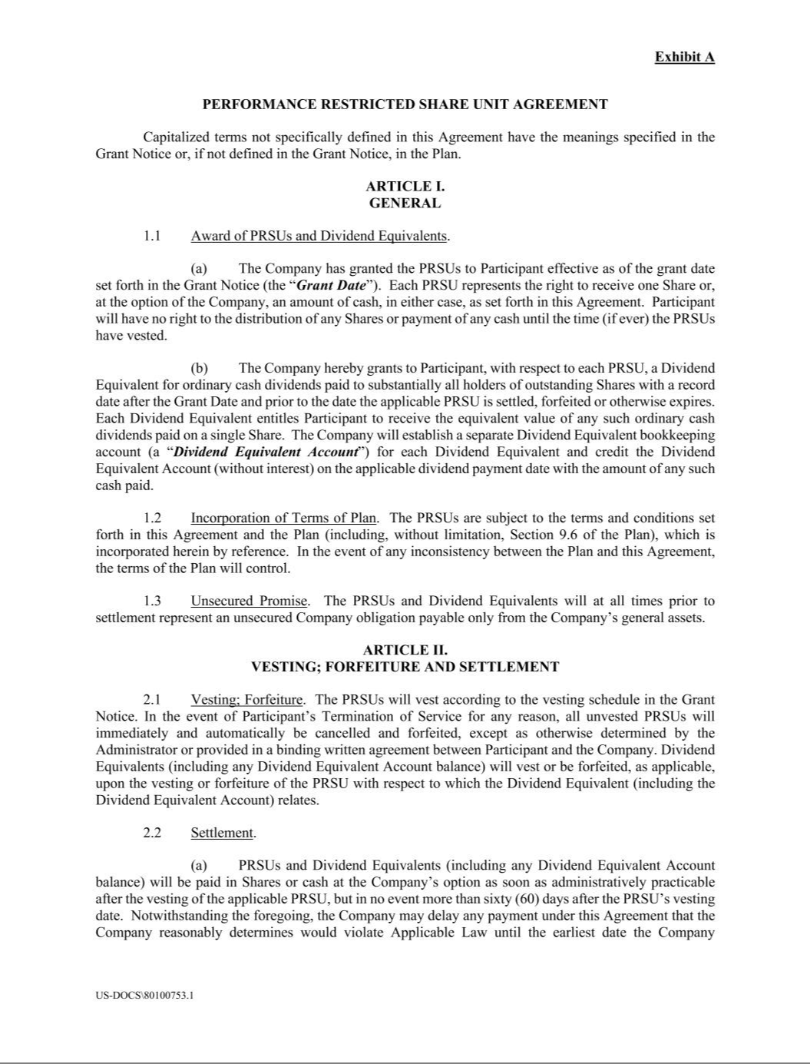

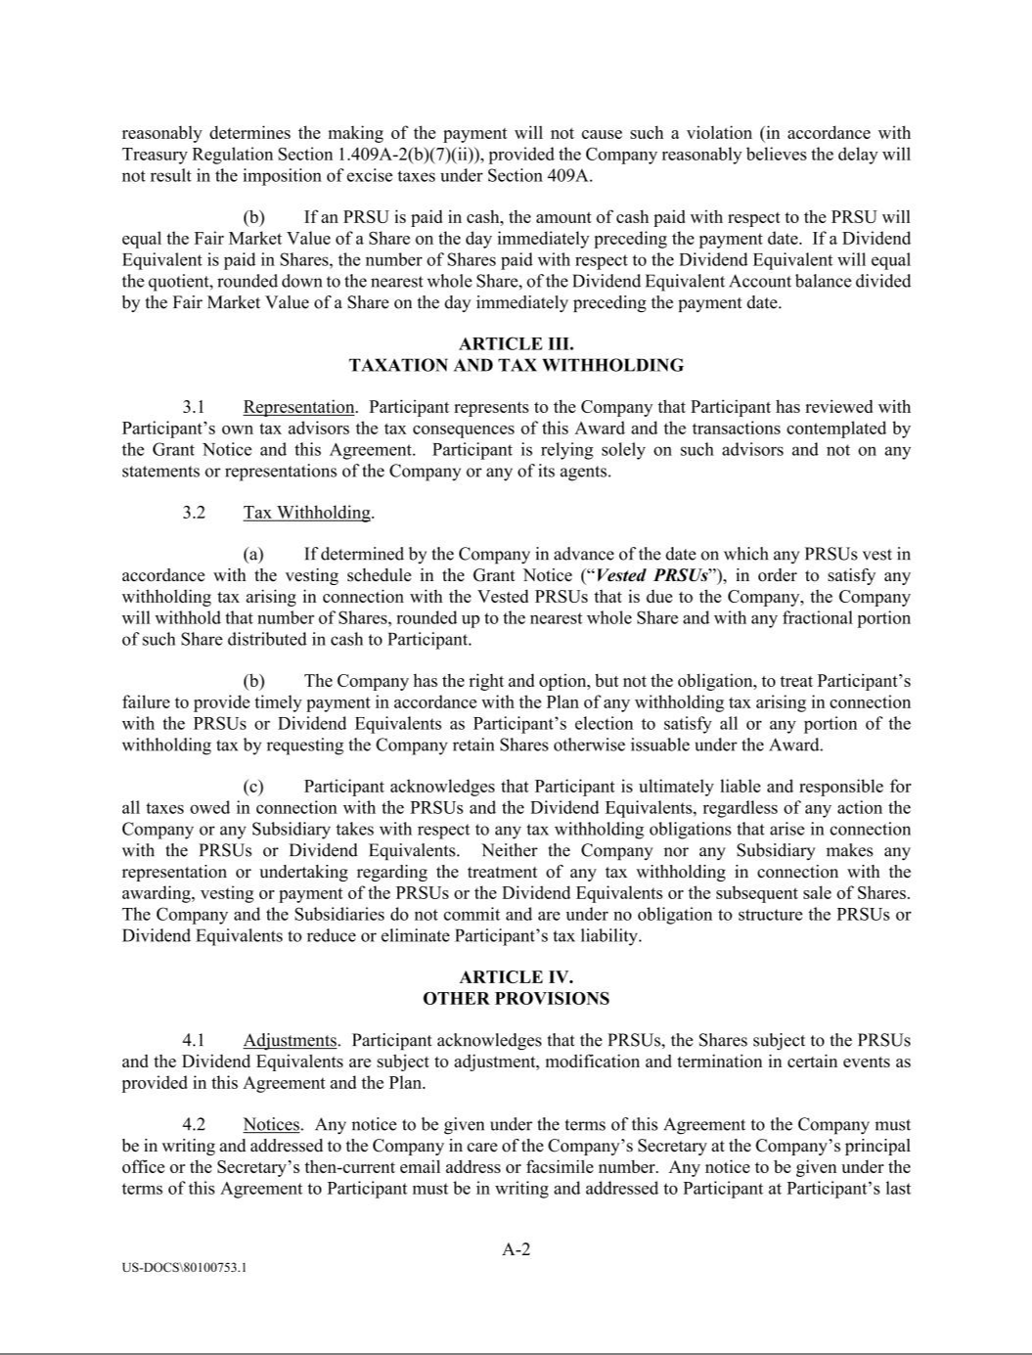

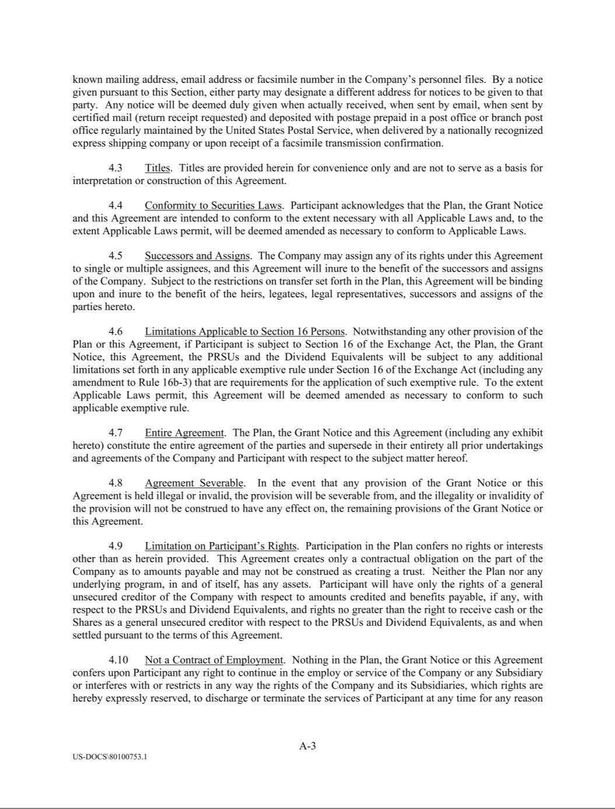



Exhibit 31.1

CERTIFICATION

I, David Zaccardelli, Pharm.D., certify that:

- I have reviewed this Quarterly Report on Form 10-Q of Verona Pharma plc;

- Based on my knowledge, this report does not contain any untrue statement of a material fact or omit to state a material fact necessary to make the statements made, in light of the circumstances under which such statements were made, not misleading with respect to the period covered by this report;

- Based on my knowledge, the financial statements, and other financial information included in this report, fairly present in all material respects the financial condition, results of operations and cash flows of the registrant as of, and for, the periods presented in this report;

- The registrant’s other certifying officer and I are responsible for establishing and maintaining disclosure controls and procedures (as defined in Exchange Act Rules 13a-15(e) and 15d-15(e)) and internal control over financial reporting (as defined in Exchange Act Rules 13a-15(f) and 15d-15(f)) for the registrant and have:

  - Designed such disclosure controls and procedures, or caused such disclosure controls and procedures to be designed under our supervision, to ensure that material information relating to the registrant, including its consolidated subsidiaries, is made known to us by others within those entities, particularly during the period in which this report is being prepared;

  - Designed such internal control over financial reporting, or caused such internal control over financial reporting to be designed under our supervision, to provide reasonable assurance regarding the reliability of financial reporting and the preparation of financial statements for external purposes in accordance with generally accepted accounting principles;

  - Evaluated the effectiveness of the registrant’s disclosure controls and procedures and presented in this report our conclusions about the effectiveness of the disclosure controls and procedures, as of the end of the period covered by this report based on such evaluation; and

  - Disclosed in this report any change in the registrant’s internal control over financial reporting that occurred during the registrant’s most recent fiscal quarter (the registrant’s fourth fiscal quarter in the case of an annual report) that has materially affected, or is reasonably likely to materially affect, the registrant’s internal control over financial reporting; and

- The registrant’s other certifying officer and I have disclosed, based on our most recent evaluation of internal control over financial reporting, to the registrant’s auditors and the audit committee of the registrant’s board of directors (or persons performing the equivalent functions):

  - All significant deficiencies and material weaknesses in the design or operation of internal control over financial reporting which are reasonably likely to adversely affect the registrant’s ability to record, process, summarize and report financial information; and

  - Any fraud, whether or not material, that involves management or other employees who have a significant role in the registrant’s internal control over financial reporting.

Date: April 29, 2025 By: /s/ David Zaccardelli, Pharm.D.

David Zaccardelli, Pharm.D.

Chief Executive Officer

(principal executive officer)

Exhibit 31.2

CERTIFICATION

I, Mark W. Hahn, certify that:

- I have reviewed this Quarterly Report on Form 10-Q of Verona Pharma plc;

- Based on my knowledge, this report does not contain any untrue statement of a material fact or omit to state a material fact necessary to make the statements made, in light of the circumstances under which such statements were made, not misleading with respect to the period covered by this report;

- Based on my knowledge, the financial statements, and other financial information included in this report, fairly present in all material respects the financial condition, results of operations and cash flows of the registrant as of, and for, the periods presented in this report;

- The registrant’s other certifying officer and I are responsible for establishing and maintaining disclosure controls and procedures (as defined in Exchange Act Rules 13a-15(e) and 15d-15(e)) and internal control over financial reporting (as defined in Exchange Act Rules 13a-15(f) and 15d-15(f)) for the registrant and have:

  - Designed such disclosure controls and procedures, or caused such disclosure controls and procedures to be designed under our supervision, to ensure that material information relating to the registrant, including its consolidated subsidiaries, is made known to us by others within those entities, particularly during the period in which this report is being prepared;

  - Designed such internal control over financial reporting, or caused such internal control over financial reporting to be designed under our supervision, to provide reasonable assurance regarding the reliability of financial reporting and the preparation of financial statements for external purposes in accordance with generally accepted accounting principles;

  - Evaluated the effectiveness of the registrant’s disclosure controls and procedures and presented in this report our conclusions about the effectiveness of the disclosure controls and procedures, as of the end of the period covered by this report based on such evaluation; and

  - Disclosed in this report any change in the registrant’s internal control over financial reporting that occurred during the registrant’s most recent fiscal quarter (the registrant’s fourth fiscal quarter in the case of an annual report) that has materially affected, or is reasonably likely to materially affect, the registrant’s internal control over financial reporting; and

- The registrant’s other certifying officer and I have disclosed, based on our most recent evaluation of internal control over financial reporting, to the registrant’s auditors and the audit committee of the registrant’s board of directors (or persons performing the equivalent functions):

  - All significant deficiencies and material weaknesses in the design or operation of internal control over financial reporting which are reasonably likely to adversely affect the registrant’s ability to record, process, summarize and report financial information; and

  - Any fraud, whether or not material, that involves management or other employees who have a significant role in the registrant’s internal control over financial reporting.

Date: April 29, 2025 By: /s/ Mark W. Hahn

Mark W. Hahn

Chief Financial Officer (principal financial officer)

Exhibit 32.1

CERTIFICATION PURSUANT TO

18 U.S.C. SECTION 1350, AS ADOPTED PURSUANT TO

SECTION 906 OF THE SARBANES-OXLEY ACT OF 2002

In connection with the Quarterly Report on Form 10-Q of Verona Pharma plc (the “Company”) for the period ended March 31, 2025 as filed with the Securities and Exchange Commission on the date hereof (the “Report”), I certify, pursuant to 18 U.S.C. § 1350, as adopted pursuant to § 906 of the Sarbanes-Oxley Act of 2002, that, to the best of my knowledge:

- The Report fully complies with the requirements of Section 13(a) or 15(d) of the Securities Exchange Act of 1934, as amended; and

- The information contained in the Report fairly presents, in all material respects, the financial condition and results of operations of the Company.

Date: April 29, 2025 By: /s/ David Zaccardelli, Pharm.D.

David Zaccardelli, Pharm.D.

Chief Executive Officer

(principal executive officer)

Exhibit 32.2

CERTIFICATION PURSUANT TO

18 U.S.C. SECTION 1350, AS ADOPTED PURSUANT TO

SECTION 906 OF THE SARBANES-OXLEY ACT OF 2002

In connection with the Quarterly Report on Form 10-Q of Verona Pharma plc (the “Company”) for the period ended March 31, 2025 as filed with the Securities and Exchange Commission on the date hereof (the “Report”), I certify, pursuant to 18 U.S.C. § 1350, as adopted pursuant to § 906 of the Sarbanes-Oxley Act of 2002, that, to the best of my knowledge:

- The Report fully complies with the requirements of Section 13(a) or 15(d) of the Securities Exchange Act of 1934, as amended; and

- The information contained in the Report fairly presents, in all material respects, the financial condition and results of operations of the Company.

Date: April 29, 2025 By: /s/ Mark W. Hahn

Mark W. Hahn

Chief Financial Officer (principal financial officer)

