UNITED STATES

SECURITIES AND EXCHANGE COMMISSION

Washington, D.C. 20549

FORM 10-Q

- QUARTERLY REPORT PURSUANT TO SECTION 13 OR 15(d) OF THE SECURITIES EXCHANGE ACT OF 1934

For the quarterly period ended March 31, 2022

OR

- TRANSITION REPORT PURSUANT TO SECTION 13 OR 15(d) OF THE SECURITIES EXCHANGE ACT OF 1934

FOR THE TRANSITION PERIOD FROM __________ TO __________

Commission File Number: 001-38067

Verona Pharma plc

 | (Exact name of Registrant as specified in its Charter)
United Kingdom |  | 98-1489389
(State or other jurisdiction of incorporation or organization) |  | (I.R.S. Employer Identification No.)
3 More London Riverside
London SE1 2RE United Kingdom |  | Not Applicable
(Address of principal executive offices) |  | (Zip Code)
 | Registrant’s telephone number, including area code: +44 203 283 4200
 | Securities registered pursuant to Section 12(b) of the Act:
Title of each class | Trading Symbol(s) | Name of each exchange on which registered
Ordinary shares, nominal value £0.05 per share* | VRNA | The Nasdaq Stock Market LLC (Nasdaq Global Market)

- The ordinary shares are represented by American Depositary Shares (each representing 8 ordinary shares), which are exempt from the operation of Section 12(a) of the Securities Exchange Act of 1934, as amended, pursuant to Rule 12a-8 thereunder.

Indicate by check mark whether the registrant (1) has filed all reports required to be filed by Section 13 or 15(d) of the Securities Exchange Act of 1934 during the preceding 12 months (or for such shorter period that the registrant was required to file such reports), and (2) has been subject to such filing requirements for the past 90 days. Yes ☒ No ☐

Indicate by check mark whether the registrant has submitted electronically every Interactive Data File required to be submitted pursuant to Rule 405 of Regulation S-T (§232.405 of this chapter) during the preceding 12 months (or for such shorter period that the registrant was required to submit such files). Yes ☒ No ☐

Indicate by check mark whether the registrant is a large accelerated filer, an accelerated filer, a non-accelerated filer, a smaller reporting company, or an emerging growth company. See the definitions of “large accelerated filer,” “accelerated filer,” “smaller reporting company,” and “emerging growth company” in Rule 12b-2 of the Exchange Act.

Large accelerated filer | ☐ | Accelerated filer | ☐
Non-accelerated filer | ☒ | Smaller reporting company | ☒
 |  | Emerging growth company | ☒

If an emerging growth company, indicate by check mark if the registrant has elected not to use the extended transition period for complying with any new or revised financial accounting standards provided pursuant to Section 13(a) of the Exchange Act. ☒

Indicate by check mark whether the registrant is a shell company (as defined in Rule 12b-2 of the Exchange Act). Yes ☐ No ☒

As of April 29, 2022, the registrant had 482,944,390 ordinary shares, nominal value £0.05 per share, outstanding, which if all held in ADS form, would be represented by 60,368,049 American Depositary Shares, each representing eight (8) ordinary shares.

 |  |  |  |  |  | Page
 | PART I - FINANCIAL INFORMATION
 | Item 1 |  |  |  | Financial Statements | 2
 | Item 2 |  |  |  | Management’s Discussion and Analysis of Financial Condition and Results of Operations | 15
 | Item 3 |  |  |  | Quantitative and Qualitative Disclosures About Market Risk | 26
 | Item 4 |  |  |  | Controls and Procedures | 26
 | PART II - OTHER INFORMATION
 | Item 1 |  |  |  | Legal Proceedings | 27
 | Item 1A. |  |  |  | Risk Factors | 27
 | Item 2 |  |  |  | Unregistered Sales of Equity Securities and Use of Proceeds | 27
 | Item 3 |  |  |  | Defaults Upon Senior Securities | 27
 | Item 4 |  |  |  | Mine Safety Disclosure | 27
 | Item 5 |  |  |  | Other Information | 27
 | Item 6 |  |  |  | Exhibits | 28
 | Signatures |  |  |  |  | 29

1

PART I - FINANCIAL INFORMATION

Item 1. Financial statements

2

Verona Pharma plc

Condensed Consolidated Balance Sheets

(unaudited)

(in thousands, except per share amounts and par value of shares)

 |  | March 31, |  |  | December 31,
 |  | 2022 |  |  | 2021
ASSETS
Current assets:
Cash and cash equivalents | $ | 132,764 |  | $ | 148,380
Prepaid expenses |  | 1,246 |  |  | 4,037
Tax and tax incentive receivable |  | 16,420 |  |  | 15,583
Other current assets |  | 2,525 |  |  | 2,063
Total current assets |  | 152,955 |  |  | 170,063
Non-current assets:
Furniture and equipment, net |  | 71 |  |  | 80
Goodwill |  | 545 |  |  | 545
Equity interest |  | 15,000 |  |  | 15,000
Right-of-use assets |  | 744 |  |  | 899
Total non-current assets |  | 16,360 |  |  | 16,524
Total assets | $ | 169,315 |  | $ | 186,587
LIABILITIES AND SHAREHOLDERS’ EQUITY
Current liabilities:
Accounts payable | $ | 8,064 |  | $ | 10,044
Accrued expenses |  | 28,877 |  |  | 22,256
Operating lease liability |  | 583 |  |  | 648
Taxes payable |  | 235 |  |  | 147
Other current liabilities |  | 144 |  |  | 327
Total current liabilities |  | 37,903 |  |  | 33,422
Non-current liabilities:
Term loan |  | 4,928 |  |  | 4,874
Operating lease liability |  | 177 |  |  | 286
Total non-current liabilities |  | 5,105 |  |  | 5,160
Total liabilities |  | 43,008 |  |  | 38,582
Commitments and contingencies
Shareholders' equity:
Ordinary £0.05 par value shares; 494,058,246 and 489,177,550 issued, and 482,944,390 and 480,082,966 outstanding, at March 31, 2022 and
December 31, 2021, respectively |  | 32,182 |  |  | 31,855
Additional paid-in capital |  | 388,204 |  |  | 385,070
Ordinary shares held in treasury |  | (739) |  |  | (603)
Accumulated other comprehensive loss |  | (4,601) |  |  | (4,601)
Accumulated deficit |  | (288,739) |  |  | (263,716)
Total shareholders' equity |  | 126,307 |  |  | 148,005
Total liabilities and shareholders' equity | $ | 169,315 |  | $ | 186,587

The accompanying notes are an integral part of these unaudited condensed consolidated financial statements.

3

Verona Pharma plc

Condensed Consolidated Statements of Operations and Comprehensive Loss

(unaudited)

(in thousands, except per share amounts)

 | Three months ended March 31,
 | 2022 |  |  | 2021
Operating expenses
Research and development | $ | 17,625 |  | $ | 13,574
Selling, general and administrative |  | 7,440 |  |  | 9,282
Total operating expenses |  | 25,065 |  |  | 22,856
Operating loss |  | (25,065) |  |  | (22,856)
Other income/(expense)
Research and development tax credit |  | 1,302 |  |  | 2,070
Interest income |  | 15 |  |  | 4
Interest expense |  | (84) |  |  | (84)
Fair value movement on warrants |  | — |  |  | (507)
Foreign exchange (loss)/gain |  | (923) |  |  | 163
Total other income, net |  | 310 |  |  | 1,646
Loss before income taxes |  | (24,755) |  |  | (21,210)
Income tax expense |  | (82) |  |  | (80)
Net loss | $ | (24,837) |  | $ | (21,290)
Loss per ordinary share - basic and diluted | $ | (0.05) |  | $ | (0.05)

The accompanying notes are an integral part of these unaudited condensed consolidated financial statements.

4

Verona Pharma plc

Condensed Consolidated Statements of Shareholders’ Equity

(unaudited)

(in thousands except share data)

 | Ordinary shares |  |  |  |  | Additional paid-in |  |  | Ordinary shares held |  |  |  | Accumulated other |  |  |  |  |  | Total shareholders'
 | Number |  |  | Amount |  |  | capital |  |  | in treasury |  |  | comprehensive loss |  |  | Accumulated deficit |  |  | equity
Balance at January 1, 2022 | 489,177,550 |  | $ | 31,855 |  | $ | 385,070 |  | $ | (603) |  | $ | (4,601) |  | $ | (263,716) |  | $ | 148,005
Net loss | — |  |  | — |  |  | — |  |  | — |  |  | — |  |  | (24,837) |  |  | (24,837)
Issuance of common shares under at-
the-market sales agreement | 80,696 |  |  | 5 |  |  | 62 |  |  | — |  |  | — |  |  | — |  |  | 67
Restricted share units vested | — |  |  | — |  |  | — |  |  | 186 |  |  | — |  |  | (186) |  |  | —
Issuance of ordinary shares to treasury | 4,800,000 |  |  | 322 |  |  | — |  |  | (322) |  |  | — |  |  | — |  |  | —
Common shares withheld for taxes on
vested stock awards | — |  |  | — |  |  | (793) |  |  | — |  |  | — |  |  | — |  |  | (793)
Equity settled share-based
compensation reclassified as cash-
settled | — |  |  | — |  |  | 118 |  |  | — |  |  | — |  |  | — |  |  | 118
Share-based compensation | — |  |  | — |  |  | 3,747 |  |  | — |  |  | — |  |  | — |  |  | 3,747
Balance at March 31, 2022 | 494,058,246 |  | $ | 32,182 |  | $ | 388,204 |  | $ | (739) |  | $ | (4,601) |  | $ | (288,739) |  | $ | 126,307

The accompanying notes are an integral part of these unaudited condensed consolidated financial statements.

5

Verona Pharma plc

Condensed Consolidated Statements of Shareholders’ Equity

(unaudited)

(in thousands except share data)

 | Ordinary shares |  |  |  |  | Additional paid-in |  |  | Ordinary shares held |  |  |  | Accumulated other |  |  |  |  |  | Total shareholders'
 | Number |  |  | Amount |  |  | capital |  |  | in treasury |  |  | comprehensive loss |  |  | Accumulated deficit |  |  | equity
Balance at January 1, 2021 | 488,304,446 |  | $ | 31,794 |  | $ | 366,411 |  | $ | (1,700) |  | $ | (4,601) |  | $ | (207,050) |  | $ | 184,854
Net loss | — |  |  | — |  |  | — |  |  | — |  |  | — |  |  | (21,290) |  |  | (21,290)
Restricted share units vested | — |  |  | — |  |  | — |  |  | 30 |  |  | — |  |  | (30) |  |  | —
Share-based compensation | — |  |  | — |  |  | 8,850 |  |  | — |  |  | — |  |  | — |  |  | 8,850
Balance at March 31, 2021 | 488,304,446 |  | $ | 31,794 |  | $ | 375,261 |  | $ | (1,670) |  | $ | (4,601) |  | $ | (228,370) |  | $ | 172,414

The accompanying notes are an integral part of these unaudited condensed consolidated financial statements.

6

Verona Pharma plc

Condensed Consolidated Statements of Cash Flows

(unaudited)

(in thousands)

 | Three months ended March 31,
 | 2022 |  |  | 2021
Operating activities:
Net loss: | $ | (24,837) |  | $ | (21,290)
Adjustments to reconcile net income to net cash used in operating activities:
Foreign exchange loss/(gain) |  | 1,119 |  |  | (155)
Amortization of debt issue costs |  | 23 |  |  | 19
Accretion of redemption premium on debt |  | 31 |  |  | 31
Fair value movement on warrants |  | — |  |  | 507
Share-based compensation |  | 3,748 |  |  | 8,850
Depreciation and amortization |  | 163 |  |  | 153
Changes in operating assets and liabilities:
Prepaid expenses |  | 2,791 |  |  | (2,709)
Tax incentive receivable |  | (1,578) |  |  | (2,012)
Other current assets |  | (462) |  |  | 236
Accounts payable |  | (1,980) |  |  | 363
Accrued expenses |  | 6,621 |  |  | (2,349)
Lease liabilities |  | (174) |  |  | (210)
Taxes payable |  | 88 |  |  | —
Other current liabilities |  | (65) |  |  | 15
Net cash used in operating activities |  | (14,512) |  |  | (18,551)
Cash flows from investing activities:
Net cash used in investing activities |  | — |  |  | —
Cash flows from financing activities:
Payments of withholding taxes from share-based awards |  | (793) |  |  | —
Proceeds from at-the-market sales agreement |  | 67 |  |  | —
Net cash used in financing activities |  | (726) |  |  | —
Effect of exchange rate changes on cash and cash equivalents |  | (378) |  |  | 163
Net change in cash and cash equivalents |  | (15,616) |  |  | (18,388)
Cash and cash equivalents at beginning of the period |  | 148,380 |  |  | 187,986
Cash and cash equivalents at end of the period | $ | 132,764 |  | $ | 169,598
Supplemental disclosure of cash flow information:
Income taxes paid | $ | 1 |  | $ | —
Interest paid | $ | 53 |  | $ | 55

The accompanying notes are an integral part of these unaudited condensed consolidated financial statements.

7

Verona Pharma plc

Notes to Condensed Consolidated Financial Statements

(unaudited)

Note 1 - Organization and description of business operations

Verona Pharma plc (the “Company”) is incorporated and domiciled in the United Kingdom. Verona Pharma plc has one wholly-owned subsidiary, Verona Pharma, Inc., a Delaware corporation. Rhinopharma Limited, a Canadian company that was previously a non-operating, wholly-owned subsidiary, was dissolved in June 2021. The address of the registered office is 1 Central Square, Cardiff, CF10 1FS, United Kingdom.

The Company is a clinical-stage biopharmaceutical group focused on developing and commercializing innovative therapeutics for the treatment of respiratory diseases with significant unmet medical needs. The Company’s American Depositary Shares (“ADSs”) are listed on the Nasdaq Global Market (“Nasdaq”) and trade under the symbol “VRNA”.

Liquidity

The Company has incurred recurring losses and negative cash flows from operations since inception, and has an accumulated deficit of $288.7 million as of March 31, 2022. The Company expects to incur additional losses and negative cash flows from operations until its products potentially gain regulatory approval and reach commercial profitability, if at all.

The Company expects that its cash and cash equivalents as of March 31, 2022, will be sufficient to fund its operating expenses and capital expenditure requirements for at least the next 12 months from the date of issuance.

In March, 2021, the Company entered into an open market sale agreement with respect to an at-the-market offering program (the “ATM Program”) under which the Company may issue and sell its ordinary shares in the form of ADSs, with an aggregate offering price of up to $100.0 million.

During the three months ended March 31, 2022, the Company sold 80,696 ordinary shares (equivalent to 10,087 ADSs) under the ATM Program, at an average price of approximately $0.86 per share (equivalent to $6.86 per ADS), raising aggregate net proceeds of approximately $0.1 million after deducting issuance costs. As of March 31, 2022, there remained ordinary shares, in the form of ADSs, with a value up to $99.2 million available for sale under the ATM Program.

The Company’s commercial revenue, if any, will be derived from sales of products that we do not expect to be commercially available for several years, if ever. Additionally we may enter into out-licensing transactions from time to time but there can be no assurance that the company can secure such transactions in the future. Accordingly, we will need to obtain substantial additional funds to achieve our business objectives including to further advance clinical and regulatory activities, to fund prelaunch and launch related costs and to create an effective sales and marketing organization to commercialize ensifentrine. We will need to seek additional funding through public or private financings, debt financing, collaboration or licensing agreements and other arrangements. However, there is no guarantee that we will be successful in securing additional capital on acceptable terms, or at all.

Note 2 - Basis of presentation and summary of significant accounting policies

Basis of presentation and consolidation

The unaudited condensed consolidated financial statements include the accounts of Verona Pharma plc and its wholly-owned subsidiary Verona Pharma, Inc. All inter-company balances and transactions have been eliminated.

The accompanying unaudited condensed consolidated financial statements included in this Quarterly Report on Form 10-Q have been prepared in conformity with accounting principles generally accepted in the U.S. (“U.S. GAAP”).

The unaudited condensed consolidated financial statements presented in this Quarterly Report should be read in conjunction with the consolidated financial statements and accompanying notes included in the Company’s Annual Report on Form 10-K filed with the SEC on March 3, 2022 (the “2021 Form 10-K”). The Consolidated Balance Sheet as of December 31, 2021, was derived from audited consolidated financial statements included in the 2021 Form 10-K but does not include all disclosures required by U.S. GAAP for complete financial statements. The Company’s significant accounting policies are described in Note 2 to those consolidated financial statements.

Certain information and footnote disclosures normally included in financial statements prepared in accordance with U.S. GAAP have been condensed or omitted from these interim financial statements. The unaudited condensed consolidated financial statements reflect all adjustments which in the opinion of management are necessary for a fair statement of results of operations, comprehensive income, financial condition, cash flows and shareholders' equity for the periods presented. Except as otherwise disclosed, all such adjustments are of a normal recurring nature. Operating results for the interim periods are not necessarily indicative of the results that may be expected for the full year.

Segment reporting

The Company has one operating and reportable segment, pharmaceutical development.

Use of estimates

The preparation of interim unaudited condensed consolidated financial statements in conformity with U.S. GAAP requires management to make estimates and assumptions that affect the reported amounts of assets, liabilities, the disclosure of contingent assets and liabilities at the date of the financial statements and the reported amounts of expenses during the reporting periods. Significant estimates and assumptions reflected in these unaudited condensed consolidated financial statements include, but are not limited to, the accrual and prepayment of research and development expenses, the fair value of share-based compensation, the fair value of warrants, research and development tax credit and the carrying value of the equity interest in Nuance Pharma (as defined below). Estimates are periodically reviewed in light of changes in circumstances, facts and experience. Changes in estimates are recorded in the period in which they become known. Actual results could differ from the Company’s estimates.

Recently adopted accounting standards and recent accounting standards not yet adopted

There are no recently adopted accounting standards and recent accounting standards not yet adopted that the Company believes will have a material impact on the Company’s consolidated financial statements.

Note 3 - Prepaid expenses

Prepaid expenses consisted of the following (in thousands):

 | March 31, |  |  |  | December 31,
 | 2022 |  |  |  | 2021
Clinical trial and other development costs | $ | 452 |  | $ | 2,169
Insurance |  | 435 |  |  | 1,555
Other |  | 359 |  |  | 313
Total prepaid expenses | $ | 1,246 |  | $ | 4,037

8

Verona Pharma plc

Notes to Condensed Consolidated Financial Statements

(unaudited)

Note 4 - Tax and tax incentive receivables

Tax and tax incentive receivables consisted of the following (in thousands):

 | March 31, |  |  |  | December 31,
 | 2022 |  |  |  | 2021
Research and development tax credit receivable - U.K. | $ | 16,420 |  | $ | 15,583
Total tax receivable | $ | 16,420 |  | $ | 15,583

The Company conducts research and development activities including, but not limited to, developing ensifentrine for various indications and delivery methods, and as a result the Company benefits in the U.K. from the HM Revenue and Customs, or HMRC, small and medium sized enterprises research and development relief, or SME R&D credit, which provides relief against U.K. Corporation Tax.

Effective for accounting periods starting after April 1, 2021, new rules were introduced whereby the amount of SME R&D tax credit that a business can receive in any one year will be capped at £20,000 plus three times the company’s total Pay As You Earn (“PAYE”) and National Insurance contributions (“NIC”) liability. Exemptions to the cap have been introduced which are available to companies that meet certain conditions. The Company believes it may be eligible for an exemption and has requested feedback from HMRC. If the cap does not apply the Company would have recorded $3.6 million relating to the quarter ended March 31, 2022 instead of the $1.3 million reported in the condensed consolidated statements of operations. Until we receive this feedback the Company is accounting for the credit as if the cap applied.

Note 5 - Accrued expenses

Accrued expenses consisted of the following (in thousands):

 | March 31, |  |  |  | December 31,
 | 2022 |  |  |  | 2021
Clinical trial and other development costs | $ | 27,520 |  | $ | 21,336
Professional fees and general corporate costs |  | 846 |  |  | 919
People related costs |  | 511 |  |  | 1
Total accrued expenses | $ | 28,877 |  | $ | 22,256

Note 6 - Term loan

In November 2020, the Company entered into a term loan facility of up to $30.0 million (the “Term Loan”), consisting of advances of $5.0 million funded at closing and $10.0 million and $15.0 million contingent upon achievement of certain clinical development milestones and other specified conditions. As of March 31, 2022, the Company had $5.0 million principal outstanding under the Term Loan.

The Term Loan is governed by a loan and security agreement, dated as of November 19, 2020, between the Borrowers and SVB, as amended (the “Loan Agreement”). The Term B Loan will be available, subject to and customary terms and conditions, only during the period commencing upon the achievement of a specific clinical milestone relating to ensifentrine through and including September 30, 2022. The Term C Loan will be available, subject to customary terms and conditions, only during the period commencing upon the achievement of an additional specific clinical milestone relating to ensifentrine through and including June 30, 2023.

The Term Loan will mature on November 1, 2024. Each advance under the Term Loan accrues interest at a floating per annum rate equal to the greater of (a) the sum of the prime rate reported in The Wall Street Journal plus 1.00% and (b) four and one-quarter of one percent (4.25%). The Term Loan provides for interest-only payments on a monthly basis until the payment date immediately preceding December 1, 2023. Thereafter, amortization payments will be payable monthly in equal installments of principal plus monthly payments of accrued interest. Upon repayment (whether at maturity, upon acceleration or by prepayment or otherwise), the Borrowers shall make a final payment to SVB in the amount of 10% of the aggregate Term Loans advanced (the "Final Payment"). The Borrowers may prepay the Term Loan in full but not in part provided that the Borrowers (i) provide ten days’ prior written notice to SVB, (ii) pays on the date of such prepayment (A) all outstanding principal plus accrued and unpaid interest, (B) a prepayment fee of $450,000 plus 3.0% of the Term C Loans advanced if paid on or before the

9

Verona Pharma plc

Notes to Condensed Consolidated Financial Statements

(unaudited)

first anniversary of the closing date; $300,000 plus 2.00% of the Term C Loans advanced if paid after the first anniversary of the closing date and on or before the second anniversary of the closing date; and $150,000 plus 1.00% of the Term C Loans advanced if paid thereafter and prior to maturity, (C) the Final Payment and (D) all other sums, if any, that shall become due and payable with respect to the Term Loan Advances, including interest at the Default Rate with respect to any past due amounts. Amounts outstanding during an event of default are payable upon SVB's demand and shall accrue interest at an additional rate of 3.0% per annum.

The Term Loan is secured by a lien on substantially all of the assets of the Borrowers, other than the equity interests of Verona U.S. and other than intellectual property, provided that such lien on substantially all assets includes any rights to payments and proceeds from the sale, licensing or disposition of intellectual property. The Borrowers have also granted SVB a negative pledge with respect to its intellectual property.

The Loan Agreement contains customary covenants and representations, including but not limited to financial reporting obligations and limitations on dividends, indebtedness, collateral, investments, distributions, transfers, mergers or acquisitions, taxes, corporate changes, deposit accounts, and subsidiaries. The Loan Agreement also contains other customary provisions, such as expense reimbursement, non-disclosure obligations as well as indemnification rights for the benefit of SVB. The Loan Agreement includes a minimum cash covenant triggered when Borrowers' consolidated cash and cash equivalents drop below $45.0 million at any time after the earliest to occur of any of the following: (i) the release of negative data from ENHANCE-2 and/or ENHANCE-1, which in the reasonable business discretion Borrowers’ senior management, would be considered insufficient to support submission of an NDA to the FDA, (ii) the FDA issues a complete response letter with respect to an NDA submitted for ensifentrine, or (iii) failure to achieve a specific regulatory milestone relating to ensifentrine by June 30, 2023 (extendable to March 31, 2024 upon the Borrowers receiving a specified amount of new cash proceeds after September 8, 2020 from the sale of equity securities in one or more public financings or other bona fide equity financings, subordinated debt and/or upfront/milestone payments from one or more collaboration agreements not prohibited in the Loan Agreement). Upon such trigger, Borrowers must cash collateralize an amount equal to the outstanding obligations to SVB plus the amount of any prepayment penalty and Final Payment which would be due in the event the Loan Agreement were prepaid in full with respect to the Term Loans advanced as of such time.

As of March 31, 2022, the carrying value of the Term Loan was approximately $4.9 million, of which all was due in more than 12 months. The debt balance has been categorized within Level 3 of the fair value hierarchy. The carrying amount of the debt approximates its fair value based on prevailing interest rates as of the balance sheet date.

Note 7 - Equity interest

The Company entered into a collaboration and license agreement (the “Nuance Agreement”) with Nuance Pharma Limited (“Nuance Pharma”) effective June 9, 2021 (the “Effective Date”), under which the Company granted Nuance Pharma the exclusive rights to develop and commercialize ensifentrine in Greater China (China, Taiwan, Hong Kong and Macau). In return, the Company received an unconditional right to consideration aggregating $40.0 million consisting of $25.0 million in cash and an equity interest, valued at $15.0 million as of the Effective Date, in Nuance Biotech, the parent company of Nuance Pharma.

The Company follows guidance from ASC 321-10-35-2 and uses the fair value measurement alternative and measures the securities at cost, which is deemed to be the value indicated by the last observable transaction in Nuance Biotech's stock, subject to impairment. The valuation will be adjusted for any observable price changes in orderly transactions for an identical or similar investment in Nuance Biotech, or if there is an indicator of impairment. As of March 31, 2022, there had been no observable transactions to indicate any price changes in the value of Nuance Biotech’s stock, nor had there been any indications of impairment. The equity interest is therefore recorded at a value of $15.0 million.

10

Verona Pharma plc

Notes to Condensed Consolidated Financial Statements

(unaudited)

Note 8 - Significant agreements

Ligand agreement

In 2006 the Company acquired Rhinopharma and assumed contingent liabilities owed to Ligand UK Development Limited (“Ligand”) (formerly Vernalis Development Limited). The Company refers to the assignment and license agreement as the Ligand Agreement.

Ligand assigned to the Company all of its rights to certain patents and patent applications relating to ensifentrine and related compounds (the “Ligand Patents”) and an exclusive, worldwide, royalty-bearing license under certain Ligand know-how to develop, manufacture and commercialize products (the “Ligand Licensed Products”) developed using Ligand Patents, Ligand know-how and the physical stock of certain compounds.

The contingent liability comprises a milestone payment (the “Milestone Payment”) on obtaining the first approval of any regulatory authority for the commercialization of a Ligand Licensed Product, low single digit royalties based on the future sales performance of all Ligand Licensed Products and a portion equal to a mid-twenty percent of any consideration received from any sub-licensees for the Ligand Patents and for Ligand know-how.

At the time of the acquisition the contingent liability was not recognized as part of the acquisition accounting as it was immaterial. The Company will therefore record as a research and development expense the Milestone Payment or royalties when they are probable.

In March 2022 we entered into an Amendment Agreement (the “Amendment”) with Ligand whereby the Ligand Agreement was amended to clarify certain ambiguous terms in the Ligand Agreement. Pursuant to the Amendment:

- the Company agreed to pay to Ligand (i) $2.0 million within five business days of the date of the Amendment and (ii) $15.0 million upon the first commercial sale of ensifentrine by the Company or a sub-licensee, which amount is payable in cash or, at the Company's discretion, by the issuance of Company equity of equivalent value, as determined based on the volume-weighted average price of the Company's American Depositary Shares on the Nasdaq Global Market over the ten (10) trading days including and prior to such milestone event;

- the Ligand Agreement shall expire on March 24, 2042 unless terminated earlier by either party in accordance with its terms;

- upon termination of the Ligand Agreement, any Sub-licensee (as defined in the Amendment) shall have the right to enter into a direct license agreement with Ligand for the portion of the Program IP (as defined in the Amendment) that was sub-licensed by such Sub-licensee;

- the Milestone Payment may be paid in cash or, at the Company’s discretion, by issuing to Ligand shares in the Company of equivalent value; and

- each party’s right to terminate the Ligand Agreement is conditioned upon such party obtaining a final judgment of the English High Court declaring that the other party is in material breach of its obligations under the Ligand Agreement.

The Company accounted for the $2.0 million payment at execution as selling, general and administrative expense in the condensed consolidated statements of operations as the payment is related to a contract modification.

11

Verona Pharma plc

Notes to Condensed Consolidated Financial Statements

(unaudited)

Nuance agreement

The Company entered into a collaboration and license agreement (the “Nuance Agreement”) with Nuance Pharma Limited (“Nuance Pharma”) effective June 9, 2021 (the “Effective Date”) under which the Company granted Nuance Pharma the exclusive rights to develop and commercialize ensifentrine in Greater China (China, Taiwan, Hong Kong and Macau). In return, the Company received an unconditional right to consideration aggregating $40.0 million consisting of $25.0 million in cash and an equity interest, valued at $15.0 million as of the Effective Date, in Nuance Biotech, the parent company of Nuance Pharma. The Company is eligible to receive future milestone payments of up to $179.0 million triggered upon achievement of certain clinical, regulatory, and commercial milestones, as well as tiered double-digit royalties as a percentage of net sales of the products in Greater China.

As of March 31, 2022, the $25.0 million cash payment and $15.0 million equity interest had been received and the holding in Nuance Biotech was recorded as Equity Interest on our unaudited condensed consolidated balance sheets included elsewhere in this Quarterly Report on Form 10-Q. The Company follows guidance from ASC 321-10-35-2 and uses the fair value measurement alternative and measures the securities at cost, which is deemed to be the value indicated by the last observable transaction in Nuance Biotech's stock, subject to impairment. The valuation will be adjusted for any observable price changes in orderly transactions for an identical or similar investment in Nuance Biotech, or if there is an indicator of impairment. As of March 31, 2022, there had been no other transactions to indicate any price changes in the value of Nuance Biotech’s stock, nor had there been any indications of impairment. The Equity Interest is therefore recorded at a value of $15 million.

Under the terms of the Nuance Agreement, at any time until three months prior to the expected submission of the first New Drug Application in Greater China, if (i) a third party is interested in partnering with the Company, either globally or in territory covering at least the United States or Europe, for the development and/or commercialization of ensifentrine or (ii) the Company undergoes a change of control, the Company will have an exclusive option right to buy back the license granted to Nuance Pharma and all related assets. The price is agreed to be equal to the aggregate of (i) all prior amounts paid by Nuance Pharma to the Company in cash under the agreement and (ii) all development and regulatory costs incurred and paid by Nuance Pharma in connection with the development and commercialization of ensifentrine under the Nuance Agreement multiplied by a single-digit factor range dependent upon achievement of certain milestones, subject to a specified maximum amount.

The Nuance Agreement will continue on a jurisdiction-by-jurisdiction and product-by-product basis until the expiration of royalty payment obligations with respect to such product in such jurisdiction unless earlier terminated by the parties. Either party may terminate the Nuance Agreement for an uncured material breach or bankruptcy of the other party. Nuance Pharma may also terminate the Nuance Agreement at will upon 90 days' prior written notice.

The Company reviewed the buy-back option and determined that because it is conditional on a third party the Company does not have the practical ability to exercise it and, accordingly, the contract is accounted for under ASC 606.

The transaction price at the Effective Date of the Nuance Agreement was $40.0 million consisting of the $25.0 million upfront cash payment and $15.0 million equity interest. Developmental and regulatory milestones, and the manufacture and supply of ensifentrine drug product, were not included in the transaction price as management determined that it is not probable that a significant reversal in the amount of cumulative revenue recognized will not occur. Commercial milestones and sales royalties were also excluded and will be recognized when the milestones are achieved or the sales occur in Greater China.

The performance obligations in the Nuance Agreement include the grant of the license (including the right to commercialize ensifentrine until the end of the term, the sharing of certain know how, and the sharing of certain clinical and regulatory data), and manufacture and supply of ensifentrine drug product.

The Company has determined that the license and the know how shared with Nuance Pharma constitutes functional intellectual property and that revenue relating to this should be recognized at a point in time. Consequently, the Company determined that it fulfilled its obligations to Nuance Pharma after it delivered the know how that will allow Nuance Pharma to file an investigational new drug application in Greater China. This know how was delivered in the year ended December 31, 2021, and the $40.0 million revenue was therefore recognized as revenue in the year ended December 31, 2021. Revenue relating to the manufacture and supply obligations will be recognized when the drug product is delivered.

12

Verona Pharma plc

Notes to Condensed Consolidated Financial Statements

(unaudited)

Note 9 - Share-based compensation

The following table shows the allocation of share-based compensation between research and development and selling, general and administrative costs (in thousands):

 |  | Three months ended March 31,
 |  | 2022 |  |  | 2021
Research and development | $ | 1,539 |  | $ | 3,432
Selling, general and administrative |  | 2,209 |  |  | 5,418
Total | $ | 3,748 |  | $ | 8,850
Share options
The following table shows share option activity, in ordinary shares, in the period:
 |  | 2022
 |  | Number of share options |  | Weighted average exercise
 |  | outstanding |  |  | price
Outstanding at January 1 |  | 12,695,200 |  | $ | 1.38
Granted |  | 608,000 |  |  | 0.62
Outstanding at March 31 |  | 13,303,200 |  | $ | 1.34
Restricted stock units activity
The following table shows restricted stock unit (“RSU”) activity, in ordinary shares, in the period:
 |  | 2022
 |  | Number of RSUs |  |  | Weighted average
 |  |  |  | remaining contractual term
 |  | outstanding |  |  | (years)
Outstanding at January 1 |  | 38,347,352 |  |  | 1.2
Granted |  | 468,224
Vested |  | (3,943,144)
Outstanding at March 31 |  | 34,872,432 |  |  | 1.1

13

Verona Pharma plc

Notes to Condensed Consolidated Financial Statements

(unaudited)

Note 10 - Net loss per share

Net loss per share is calculated on an ordinary share basis. The Company’s ADSs that are listed on the Nasdaq Global Market each represent eight ordinary shares. The following table shows the computation of basic and diluted net loss per share for the periods ended March 31, 2022 and 2021 (net loss in thousands, loss per share in dollars):

 |  | Three months ended March 31,
 |  | 2022 |  |  | 2021
Numerator:
Net loss | $ | (24,837) |  | $ | (21,290)
Denominator:
Weighted-average shares outstanding - basic and diluted |  | 481,941,527 |  |  | 469,465,085
Net loss per share - basic and diluted | $ | (0.05) |  | $ | (0.05)

During the three months ended March 31, 2022 and 2021, outstanding share options, RSUs and warrants over 60,576,894 and 77,584,846 ordinary shares, respectively, were not included in the computation of diluted earnings per ordinary share, because to do so would be antidilutive.

14

Item 2. Management’s discussion and analysis of financial condition and results of operations

You should read the following discussion and analysis of our financial condition and results of operations together with our unaudited condensed consolidated financial statements and related notes included elsewhere in this Quarterly Report on Form 10-Q, as well as our audited consolidated financial statements and related notes as disclosed in our Annual Report on Form 10-K for the year ended December 31, 2021 filed with the Securities and Exchange Commission on March 3, 2022 (the “2021 Form 10-K”).

In addition to historical information, this Quarterly Report on Form 10-Q contains statements that constitute forward-looking statements. In some cases, you can identify forward-looking statements by terms such as “may,” “will,” “should,” “expect,” “plan,” “anticipate,” “could,” “intend,” “target,” “project,” “contemplate,” “believe,” “estimate,” “predict,” “potential” or “continue” or the negative of these terms or other similar expressions, although not all forward-looking statements contain these words.

All statements other than statements of historical facts contained in this Quarterly Report on Form 10-Q, including without limitation statements regarding our future results of operations and financial position, business strategy and plans and objectives of management for future operations, the development of ensifentrine or any other product candidates, including statements regarding the expected initiation, timing, progress and availability of data from our clinical trials and potential regulatory approvals, research and development costs, timing and likelihood of success, potential collaborations, our estimates regarding expenses, future revenues, capital requirements, debt service obligations and our need for additional financing, the funding we expect to become available from cash receipts from U.K. tax credits, and the sufficiency of our cash and cash equivalents to fund operations, are forward-looking statements.

The forward-looking statements in this Quarterly Report on Form 10-Q are only predictions and are based largely on our current expectations and projections about future events and financial trends that we believe may affect our business, financial condition and results of operations. These forward-looking statements speak only as of the date of this Quarterly Report on Form 10-Q and are subject to a number of known and unknown risks, uncertainties, assumptions, and other important factors including, but not limited to, those set forth under Part I, Item 1A of the 2021 Form 10-K under the heading “Risk Factors”. Because forward-looking statements are inherently subject to risks and uncertainties, some of which cannot be predicted or quantified and some of which are beyond our control, you should not rely on these forward-looking statements as predictions of future events.

Except as required by applicable law, we do not plan to publicly update or revise any forward-looking statements contained herein, whether as a result of any new information, future events, changed circumstances or otherwise. We intend the forward-looking statements contained in this Quarterly Report on Form 10-Q to be covered by the safe harbor provisions for forward-looking statements contained in Section 27A of the Securities Act and Section 21E of the Securities Exchange Act of 1934, as amended (the “Exchange Act”).

15

Overview

We are a clinical-stage biopharmaceutical company focused on developing and commercializing innovative therapeutics for the treatment of respiratory diseases with significant unmet medical need. Our product candidate, ensifentrine, is an investigational, potential first-in-class, inhaled, dual inhibitor of the enzymes phosphodiesterase 3 and 4 (“PDE3” and “PDE4”), which is designed to act as both a bronchodilator and an anti-inflammatory agent. In the third quarter of 2020 we commenced our Phase 3 ENHANCE (“Ensifentrine as a Novel inHAled Nebulized COPD thErapy”) trials and, if approved, we intend to commercialize ensifentrine for the maintenance treatment of chronic obstructive pulmonary disease (“COPD”) for the nebulized formulation in the United States.

We have incurred recurring losses and negative cash flows from operations since inception, and have an accumulated deficit of $288.7 million as of March 31, 2022. We expect to incur additional losses and negative cash flows from operations until our product candidates potentially gain regulatory approval and reach commercial profitability, if at all.

We anticipate that our expenses will increase significantly in connection with our ongoing activities, as we:

- continue to invest in the clinical development of ensifentrine for the treatment of COPD;

- manufacture ensifentrine and engage in other Chemistry, Manufacturing and Controls activities;

- maintain, expand and protect our intellectual property portfolio; and

- build out infrastructure and prepare for commercial launch.

We believe that our cash and cash equivalents as of March 31, 2022, expected cash receipts from U.K. tax credits and funding expected to become available under the $30.0 million debt financing facility secured in November 2020, will enable us to fund our planned operating expenses and capital expenditure requirements through at least the end of 2023. The Term Loan advances are contingent upon achievement of certain clinical development milestones and other specified conditions. See “Indebtedness” for additional information.

16

Clinical development update

During the first quarter of 2022, we continued enrollment in our Phase 3 ENHANCE clinical program and we are now close to completing enrollment for this program. As of May 2, 2022, approximately 90% of subjects were randomized into ENHANCE-1, and complete enrollment in ENHANCE-1 is expected in the second quarter of 2022. This would conclude enrollment in the Phase 3 ENHANCE program. The Company projects approximately 55-65% of subjects will be receiving background therapy in each study.

Based on our current models of forecasted recruitment and study progress, we expect to report top-line data for ENHANCE-2 in the third quarter of 2022 and for ENHANCE-1 around the end of 2022. The top-line data from both ENHANCE trials will include the primary endpoint, improvement in lung function as measured by average forced expiratory volume in one second (“FEV_{1”}) area under the curve (“AUC”) 0-12 hours post dose at week 12, as well as key secondary endpoints comprising measurements of COPD symptoms and health-related quality of life, including E-RS and SGRQ endpoints, as well as overall safety data.

The design of the ENHANCE program was based on analysis of our two Phase 2b clinical trials, which both enrolled 400 subjects with moderate to severe COPD. This includes similar entry and exclusion parameters as well as key study endpoints. To date, overall population attributes including demographics and baseline COPD characteristics including smoking history, lung function, symptoms and quality of life for subjects in the ENHANCE program are similar to those seen in the Phase 2b trials.

Board update

In March 2022, James Brady joined our board as a Non-Executive Director. Mr. Brady has extensive experience in the biopharmaceutical industry, serving in multiple leadership roles across the U.S., Europe and China during his 30-plus-year career at AstraZeneca. Most recently, he served as Chief Financial Officer of MedImmune, the biologics discovery and development division of AstraZeneca.

COVID-19 impact

Verona Pharma continues to monitor the impact of the COVID-19 pandemic on its operations and clinical trials, in particular the timelines and costs of its Phase 3 clinical program ENHANCE. The pandemic and government and other measures in response continue to impact a number of clinical trial activities and the Company will provide an update if it becomes aware of any meaningful disruption caused by the pandemic to its clinical trials.

To help protect the health and safety of the subjects, caregivers and healthcare professionals involved in its clinical trials, as well as its employees and independent contractors, the Company continues to follow guidance from the FDA and other health regulatory authorities regarding the conduct of clinical trials during the COVID-19 pandemic to ensure the safety of study participants, minimize risks to study integrity, and maintain compliance with good clinical practice (GCP).

The COVID-19 pandemic is disrupting supply chains, and employee retention and recruitment, globally and the Company is closely monitoring this situation and will provide an update if it becomes aware of any meaningful disruption caused by the pandemic to the supply of ensifentrine and drug-related products, equipment and services for its clinical trials.

Russia-Ukraine Conflict

Verona Pharma is conducting its ENHANCE-1 program at a number of clinical trial sites in Russia and Europe (but not including Ukraine). The sanctions and other restrictions imposed by the U.S. and other countries as a result of the current conflict between Russia and Ukraine may impact our outsourced clinical research vendor’s ability to pay the clinical trial sites in Russia, to supply ensifentrine and equipment to the sites, or validate their trial data. If the conflict extends into other countries in Europe where our clinical trials are being conducted, our clinical trial activities in those countries may also be impacted. The Company is closely monitoring the Russia-Ukraine conflict and will provide an update if it becomes aware of any meaningful disruption to the cost and timelines of our Phase 3 program or our plans to submit an NDA for ensifentrine.

17

Significant agreements

Ligand agreement

In 2006 we acquired Rhinopharma and assumed contingent liabilities owed to Ligand UK Development Limited (“Ligand”) (formerly Vernalis Development Limited). We refer to the assignment and license agreement as the Ligand Agreement.

Ligand assigned to us all of its rights to certain patents and patent applications relating to ensifentrine and related compounds (the “Ligand Patents”) and an exclusive, worldwide, royalty-bearing license under certain Ligand know-how to develop, manufacture and commercialize products (the ”Ligand Licensed Products”) developed using Ligand Patents, Ligand know-how and the physical stock of certain compounds.

The contingent liability comprises a milestone payment (the “Milestone Payment”) on obtaining the first approval of any regulatory authority for the commercialization of a Ligand Licensed Product, low single digit royalties based on the future sales performance of all Ligand Licensed Products and a portion equal to a mid-twenty percent of any consideration received from any sub-licensees for the Ligand Patents and for Ligand know-how.

At time of the acquisition the contingent liability was not recognized as part of the acquisition accounting as it was immaterial. We will therefore record as a research and development expense the Milestone Payment or royalties when they are probable.

In March 2022 we entered into an Amendment Agreement (the “Amendment”) with Ligand whereby the Ligand Agreement was amended to clarify certain ambiguous terms in the Ligand Agreement. Pursuant to the Amendment:

- we agreed to pay to Ligand (i) $2.0 million within five business days of the date of the Amendment and (ii) $15.0 million upon the first commercial sale of ensifentrine by us or a sub-licensee, which amount is payable in cash or, at the our discretion, by the issuance of Company equity of equivalent value, as determined based on the volume-weighted average price of the our American Depositary Shares on the Nasdaq Global Market over the ten (10) trading days including and prior to such milestone event;

- the Ligand Agreement shall expire on March 24, 2042 unless terminated earlier by either party in accordance with its terms;

- upon termination of the Ligand Agreement, any Sub-licensee (as defined in the Amendment) shall have the right to enter into a direct license agreement with Ligand for the portion of the Program IP (as defined in the Amendment) that was sub-licensed by such Sub-licensee;

- the Milestone Payment may be paid in cash or, at our discretion, by issuing to Ligand shares in the Company of equivalent value; and

- each party’s right to terminate the Ligand Agreement is conditioned upon such party obtaining a final judgment of the English High Court declaring that the other party is in material breach of its obligations under the Ligand Agreement.

Nuance agreement

We entered into a collaboration and license agreement (the “Nuance Agreement”) with Nuance Pharma Limited (“Nuance Pharma”) effective June 9, 2021 (the “Effective Date”) under which we granted Nuance Pharma the exclusive rights to develop and commercialize ensifentrine in Greater China (China, Taiwan, Hong Kong and Macau). In return, we received an unconditional right to consideration aggregating $40.0 million consisting of $25.0 million in cash and an equity interest valued at $15.0 million as of the Effective Date in Nuance Biotech, the parent company of Nuance Pharma. We are eligible to receive future milestone payments of up to $179.0 million, triggered upon achievement of certain clinical, regulatory, and commercial milestones as well as tiered double-digit royalties on net sales in Greater China.

As of March 31, 2022, the $25.0 million cash payment and $15.0 million equity interest had been received and the holding in Nuance Biotech was recorded as Equity Interest on our unaudited condensed consolidated balance sheet included elsewhere in this Quarterly Report on Form 10-Q. The equity interest is recorded at the fair value indicated by the last observable transaction in Nuance Biotech’s stock, which was a fund raising in November, 2020. As of March 31, 2022, there had been no other observable transactions to indicate any price changes in the value of Nuance Biotech’s stock, nor had there been any indications of impairment. The equity interest is therefore recorded at a value of $15.0 million.

18

Nuance Pharma will be responsible for all costs related to clinical development and commercialization of ensifentrine in Greater China. A joint steering committee has been established between us and Nuance Pharma to oversee and coordinate the overall conduct of such clinical development and commercialization. We intend to use the joint steering committee to help ensure the clinical development of ensifentrine in Greater China aligns with our overall global development and commercialization strategy.

Under the terms of the Nuance Agreement, at any time until three months prior to the expected submission of the first New Drug Application in Greater China, if (i) a third party is interested in partnering with us, either globally or in territory covering at least the United States or Europe, for the development and/or commercialization of ensifentrine or (ii) we undergo a change of control, we will have an exclusive option right to buy back the license granted to Nuance Pharma and all related assets. The price is agreed to be equal to the aggregate of (i) all prior amounts paid by Nuance Pharma to us in cash under the agreement and (ii) all development and regulatory costs incurred and paid by Nuance Pharma in connection with the development and commercialization of the ensifentrine under the Nuance Agreement multiplied by a single-digit factor range dependent upon achievement of certain milestones, subject to a specified maximum amount.

The Nuance Agreement will continue on a jurisdiction-by-jurisdiction and product-by-product basis until the expiration of royalty payment obligations with respect to such product in such jurisdiction unless earlier terminated by the parties. Either party may terminate the Nuance Agreement for an uncured material breach or bankruptcy of the other party. Nuance Pharma may also terminate the Nuance Agreement at will upon 90 days' prior written notice.

We reviewed the buy-back option and determined that because it is conditional on a third party we do not have the practical ability to exercise it and, accordingly, the contract is accounted for under ASC 606.

The transaction price at the Effective Date of the Nuance Agreement was $40.0 million consisting of the $25.0 million upfront cash payment and $15.0 million equity interest. Developmental and regulatory milestones, and the manufacture and supply of ensifentrine drug product, were not included in the transaction price as we determined that it is not probable that a significant reversal in the amount of cumulative revenue recognized will not occur. Commercial milestones and sales royalties were also excluded and will be recognized when the milestones are achieved or the sales occur in Greater China.

The performance obligations in the Nuance Agreement include the grant of the license (including the right to commercialize ensifentrine until the end of the term, the sharing of certain know how, and the sharing of certain clinical and regulatory data), and manufacture and supply of ensifentrine drug product. We have determined that the manufacturing and supply was not at a discount.

We have determined that the license and the know how shared with Nuance Pharma constitutes functional intellectual property and that revenue relating to this should be recognized at a point in time. Consequently, we have determined that we fulfilled our obligations to Nuance Pharma when we delivered the know how that will allow Nuance Pharma to file an investigational new drug application in Greater China. We delivered this know how in the year ended December 31, 2021, and the $40.0 million revenue was therefore recognized as revenue in the year ended December 31, 2021. Revenue relating to the manufacture and supply obligations will be recognized when the drug product is delivered.

On the Effective Date, $4.0 million of costs of obtaining the contract were recorded as a contract asset. The entire cost had been recognized as Selling, General and Administrative expense in the Consolidated Statement of Operations, in line with recognition of the revenue relating to the contract in the year ended December 31, 2021.

For additional information regarding the Nuance Agreement, see Note 7 to our unaudited condensed consolidated financial statements and related notes included elsewhere in this Quarterly Report on Form 10-Q.

Warrants

On July 29, 2016, as part of a private placement we issued warrants to investors. The warrant holders can subscribe for an ordinary share at a per share exercise price of £1.7238. They can also opt for a cashless exercise of their warrants whereby they can choose to exchange the warrants held for a reduced number of warrants exercisable at nil consideration.

If, after a transaction, should the warrants be exercisable for unlisted securities, the warrant holders may demand a cash payment instead of the delivery of the underlying securities. Accordingly, they are accounted for as a liability under ASC 480 “Distinguishing Liabilities from Equity” and recorded at fair value using the Black-Scholes valuation methodology, on recognition and at each reporting date. The warrants were exercisable by the holders until May 2, 2022 the warrants are now expired.

19

Loan and security agreement

In November 2020 we and Verona Pharma Inc. entered into a term loan facility of up to $30.0 million with Silicon Valley Bank (the “Term Loan”). See “Indebtedness” for additional information.

Critical accounting estimates

The preparation of consolidated financial statements in conformity with accounting principles generally accepted in the U.S. (“U.S. GAAP”) requires management to make estimates and assumptions that affect the reported amounts of assets, liabilities, the disclosure of contingent assets and liabilities at the date of the financial statements and the reported amounts of expenses during the reporting periods. Significant estimates and assumptions reflected in these consolidated financial statements include, but are not limited to, the recognition of revenue, the accrual and prepayment of research and development expenses, the fair value of share-based compensation, the carrying value of the equity interest in Nuance Pharma (as defined below), research and development tax credit and the fair value of warrants. Estimates are periodically reviewed in light of changes in circumstances, facts and experience. Changes in estimates are recorded in the period in which they become known. Actual results could differ from our estimates. The accounting policies considered to be critical to the judgments and estimates used in the preparation of our financial statements are disclosed in the Management’s Discussion and Analysis of Financial Condition and Results of Operations included in our 2021 Form 10-K. There have been no material changes to that information disclosed in our 2021 Form 10-K during the three months ended March 31, 2022.

Components of results of operations

We anticipate that our expenses will increase substantially if and as we:

- conduct our ongoing Phase 3 clinical trials for ensifentrine for the maintenance treatment of COPD;

- continue the clinical development of our DPI and pMDI formulations of ensifentrine and research and develop other formulations of ensifentrine;

- initiate and conduct further clinical trials for ensifentrine for the treatment of acute COPD, CF or any other indication;

- initiate and progress pre-clinical studies relating to other potential indications of ensifentrine;

- seek to discover and develop additional product candidates;

- seek regulatory approvals for any of our product candidates that successfully complete clinical trials;

- potentially establish a sales, marketing and distribution infrastructure and scale-up manufacturing capabilities to commercialize any products for which we may obtain regulatory approval;

- maintain, expand and protect our intellectual property portfolio;

- add clinical, scientific, operational, financial and management information systems and personnel, including personnel to support our product development and potential future commercialization efforts and to support our continuing operations as a U.S. public company; or

- experience any delays or encounter any issues from any of the above, including but not limited to failed studies, complex results, safety issues or other regulatory challenges.

20

Operating expenses

Research and development costs

Research and development costs consist of salary and personnel related costs and third party costs for our research and development activities for ensifentrine. Personnel related costs include a share-based compensation charge relating to our stock option plan. The largest component of third party costs is for clinical trials, as well as manufacturing for clinical supplies and associated development, and pre-clinical studies. Research and development costs are expensed as incurred.

We expect our research and development costs to essentially remain at current levels through at least the first half of 2022 as we progress our ENHANCE program. Until we add new compounds or develop ensifentrine further in other delivery methods or indications, we expect our research and development costs to begin to decrease in the second half of 2022. Due to the nature of research and development, the expected costs are inherently uncertain and may vary significantly from our current expectations.

Selling, general and administrative costs

Selling, general and administrative costs consist of salary and personnel related costs, including share-based compensation, expenses relating to operating as a public company, including professional fees, insurance and commercial related costs, as well as other operating expenses.

We expect commercial costs to increase as we continue to develop our potential commercial operations and, in the event of successful regulatory approval, we expect to incur sales force, marketing and other launch related costs. As we develop our knowledge of the market and refine our commercialization plans, expected costs may vary significantly from our current expectations.

Other income/(expense)

Other income/(expense) are driven by interest income and expense, the fair value movement of the warrant liability, foreign exchange movements on cash and cash equivalents and taxes receivable, and the U.K. research and development tax credits.

We are entitled to participate in the U.K. Small and Medium Enterprises research and development tax relief program. The tax credits are calculated as a percentage of qualifying research and development expenditure and are payable in cash by the U.K. government to us. Credits recorded in the 2021 financial year are expected to be received in the 2022 financial year.

Effective January 1, 2022, this tax credit will be subject to a cap equal to a multiple of employment taxes the entity pays in the year in question. We are currently reviewing the impact these changes could have on our tax credit for the 2022 financial year, receivable in 2023.

Taxation

We are subject to corporate taxation in the United States and the United Kingdom. We have generated losses since inception and have therefore not paid United Kingdom corporation tax. The income taxes presented in our consolidated statements of operations and comprehensive loss represents the tax impact from our operating activities in the United States, which generates taxable income based on intercompany service arrangements.

United Kingdom losses may be carried forward indefinitely to be offset against future taxable profits, subject to various utilization criteria and restrictions. The amount that can be offset each year is limited to £5.0 million plus an incremental 50% of U.K. taxable profits.

21

Results of operations for the three months ended March 31, 2022 and 2021

The following table shows our statements of operations for the three months ended March 31, 2022 and 2021 (in thousands):

 | Three months ended March 31,
 | 2022 |  |  | 2021 |  |  |  | Change
Operating expenses
Research and development | $ | 17,625 |  | $ | 13,574 |  | $ | 4,051
Selling, general and administrative |  | 7,440 |  |  | 9,282 |  |  | (1,842)
Total operating expenses |  | 25,065 |  |  | 22,856 |  |  | 2,209
Operating loss |  | (25,065) |  |  | (22,856) |  |  | (2,209)
Other income/(expense)
Research and development tax credit |  | 1,302 |  |  | 2,070 |  |  | (768)
Interest income |  | 15 |  |  | 4 |  |  | 11
Interest expense |  | (84) |  |  | (84) |  |  | —
Fair value movement on warrants |  | — |  |  | (507) |  |  | 507
Foreign exchange (loss)/gain |  | (923) |  |  | 163 |  |  | (1,086)
Total other income, net |  | 310 |  |  | 1,646 |  |  | (1,336)
Loss before income taxes |  | (24,755) |  |  | (21,210) |  |  | (3,545)
Income tax expense |  | (82) |  |  | (80) |  |  | (2)
Net loss | $ | (24,837) |  | $ | (21,290) |  | $ | (3,547)

Research and development costs

Research and development costs were $17.6 million for the three months ended March 31, 2022, compared to $13.6 million for the three months ended March 31, 2021, an increase of $4.0 million. This increase was primarily due to a $5.6 million increase in clinical trial and other development costs, as we progressed our Phase 3 ENHANCE program, offset by a $2.0 million decrease in share-based compensation charges.

Selling, general and administrative costs

Selling, general and administrative costs were $7.4 million for the three months ended March 31, 2022 compared to $9.3 million for the three months ended March 31, 2021, a decrease of $1.9 million. This decrease was driven primarily by a $3.1 million decrease in share-based compensation charges and a $0.6 million decrease in professional fees, partially offset by a $2.0 million charge related to the modification of the Ligand Agreement.

Other income/(expense)

The research and development tax credit for the three months ended March 31, 2022 was $1.3 million compared to $2.1 million for the three months ended March 31, 2021, a decrease of $0.8 million. The decrease is due to changes in the SME R&D tax credit program that established a cap limiting the research and development tax credit to £20,000 plus three times UK pay as you earn and national insurance taxes.

We recorded no income in the three months ended March 31, 2022, compared to a charge of $0.5 million in the comparative period relating to the fair value movements of the warrants. In the three months ended March 31, 2021, there was a loss due to a rise in the share price in that period and greater volatility.

Net loss

Net loss was $24.8 million for the three months ended March 31, 2022, compared to $21.3 million for the three months ended March 31, 2021, because of the factors outlined above.

22

Cash flows

The following table summarizes our cash flows for the three months ended March 31, 2022 and 2021 (in thousands):

 | Three months ended March 31,
 |  |  |  |  |  |  |  | Change
 | 2022 |  |  | 2021 |  |  |  | Change
Cash and cash equivalents at beginning of the period | $ | 148,380 |  | $ | 187,986 |  | $ | (39,606)
Net cash used in operating activities |  | (14,512) |  |  | (18,551) |  |  | 4,039
Net cash used in investing activities |  | — |  |  | — |  |  | —
Net cash used in financing activities |  | (726) |  |  | — |  |  | (726)
Effect of exchange rate changes on cash and cash equivalents |  | (378) |  |  | 163 |  |  | (541)
Cash and cash equivalents at end of the period | $ | 132,764 |  | $ | 169,598 |  | $ | (36,834)

Operating activities

Net cash used in operating activities was $14.5 million in the three months ended March 31, 2022, compared to $18.6 million during the three months ended March 31, 2021, a decrease of $4.1 million. This decrease is predominantly due to timing of supplier payments.

Financing activities

Net cash used in financing activities was $0.7 million in the three months ended March 31, 2022, compared to $0.0 million provided in the three months ended March 31, 2021. This consisted of $0.8 million for payment of withholding taxes due on the net-settling of certain employees’ RSU awards, partially offset by $0.1 million generated from the issuance of ADSs under the ATM Program.

23

Liquidity and capital resources

We do not currently have any approved products and have never generated any revenue from product sales. To date, we have financed our operations primarily through the issuances of our equity securities, including warrants, from borrowings under the Term Loan and upfront payments from the Nuance Agreement. See “Significant Agreements” and “Indebtedness” for additional information.

We have incurred recurring losses since inception, including net losses of $24.8 million for the three months ended March 31, 2022, and $55.6 million for the year ended December 31, 2021. As of March 31, 2022, we had an accumulated deficit of $288.7 million. We expect to continue to generate operating losses for the foreseeable future.

We have no ongoing material financing commitments, such as lines of credit or guarantees, that are expected to affect our liquidity over the next five years, other than leases and the Term Loan with Silicon Valley Bank.

Open market sale agreement

In March 2021, we entered into an open market sale agreement with Jefferies LLC (“Jefferies”) to sell shares of our ordinary shares, in the form of ADSs, with aggregate gross sales proceeds of up to $100.0 million, from time to time, through an “at the market” equity offering program under which Jefferies will act as sales agent (the “ATM Program”).

During the three months ended March 31, 2022, we sold 80,696 ordinary shares (equivalent to 10,087 ADSs) under the ATM Program, at an average price of approximately $0.86 per share (equivalent to $6.86 per ADS), raising aggregate net proceeds of approximately $0.1 million after deducting issuance costs. As of March 31, 2022, $99.2 million of ordinary shares, in the form of ADSs, remained available for sale under the ATM Program.

Indebtedness

In November 2020, we and Verona Pharma, Inc. entered into a term loan facility of up to $30.0 million with Silicon Valley Bank, which we refer to as the Term Loan, consisting of term loan advances in an aggregate amount of $5.0 million funded at closing, a term loan advance of an aggregate amount of $10.0 million available subject to certain terms and conditions and the achievement of a specific clinical milestone, and a term loan advance of an aggregate amount of $15.0 million contingent upon achievement of a specific clinical development milestone and other specified conditions. As of March 31, 2022, the Company had $5.0 million principal outstanding under the Term Loan. Additional detail surrounding the Term Loan is included under the caption “Management’s Discussion and Analysis of Financial Condition and Results of Operations” in our 2021 Form 10-K. There have been no material changes to that information disclosed in our 2021 Form 10-K during the three months ended March 31, 2022.

Funding requirements

We believe that our cash and cash equivalents as of March 31, 2022, expected cash receipts from U.K. tax credits and funding expected to become available under the Term Loan, will enable us to fund our planned operating expenses and capital expenditure requirements through at least the end of 2023. The Term Loan advances are contingent upon achievement of certain clinical development milestones and other specified conditions.

We will require significant additional capital to further advance clinical and regulatory activities, to fund prelaunch and launch related costs and to create an effective sales and marketing organization to commercialize ensifentrine. We will need to seek additional funding through public or private financings, debt financing, collaboration or licensing agreements and other arrangements. However, there is no guarantee that we will be successful in securing additional capital on acceptable terms, or at all.

To the extent that we raise additional capital through the sale of equity or convertible debt securities, the ownership interest of our shareholders and ADS holders will be diluted, and the terms of these securities may include liquidation or other preferences that adversely affect such holders’ rights as a shareholder or ADS holder. Any future debt financing or preferred equity financing, if available, may involve agreements that include covenants limiting or restricting our ability to take specific actions, such as incurring additional debt, making capital expenditures or declaring dividends and may require the issuance of warrants, which could potentially dilute our security holders’ ownership interests.

If we raise additional funds through collaborations, strategic alliances or licensing arrangements with third parties, we may have to relinquish valuable rights to our technologies, future revenue streams, research programs or product

24

candidates or grant licenses on terms that may not be favorable to us. If we are unable to raise additional funds through equity or debt financings when needed, we may be required to delay, limit, reduce or terminate our product development programs or any future commercialization efforts or grant rights to develop and market product candidates that we would otherwise prefer to develop and market ourselves.

Our future capital requirements for ensifentrine or any future product candidates will depend on many factors, including:

- the progress, timing and completion of pre-clinical testing and clinical trials for ensifentrine or any future product candidates and the potential that we may be required to conduct additional clinical trials for ensifentrine;

- the number of potential new product candidates we decide to in-license and develop;

- the costs involved in growing our organization to the size needed to allow for the research, development and potential commercialization of ensifentrine or any future product candidates;

- the costs involved in filing patent applications and maintaining and enforcing patents or defending against claims or infringements raised by third parties;

- the time and costs involved in obtaining regulatory approvals for ensifentrine or any future product candidate we develop and any delays we may encounter as a result of evolving regulatory requirements or adverse results with respect to ensifentrine or any future product candidates;

- any licensing or milestone fees we might have to pay during future development of ensifentrine or any future product candidates;

- selling and marketing activities undertaken in connection with the anticipated commercialization of ensifentrine or any future product candidates, if approved, and costs involved in the creation of an effective sales and marketing organization; and

- the amount of revenues, if any, we may derive either directly or in the form of royalty payments from future sales of ensifentrine or any future product candidates, if approved.

Our commercial revenues, if any, will be derived from sales of products that we do not expect to be commercially available for several years, if ever. Accordingly, we will need to obtain substantial additional funds to achieve our business objectives.

Recent accounting pronouncements

For a discussion of pending and recently adopted accounting pronouncements, see Note 2 to our consolidated financial statements included in the 2021 Form 10-K.

25

Item 3. Quantitative and Qualitative Disclosures About Market Risk

We are a smaller reporting company as defined in Rule 12b-2 of the Exchange Act and are not required to provide the information otherwise required under this Item 3.

Item 4. Controls and Procedures

Limitations on Effectiveness of Controls and Procedures

In designing and evaluating our disclosure controls and procedures, management recognizes that any controls and procedures, no matter how well designed and operated, can provide only reasonable assurance of achieving the desired control objectives. In addition, the design of disclosure controls and procedures must reflect the fact that there are resource constraints and that management is required to apply judgment in evaluating the benefits of possible controls and procedures relative to their costs.

Evaluation of Disclosure Controls and Procedures

Our management, with the participation of our principal executive officer and principal financial officer, has evaluated the effectiveness of our disclosure controls and procedures (as defined in Rules 13a-15(e) and 15d-15(e)) under the Exchange Act as of the end of the period covered by this Quarterly Report on Form 10-Q. Based on such evaluation, our principal executive officer and principal financial officer have concluded that, as of March 31, 2022, our disclosure controls and procedures were effective at the reasonable assurance level.

Changes in Internal Control over Financial Reporting

No change in our internal control over financial reporting (as defined in Rules 13a-15(f) and 15d-15(f) under the Exchange Act) occurred during the quarter ended March 31, 2022 that has materially affected, or is reasonably likely to materially affect, our internal control over financial reporting.

26

PART II - OTHER INFORMATION

Item 1. Legal Proceedings

We are not currently subject to any material legal proceedings.

Item 1A. Risk Factors

Our business is subject to risks and events that, if they occur, could adversely affect our financial condition and results of operations and the trading price of our securities. Our risk factors have not changed materially from those described in Part I, Item 1A of the 2021 Form 10-K under the heading “Risk Factors”.

Item 2. Unregistered Sales of Equity Securities and Use of Proceeds

None.

Item 3. Defaults Upon Senior Securities

None.

Item 4. Mine Safety Disclosures

Not applicable.

Item 5. Other Information

None.

27

Item 6. Exhibits

Incorporated by Reference to Filings Indicated

Exhibit Number |  |  | Exhibit Description
3.1 |  |  | Articles of Association, as amended and as currently in effect
10.1† |  |  | Second Amendment to Loan and Security Agreement, dated as of March 2, 2022,
 |  |  | by and among Silicon Valley Bank, Verona Pharma plc and Verona Pharma, Inc.
10.2 |  |  | Amendment Agreement by and between Verona Pharma plc and Ligand UK
10.2 |  |  | Development Limited dated March 24, 2022
31.1 |  |  | Rule 13a-14(a)/15d-14(a) Certification of Chief Executive Officer
31.2 |  |  | Rule 13a-14(a)/15d-14(a) Certification of Chief Financial Officer
32.1 |  |  | Section 1350 Certification of Chief Executive Officer
32.2 |  |  | Section 1350 Certification of Chief Financial Officer
101.INS |  |  | Inline XBRL Instance Document
101.SCH |  |  | Inline XBRL Taxonomy Extension Schema Document
101.CAL |  |  | Inline XBRL Taxonomy Extension Calculation Linkbase Document
101.LAB |  |  | Inline XBRL Taxonomy Extension Label Linkbase Document
101.PRE |  |  | Inline XBRL Taxonomy Extension Presentation Linkbase Document
101.DEF |  |  | Inline XBRL Taxonomy Extension Definition Linkbase Document
Cover Page Interactive Data File (formatted as Inline XBRL and contained in
  - Exhibit 101)

* Filed herewith.

- Furnished herewith.

 |  |  |  | Filed/Furnished
Form | File No. | Exhibit No. | Filing date | Herewith
6-K | 001-38067 | 1 | 12/30/2020
 |  |  |  | *
8-K | 001-38067 | 10.1 | 3/30/2022

*

*

**

**

*

*

*

*

*

*

*

- Portions of this exhibit (indicated by asterisks) have been omitted pursuant to Regulation S-K, Item 601(b)(10). Such omitted information is not material and the registrant customarily and actually treats such information as private or confidential. Additionally, schedules and attachments to this exhibit have been omitted pursuant to Regulation S-K, Items 601(a)(5).

28

SIGNATURES

Pursuant to the requirements of the Securities Exchange Act of 1934, the registrant has duly caused this report to be signed on its behalf by the undersigned thereunto duly authorized.

 | VERONA PHARMA PLC
Date: May 3, 2022 | By: | /s/ David Zaccardelli
 |  | David Zaccardelli, Pharm. D.
 |  | President and Chief Executive Officer
Date: May 3, 2022 | By: | /s/ Mark W. Hahn
 |  | Mark W. Hahn
 |  | Chief Financial Officer

29

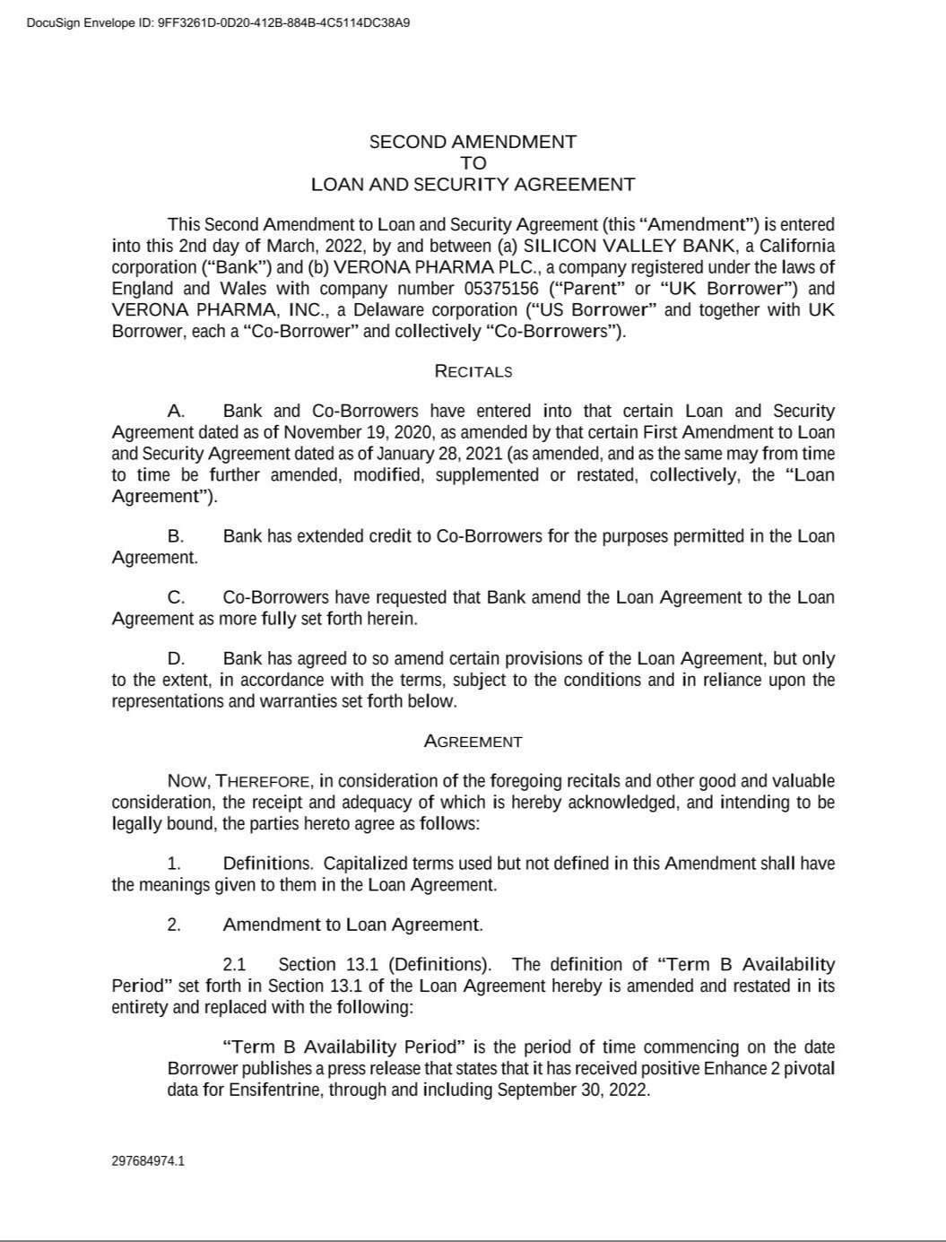

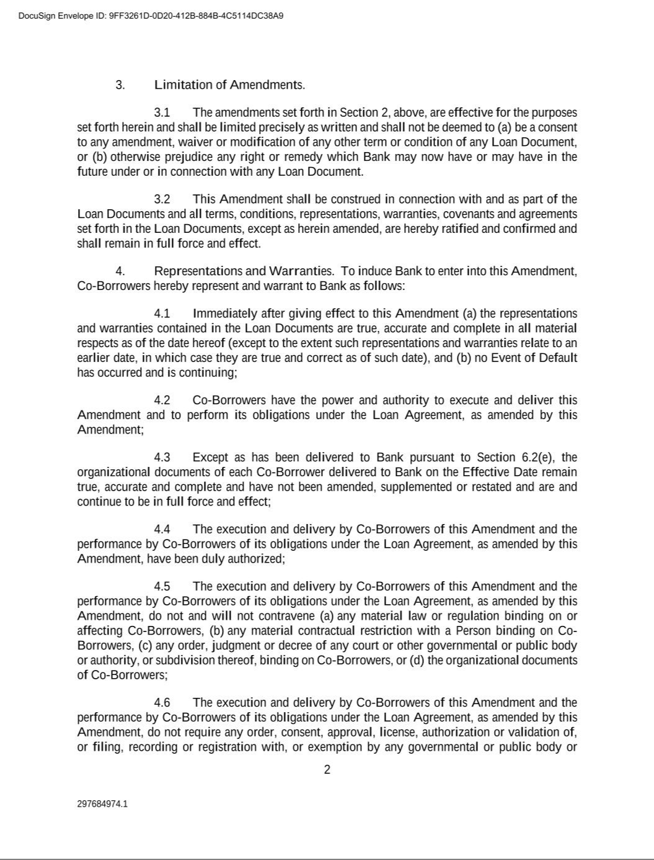

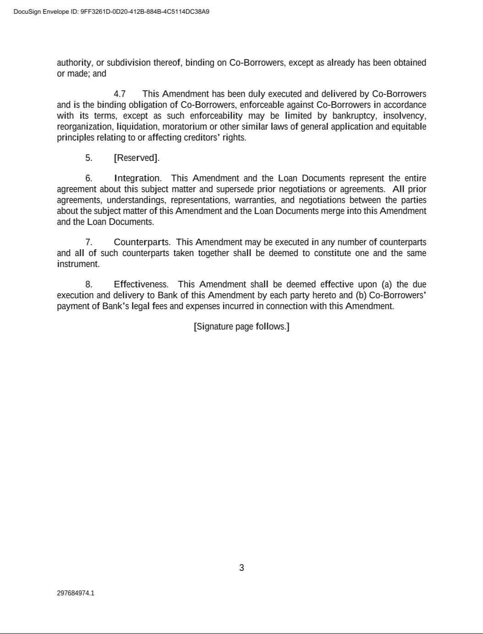

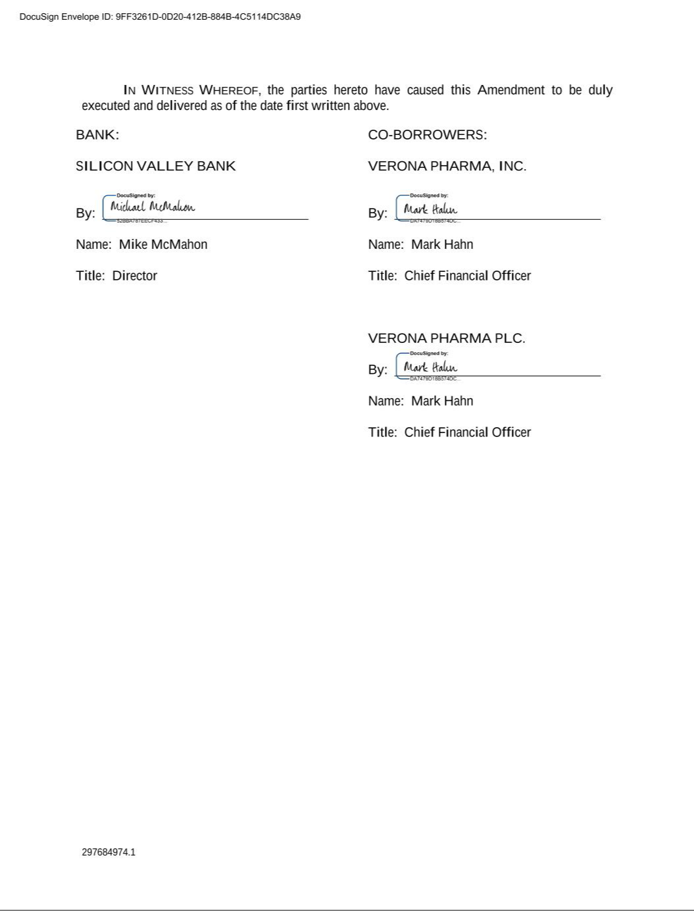

Exhibit 31.1

CERTIFICATION

I, David Zaccardelli, Pharm.D., certify that:

- I have reviewed this Quarterly Report on Form 10-Q of Verona Pharma plc;

- Based on my knowledge, this report does not contain any untrue statement of a material fact or omit to state a material fact necessary to make the statements made, in light of the circumstances under which such statements were made, not misleading with respect to the period covered by this report;

- Based on my knowledge, the financial statements, and other financial information included in this report, fairly present in all material respects the financial condition, results of operations and cash flows of the registrant as of, and for, the periods presented in this report;

- The registrant’s other certifying officer and I are responsible for establishing and maintaining disclosure controls and procedures (as defined in Exchange Act Rules 13a-15(e) and 15d-15(e)) and internal control over financial reporting (as defined in Exchange Act Rules 13a-15(f) and 15d-15(f)) for the registrant and have:

    - Designed such disclosure controls and procedures, or caused such disclosure controls and procedures to be designed under our supervision, to ensure that material information relating to the registrant, including its consolidated subsidiaries, is made known to us by others within those entities, particularly during the period in which this report is being prepared;

    - Designed such internal control over financial reporting, or caused such internal control over financial reporting to be designed under our supervision, to provide reasonable assurance regarding the reliability of financial reporting and the preparation of financial statements for external purposes in accordance with generally accepted accounting principles;

    - Evaluated the effectiveness of the registrant’s disclosure controls and procedures and presented in this report our conclusions about the effectiveness of the disclosure controls and procedures, as of the end of the period covered by this report based on such evaluation; and

    - Disclosed in this report any change in the registrant’s internal control over financial reporting that occurred during the registrant’s most recent fiscal quarter (the registrant’s fourth fiscal quarter in the case of an annual report) that has materially affected, or is reasonably likely to materially affect, the registrant’s internal control over financial reporting; and

  - The registrant’s other certifying officer and I have disclosed, based on our most recent evaluation of internal control over financial reporting, to the registrant’s auditors and the audit committee of the registrant’s board of directors (or persons performing the equivalent functions):

    - All significant deficiencies and material weaknesses in the design or operation of internal control over financial reporting which are reasonably likely to adversely affect the registrant’s ability to record, process, summarize and report financial information; and

    - Any fraud, whether or not material, that involves management or other employees who have a significant role in the registrant’s internal control over financial reporting.

Date: May 3, 2022 By: /s/ David Zaccardelli, Pharm.D.

David Zaccardelli, Pharm.D.

Chief Executive Officer

(principal executive officer)

Exhibit 31.2

CERTIFICATION

I, Mark W. Hahn, certify that:

- I have reviewed this Quarterly Report on Form 10-Q of Verona Pharma plc;

- Based on my knowledge, this report does not contain any untrue statement of a material fact or omit to state a material fact necessary to make the statements made, in light of the circumstances under which such statements were made, not misleading with respect to the period covered by this report;

- Based on my knowledge, the financial statements, and other financial information included in this report, fairly present in all material respects the financial condition, results of operations and cash flows of the registrant as of, and for, the periods presented in this report;

- The registrant’s other certifying officer and I are responsible for establishing and maintaining disclosure controls and procedures (as defined in Exchange Act Rules 13a-15(e) and 15d-15(e)) and internal control over financial reporting (as defined in Exchange Act Rules 13a-15(f) and 15d-15(f)) for the registrant and have:

  - Designed such disclosure controls and procedures, or caused such disclosure controls and procedures to be designed under our supervision, to ensure that material information relating to the registrant, including its consolidated subsidiaries, is made known to us by others within those entities, particularly during the period in which this report is being prepared;

  - Designed such internal control over financial reporting, or caused such internal control over financial reporting to be designed under our supervision, to provide reasonable assurance regarding the reliability of financial reporting and the preparation of financial statements for external purposes in accordance with generally accepted accounting principles;

  - Evaluated the effectiveness of the registrant’s disclosure controls and procedures and presented in this report our conclusions about the effectiveness of the disclosure controls and procedures, as of the end of the period covered by this report based on such evaluation; and

  - Disclosed in this report any change in the registrant’s internal control over financial reporting that occurred during the registrant’s most recent fiscal quarter (the registrant’s fourth fiscal quarter in the case of an annual report) that has materially affected, or is reasonably likely to materially affect, the registrant’s internal control over financial reporting; and

- The registrant’s other certifying officer and I have disclosed, based on our most recent evaluation of internal control over financial reporting, to the registrant’s auditors and the audit committee of the registrant’s board of directors (or persons performing the equivalent functions):

  - All significant deficiencies and material weaknesses in the design or operation of internal control over financial reporting which are reasonably likely to adversely affect the registrant’s ability to record, process, summarize and report financial information; and

  - Any fraud, whether or not material, that involves management or other employees who have a significant role in the registrant’s internal control over financial reporting.

Date: May 3, 2022 By: /s/ Mark W. Hahn

Mark W. Hahn

Chief Financial Officer (principal financial officer)

Exhibit 32.1

CERTIFICATION PURSUANT TO

18 U.S.C. SECTION 1350, AS ADOPTED PURSUANT TO

SECTION 906 OF THE SARBANES-OXLEY ACT OF 2002

In connection with the Quarterly Report on Form 10-Q of Verona Pharma plc (the “Company”) for the period ended March 31, 2022 as filed with the Securities and Exchange Commission on the date hereof (the “Report”), I certify, pursuant to 18 U.S.C. § 1350, as adopted pursuant to § 906 of the Sarbanes-Oxley Act of 2002, that, to the best of my knowledge:

- The Report fully complies with the requirements of Section 13(a) or 15(d) of the Securities Exchange Act of 1934, as amended; and

- The information contained in the Report fairly presents, in all material respects, the financial condition and results of operations of the Company.

Date: May 3, 2022 By: /s/ David Zaccardelli, Pharm.D.

David Zaccardelli, Pharm.D.

Chief Executive Officer

(principal executive officer)

Exhibit 32.2

CERTIFICATION PURSUANT TO

18 U.S.C. SECTION 1350, AS ADOPTED PURSUANT TO

SECTION 906 OF THE SARBANES-OXLEY ACT OF 2002

In connection with the Quarterly Report on Form 10-Q of Verona Pharma plc (the “Company”) for the period ended March 31, 2022 as filed with the Securities and Exchange Commission on the date hereof (the “Report”), I certify, pursuant to 18 U.S.C. § 1350, as adopted pursuant to § 906 of the Sarbanes-Oxley Act of 2002, that, to the best of my knowledge:

- The Report fully complies with the requirements of Section 13(a) or 15(d) of the Securities Exchange Act of 1934, as amended; and

- The information contained in the Report fairly presents, in all material respects, the financial condition and results of operations of the Company.

Date: May 3, 2022 By: /s/ Mark W. Hahn

Mark W. Hahn

Chief Financial Officer (principal financial officer)

